

PROCUREMENT OF SMALL WORKS
WABANE Council Internal Tender Board
RELAUNCH OF REQUEST FOR QUOTATIONS
N°016/RFQ/WC/WCTB/2025 OF 04/12/2025 CONCERNING THE CONSTRUCTION AND EQUIPPING (60 BENCHES) OF TWO CLASSROOMS AT GS MARITA, WABANE COUNCIL, LEBIALEM DIVISION, SOUTH-WEST REGION
EMERGENCY PROCEDURE

Project Name: LOCAL GOVERNANCE AND RESILIENT COMMUNITIES PROJECT (PROLOG)
Project owner: THE MAYOR OF WABANE COUNCIL (PROLOG COMMUNITY INVESTMENT SUPPORT GRANT AGREEMENT - WABANE COUNCIL, LEBIALEM DIVISION, SOUTH-WEST REGION)
Country: CAMEROON
Credit No : Crédit IDA N°72130- CM

No STEP:

Issued on : 04/12/2025

December 2025

Procurement of:

The construction and equipping (60 benches) of two classrooms at GS Marita, WABANE Council, Lebialem Division, South-West Region

EMERGENCY PROCEDURE.

Ref No: N°016/RFQ/WC/WCTB/2025 OF 04/12/2025

Project: Local Governance and Resilient Communities Project (PROLOG)

Project owner: THE MAYOR OF WABANE COUNCIL (PROLOG COMMUNITY INVESTMENT SUPPORT GRANT AGREEMENT - WABANE COUNCIL, LEBIALEM DIVISION, SOUTHWEST REGION)
Country: CAMEROON

Issued on: 04/12/2025

Table of Contents

RELAUNCH OF REQUEST FOR QUOTATIONS Erreur ! Signet non défini.

ANNEX 1: Works Requirements Erreur ! Signet non défini.

ANNEX 2: Quotation Forms Erreur ! Signet non défini.

ANNEX 3: Contract Forms Erreur ! Signet non défini.

Internal Tender Board
RELAUNCH OF REQUEST FOR QUOTATIONS
N°016/RFQ/WC/WCTB/2025 OF 04/12/2025

Concerning the construction and equipping (60 benches) of two classrooms at GS Marita, WABANE Council, Lebialem Division, South-West Region

Request for Quotation (RFQ)
- The Government of Cameroon has received funding from the World Bank to finance the cost of the Local Governance and Resilient Communities Project (PROLOG). As part of its implementation, PROLOG has signed an agreement with WABANE COUNCIL (PROLOG COMMUNITY INVESTMENT SUPPORT GRANT AGREEMENT - WABANE COUNCIL, LEBIALEM DIVISION, SOUTHWEST REGION) to build community infrastructure.
- As part of the agreement, financing for the construction and equipping (60 benches) of two classrooms at GS Marita, WABANE Council, Lebialem Division, South-West Region, for a completion period of sixty (60) calendar days.
- The Mayor of WABANE Council now invites quotations from contractors for the Works described in Annex 1: Works Requirements, attached to this RFQ. As soon as the RFQ is published, the tender’s file will be made available to all bidders, either at their request to the WABANE Concil (Employer) or the PROLOG PMU/RCU.
Fraud and Corruption
- The Bank requires compliance with the Bank’s Anti-Corruption Guidelines and its prevailing sanctions policies and procedures as set forth in the WBG’s Sanctions Framework, as set forth in Appendix A to the Contract Conditions.
- In further pursuance of this policy, Contractors shall permit and shall cause their agents (where declared or not), subcontractors, subconsultants, service providers, suppliers, and personnel, to permit the Bank to inspect all accounts, records and other documents relating to the RFQ and Contract performance (in the case of award), and to have them audited by auditors appointed by the Bank.
Eligible Materials, Equipment and Services
- The materials, equipment and services to be supplied under the Contract and financed by the Bank may have their origin in any country subject to Para. 9. At the Employer’s request, Contractors may be required to provide evidence of the origin of materials, equipment and services.
Eligible Contractors
- In case the Contractor is a joint venture (JV), all members shall be jointly and severally liable for the execution of the entire Contract in accordance with the Contract terms. The JV shall nominate a representative who shall have the authority to conduct all business for and on behalf of any and all the members of the JV during the RELAUNCH OF REQUEST FOR QUOTATIONS process and, in the event the JV is awarded the Contract, during contract execution.
- A Contractor may have the nationality of any country, subject to the restrictions pursuant to paras. 8 and 9 hereinafter. A Contractor shall be deemed to have the nationality of a country if the Contractor is constituted, incorporated or registered in, and operates in conformity with, the provisions of the laws of that country, as evidenced by its articles of incorporation (or equivalent documents of constitution or association) and its registration documents, as the case may be. This criterion also shall apply to the determination of the nationality of proposed subcontractors or subconsultants for any part of the Contract including Related Services.
- Firms and individuals may be ineligible if so indicated in para.9 below and:

as a matter of law or official regulations, the Borrower’s country prohibits commercial relations with that country, provided that the Bank is satisfied that such exclusion does not preclude effective competition for the supply of goods or the contracting of works or services required; or

by an act of compliance with a decision of the United Nations Security Council taken under Chapter VII of the Charter of the United Nations, the Borrower’s country prohibits any import of goods or contracting of works or services from that country, or any payments to any country, person, or entity in that country.
- In reference to paras. 5 and 7, for the information of Contractors, at the present time firms, goods and services from the following countries are excluded from this procurement process:
- Under para. 5 and 8 (a): “none”.
- Under para. 5 and 8 (b): “none”
- A Contractor that has been sanctioned by the Bank, pursuant to the Bank’s Anti-Corruption Guidelines, in accordance with its prevailing sanctions policies and procedures as set forth in the WBG’s Sanctions Framework as described in the appendix to the Contract Conditions (Appendix A) paragraph 2.2 d., shall be ineligible to submit Quotations or be awarded or otherwise benefit from a Bank-financed contract, financially or otherwise, during such period of time as the Bank shall have determined. A list of debarred firms and individuals is available on the Bank’s external website: http://www.worldbank.org/debarr.
- Contractors that are state-owned enterprises or institutions in the Employer’s country may be eligible to compete and be awarded a Contract(s) only if they can establish, in a manner acceptable to the Bank, that they:

are legally and financially autonomous;

operate under commercial law; and

are not under supervision of the Employer.
- A Contractor shall not have a conflict of interest. Any Contractor found to have a conflict of interest shall be disqualified. A Contractor may be considered to have a conflict of interest for the purpose of this Request for Quotations process, if the Contractor:
    - directly or indirectly controls, is controlled by or is under common control with another Contractor that submitted a Quotation;
    - receives or has received any direct or indirect subsidy from another Contractor that submitted a Quotation;
    - has the same legal representative as another Contractor that submitted a Quotation;
    - has a relationship with another Contractor that submitted a Quotation, directly or through common third parties, that puts it in a position to influence the Quotation of another Contractor, or influence the decisions of the Employer regarding this RELAUNCH OF REQUEST FOR QUOTATIONS process; or
    - or any of its affiliates participated as a consultant in the preparation of the design or technical specifications of the works that are the subject of the RELAUNCH OF REQUEST FOR QUOTATIONS process; or
    - or any of its affiliates has been hired (or is proposed to be hired) by the Employer or Borrower for implementing the Contract; or
    - would be providing goods, works, or non-consulting services resulting from, or directly related to consulting services for the preparation or implementation of the project specified in this RELAUNCH OF REQUEST FOR QUOTATIONS, that it provided or were provided by any affiliate that directly or indirectly controls, is controlled by, or is under common control with that firm; or
    - has a close business or family relationship with a professional staff of the Borrower (or of the project implementing agency, or of a recipient of a part of the loan) who: (i) are directly or indirectly involved in the preparation of the RELAUNCH OF REQUEST FOR QUOTATIONS or specifications and/or the evaluation of Quotations, of the subject Contract; or (ii) would be involved in the implementation or supervision of such Contract unless the conflict stemming from such relationship has been resolved in a manner acceptable to the Bank throughout the RELAUNCH OF REQUEST FOR QUOTATIONS process and execution of the Contract.

Validity of Quotations
- The quotations shall be valid until ninety (90) days after opening the tenders
Price
- The Contractor shall quote its total price in the Contractor’s Quotation Form.
- The Contractor shall also fill in its rates and prices for all items of the Works described in the attached Bill of Quantities. Items against which no rate or price is entered by the Contractor will not be paid for by the Employer when executed and shall be deemed covered by the rates for other items and prices in the Bill of Quantities.
The rates and prices shall include all duties, taxes, and other levies payable by the Contractor under the Contract, as of the date 7 (seven) days prior to the deadline for submission of quotations
- A Contractor expecting to incur expenditures in other currencies for inputs to the Works supplied from outside the Employer’s Country and wishing to be paid accordingly, shall indicate a foreign currency of its choice in addition to the local currency in CFA Francs XAF.
- The currency(ies) of the Quotation and the currency(ies) of payments shall be the same.
Technical proposal
- The Contractor shall furnish a technical proposal including a statement of work methods, equipment, personnel, schedule, and any other relevant information, in sufficient detail to demonstrate the adequacy of its proposal to meet the work’s requirements and the completion time.
Other: The Service Provider shall also produce an administrative file consisting of original documents or copies certified true by the issuing departments and consisting of the following valid items: (i) Trade Register; (ii) Certificate of tax compliance, (iii) Location plan signed on honor indicating the council of the tenderer; (iv) Certificate of non-bankruptcy; (v) Certificate of non-exclusion from public contracts; (vi) Tender certificate issued by the CNPS; (vii) Tax registration certificate; (viii) Bank domiciliation certificate; (ix) Site visit certificate and report signed on honor by the tenderer; (x) attestation of categorization.
Note: It should be noted that the administrative documents mentioned above must be less than three (03) months old and be produced in originals or certified copies by the competent issuing authority. The absence of all or some of the above documents will not result in the rejection of the tender at the time of evaluation. However, they will be required when the Contract is awarded.
In addition, bidders will be given 48 hours in which to compete.
Clarifications
- Any clarification request regarding this RFQ may be sent in writing to
Attention of: The Mayor of WABANE Council
Administration: WABANE Council
Town: WABANE
PO. Box:
Country: Cameroon
Cell phone:
Mail : ________________ copy to leotabeako@minddevel.gov.cm, e.abdoul2025@minddevel.gov.cm.
The deadline for receipt of requests for clarification, expressed as a number of days before the deadline for submission of tenders, is seven (07) days Employer will send a copy of its response to all the Companies, including a description of the request for clarification, but without identifying its source.
Submission of Quotations
- Quotations shall be submitted in the form attached at Annex, in seven (07) copies (including one (01) original and six (06) copies plus a USB key containing the digital PDF and editable version), to the above address, in a sealed envelope marked:
“RELAUNCH OF REQUEST FOR QUOTATIONS N°016/RFQ/WC/WCTB/2025 OF 04/12/2025 Concerning construction and equipping (60 benches) of two classrooms at GS Marita, WABANE Council, Lebialem Division, South-West Region.

NOT TO BE OPENED UNTIL THE COUNTING SESSION”

- The deadline for submission of Quotations is the 30/12/2025 at 10 am.
Note: Any tender arriving after the deadline for submission of tenders will be rejected. Tenders will be opened in the presence of the tenderers' representatives at the above-mentioned address.
- The address for submission of Quotations is:
Attention of: The Mayor of WABANE Council
Administration: WABANE Council
Town: WABANE
Located at:
PO. Box:
Country: Cameroon
Cell phone:
Mail: __________ copy to leotabeako@minddevel.gov.cm, e.abdoul2025@minddevel.gov.cm
Opening of Quotations
- The opening of the quotations will take place at the headquarters of the WABANE Council on 30/12/2025 at 11 am, local time, in the presence of the tenderers or their representatives, by the Internal Tender Board.
Evaluation of Quotations
- The quotations will be evaluated to determine substantial responsiveness of the technical proposal.
- Check that the Letter of Quotation is properly completed, dated and signed with the name and title of the signatory;
- Verification that the Unit Price Schedule and Detailed and Quantitative Specifications have been duly completed, dated and signed.
- Assessment of the technical qualification of each admissible tender in accordance with the tender evaluation grid.
TENDER EVALUATION GRID
No | Designation | BINARY NOTATION
1 | Presentation of the Offer
1 | Compliance with the order prescribed in the RFQ and dividers | Yes/No
1 | Legibility and pagination | Yes/No
2 | Experience of the bidder
2 | Two references in the execution of works contracts | Yes/No
2 | One reference similar to the mission (With supporting evidence) | Yes/No
3 | Staff quality
3 | - Mission manager
3 | Copy of the Mission manager’s diploma (Civil engineer) (Copy of the diploma) | Yes/No
3 | Curriculum Vitae of the Mission Manager, dated and signed | Yes/No
3 | ≥ 3 years' experience in a similar field | Yes/No
3 | - Site manager
3 | Site manager's diploma (at least Civil/Rural Engineering Technician level), dated and signed | Yes/No
3 | Curriculum Vitae of the Site Manager, dated and signed | Yes/No
3 | Seniority ≥ 3 years in a similar field | Yes/No
 | - Electrician
 | HND in electricity (Copy of the diploma), | Yes/No
 | Curriculum Vitae of the electriian, dated and signed | Yes/No
 | Seniority ≥ 3 years in a similar field | Yes/No
4 | Construction equipment
4 | At least one pick-up truck (produce a certified photocopy of the vehicle registration document or a rental contract with a legal photocopy of the vehicle registration document) | Yes/No
4 | List of small items of equipment appropriate to the task (photocopies of purchase invoices must be provided) | Yes/No
5 | Work execution methodology
5 | Detailed technical note on the organization of the work | Yes/No
5 | Description of the socio-environmental protection rules | Yes/No
5 | Detailed work schedule with deadlines ≤ ninety (90) days | Yes/No
6 | Special technical specifications, initialed on each page, dated, and signed on the last page | Yes/No
7 | Environmental and social clauses, initialed on each page, dated, and signed on the last page | Yes/No
8 | Special Administrative Conditions initialed on each page, dated, and signed on the last page | Yes/No
9 | Site visit report | Yes/No
 | Total of “Yes” | ….. /20
Note: Only tenders with a total of 17 “Yes” votes out of 20 will be admitted to the next stage of the procedure.
- Checking arithmetic operations, multiplying unit prices by quantities where necessary and using the price in words to make any necessary corrections;
- Drawing up a summary table of Quotations based on the amounts corrected for any arithmetical errors, listed in ascending order.
- For evaluation and comparison purposes, the currency(ies) of the Quotations shall be converted into a single currency. The currency that shall be used for comparison purposes to convert at the selling exchange rate offered prices expressed in various currencies into a single currency is: CFA Francs (XAF). The source of exchange rate shall be: Banque des Etats de l'Afrique Centrale (BEAC). The date for the exchange rate shall be: twenty-eight (28) days before the tender submission date.
(Note: If the reference currency is not quoted on this date, the exchange rate will be that of the last previous quoted day).
- For technically compliant quotations, the total evaluated prices, excluding provisional sums and any provision for contingencies but including day works where priced competitively, will be compared to determine the lowest evaluated price/s.
Contract Award
- The Contract will be awarded to the Contractor who meets the eligibility requirements in accordance with the RFQ, offers the lowest evaluated price/s, offers a technically compliant quotation, and guarantees completion of the Works by the specified date.
- The Employer shall invite by the quickest means [e.g. e-mail] the successful Contractor/s for any discussion [this is expected to be virtual in light of the emergency situation] that may be needed to conclude the contract or otherwise for contract signature.
- The Employer shall communicate by the quickest means with the other Contractors on its contract award decision. An unsuccessful Contractor may request clarifications as to why its quotation was not determined to be successful. The Employer will address this request within a reasonable time.
- The Employer shall publish a contract award notice on its website with free access, if available, or in a newspaper of national circulation or UNDB online, within 15 (fifteen) days after award of contract. The information shall include the name of the successful Contractor, the Contract Price, the Contract duration, summary of its scope and the names of the Contractors and their quoted and evaluated prices.
On behalf of the Employer:
WABANE, the_____________
Signature:

Commission Interne de Passation des Marchés
Lettre de Demande de Cotations
N°016/RFQ/WC/WCTB/2025 du 04/12/2025
Relatif à la construction et équipement (60 tables-bancs) de deux salles de classe à l’Etablissement Marita, Commune de Wabane, Département du Lebialem, Région du Sud-Ouest (Relance)
En procédure d’urgence.
Demande de Cotations (DC)
- Le Gouvernement du Cameroun a reçu un financement de la Banque mondiale pour financer le coût du Projet Gouvernance Locale et Communautés Résilientes (PROLOG). Dans le cadre de sa mise en œuvre, le PROLOG a signé une convention avec la Commune de Wabane (CONVENTION DE SUBVENTION D’APPUI AUX INVESTISSEMENTS COMMUNAUTAIRES PROLOG-COMMUNE) pour la réalisation des infrastructures communautaires.
- Dans le cadre cet l'accord, il a été convenu le financement de la construction et équipement (60 tables-bancs) de deux salles de classe à l’Etablissement Marita, Commune de Wabane, Département du Lebialem, Région du Sud-Ouest, pour un délai d’exécution de soixante (60) jours calendaires.
- Le Maire de la Commune de Wabane, invite les potentiels prestataires à soumettre les Cotations pour la prestation decrite dans l’Annex 1 : Spécifications des travaux, jointes à la présente Demande de Cotation. Dès publication de la lettre de demande de cotations, la Demande de Cotation sera mis à la disposition de tous les potentiels soumissionnaires, sur demande auprès de la Commune de Wabane (Maître d'ouvrage) ou de l'UGP/UCR PROLOG.
Fraude et Corruption
- La Banque exige le respect des Directives de la Banque en matière de lutte contre la corruption et de ses politiques et procédures de sanctions en vigueur, telles qu’énoncées dans le Cadre de sanctions du Groupe de la Banque mondiale, tel qu’il est établi à l’Annexe A des Conditions Contractuelles.
- Dans le cadre de cette politique, les Entrepreneurs autorisent et doivent faire en sorte que leurs agents (déclarés ou non), sous-traitants, prestataires de services, fournisseurs et personnel, permettent à la Banque d’inspecter tous les comptes, dossiers et autres documents relatifs à la Demande de Cotation et à l’exécution du marché (en cas d’attribution), et de les faire vérifier par les vérificateurs nommés par la Banque.
Eligibilité des matériaux, équipements et services
- Les matériaux, équipements et services qui doivent être fournis en vertu du marché et financés par la Banque peuvent avoir leur origine dans tout pays, sous réserve des dispositions du paragraphe 9. A la demande du Maître d’Ouvrage, l’Entrepreneur peut être tenu de fournir une preuve de l’origine des matériaux, de l’équipement et des services.
Eligibilité des Entreprises
- Dans le cas où l’Entreprise est un groupement d’entreprises (GE), tous les membres sont conjointement et solidairement responsables de l’exécution de l’ensemble du contrat conformément aux termes du marché. Le GE nommera un représentant qui a le pouvoir de mener toutes les affaires pour et au nom de tous les membres du GE pendant le processus de Demande de Cotation et, dans le cas où le GE est attributaire du Marché, lors de l’exécution du contrat.
- Une Entreprise peut avoir la nationalité de tout pays, sous réserve des restrictions en vertu des paragraphes 8 et 9 ci-après. Un Entreprise est réputé avoir la nationalité d’un pays si l’Entreprise est constitué, incorporé ou enregistré selon les dispositions des lois de ce pays, comme en attestent ses statuts (ou documents équivalents de constitution ou d’association) et ses documents d’enregistrement, selon le cas. Ce critère s’applique également à la détermination de la nationalité des sous-traitants proposés pour toute partie du marché, y compris les services connexes.
- Les entreprises et les personnes physiques peuvent ne pas être éligibles si indiqué au paragraphe 9 ci-dessous et:

en droit ou en vertu de règlements officiels, le pays de l’Emprunteur interdit les relations commerciales avec ce pays, à condition que la Banque soit convaincue qu’une telle exclusion n’empêche pas une concurrence effective pour la fourniture de biens ou la passation de marchés de travaux ou de services requis; ou

par un acte de conformité à une décision du Conseil de Sécurité des Nations Unies prise en vertu du chapitre VII de la Charte des Nations Unies, le pays de l’Emprunteur interdit toute importation de biens ou de passation de marchés de travaux ou de services en provenance de ce pays, ou tout paiement à un pays, une personne physique ou une entité dans ce pays.
- En ce qui concerne les paragraphes 5 et 7, pour l’information des Entreprises, à l’heure actuelle, les entreprises, les biens et les services des pays suivants sont exclus de ce processus de passation de marchés :
  - En vertu des paragraphes 5 et 8 (a) : [insérer une liste des pays après approbation de la Banque pour appliquer la restriction ou indiquer « aucun»].
  - En vertu des paragraphes 5 et 8 (b) : [insérer une liste des pays après l’approbation de la Banque pour appliquer la restriction ou indiquer « aucun»].
- Une Entreprise qui a été sanctionné par la Banque, conformément aux Directives de la Banque en matière de lutte contre la corruption, conformément à ses politiques et procédures de sanctions en vigueur, tel qu’énoncé dans le Cadre des sanctions du Groupe de la Banque mondiale tel que décrit dans l’annexe aux conditions contractuelles (Annexe A) arlinéa 2.2 d., ne sera pas admissible à soumettre une Cotation ou à être attributaire d’un marché ou bénéficier d’un marché financé par la Banque, financièrement ou autrement, pendant une période telle que la Banque aura déterminée. Une liste des entreprises et des personnes physiques exclues est disponible sur le site externe Web de la Banque : http://www.worldbank.org/debarr.
- Une Entreprise qui est une entreprise ou une institution publique dans le pays du Maître d’Ouvrage peut être admissible à participer à la mise en concurrence et se voir attribuer un marché à condition qu’elle peut établir, d’une manière acceptable pour la Banque, qu’elle :

est légalement et financièrement autonomes;

fonctionne en vertu du droit commercial; et

n’est pas sous la supervision du Maitre d’Ouvrage.
- Une Entreprise ne doit pas avoir de conflit d’intérêts. Toute Entreprise en situation de conflit d’intérêts sera disqualifiée. Une Entreprise peut être considérée comme en conflit d’intérêts aux fins du présent processus de Demande de Cotation, si l’Entreprise :
    - contrôle directement ou indirectement, est contrôlé ou est sous contrôle commun avec une autre Entreprise qui a soumis une cotation;
    - reçoit ou a reçu une subvention directe ou indirecte d’une autre Entreprise qui a soumis une cotation;
    - a le même représentant légal qu’une autre Entreprise qui a soumis une Cotation;
    - a une relation avec une autre Entreprise qui a soumis une Cotation, directement ou par l’entremise de tiers communs, qui la mette en mesure d’influencer la Cotation d’une autre Entreprise ou d’influencer les décisions du Maitre d’Ouvrage concernant le processus de Demande de Cotation; ou
    - ou l’un de ses affiliés a participé en tant que consultant à la préparation de la conception ou des spécifications techniques des ouvrages qui font l’objet du processus de Demande de Cotation; ou
    - ou l’un de ses affiliés a été recruté (ou est proposé d’être recruté) par le Maître d’Ouvrage ou l’Emprunteur pour la mise en œuvre du marché; ou
    - fournirait des biens, des travaux ou des services autres que des services de consultant résultant ou directement liés à des services de consultant pour la préparation ou la mise en œuvre du projet spécifié dans la cette Demande de Cotation, qu’elle fournissait elle-même ou par toute société affiliée qui contrôle directement ou indirectement, est contrôlée ou est sous contrôle commun avec cette entreprise; ou
    - a une relation d’affaires ou familiale étroite avec un personnel cadre de l’Emprunteur (ou de l’organisme de mise en œuvre du projet, ou d’un bénéficiaire d’une partie du prêt) qui : (i) participe directement ou indirectement à la préparation de la Demande de Cotation ou de spécifications et/ou à l’évaluation des Cotations, du marché en question; ou (ii) participerait à la mise en œuvre ou à la supervision de ce marché à moins que le conflit découlant de cette relation n’ait été résolu d’une manière acceptable pour la Banque tout au long du processus de Demande de Cotation et d’exécution du marché.
Garantie de bonne exécution (Non applicable)
- L’Entreprise retenue doit fournir une Garantie de Bonne Exécution conformément aux conditions du marché.
Validité des Cotations
- Les Cotationss seront valides jusqu’à quatre-vingt-dix (90) jours après l’ouveture des offres/cotations.
Prix proposé
- L’Entreprise devra indiquer le prix total dans le formulaire intitulé « Cotation de l’Entreprise »
- L’Entreprise doit également fournir les prix unitaires de tous les éléments des Travaux décrits dans le Détail Quantitatif et Estimatif joint. Les articles pour lesquels aucun prix unitaire n’est fourni, ne feront pas l’objet de paiement à l’Entreprise par le Maître d’Ouvrage lorsqu’ils seront exécutés et seront considérés couverts par les prix unitaires pour d’autres articles et prix du Détail Quantitatif et Estimatif.
Les prix comprendront tous les droits, taxes et autres prélèvements payables par l’Entreprise en vertu du Marché, à compter de la date 7 (sept) jours précédant la date limite de soumission des cotations.
- Un Entreprise qui prévoit d’engager des dépenses dans d’autres monnaies pour les intrants nécessaires à l’exécution des travaux provenant de l’extérieur du pays du Maître d’Ouvrage et qui souhaite être payé en conséquence, doit indiquer une monnaie étrangère de son choix en plus de la monnaie locale en Francs CFA XAF
- La/es monnaie/s de la Cotation et la/es monnaie/s de paiement devra/ont être la/es même/s.
Proposition technique
- L’Entreprise doit fournir une proposition technique comprenant la description des méthodes de travail, du matériel, du personnel, du calendrier et toute autre information pertinente, suffisamment en détail pour démontrer l’adéquation de sa proposition pour répondre aux exigences des travaux et délai de réalisation.
Autre : Le Prestataire produira également un dossier administratif composé des pièces originales ou copies certifiées conformes par les services émetteurs et composés des éléments suivants en cours de validité : (i) Registre de Commerce; (ii) Attestation de Conformité Fiscale; (iii) Plan de localisation ; (iv) Attestation de non faillite; (v) Attestation de non exclusion des marchés publics; (vi) Attestation pour soumission délivrée par la CNPS (vii) Attestation d’immatriculation fiscale et (viii) Attestation de domiciliation bancaire; (xi) une attestation de catégorisation délivrée par l’autorité compétente.

N.B : Il est rappelé que les pièces administratives citées ci-dessus devront dater de moins de trois (03) mois et être produites en originaux ou en copies certifiées conformes par l’autorité émettrice compétente, ne constituent pas un critère éliminatoire, mais seront déterminantes pour l’attribution du contrat.

De plus, les soumissionnaires disposeront de 48 heures pour compléter leur doissier.
Clarifications
- Toute demande de clarification concernant la présente Demande de Cotation (DC) peut être adressée par écrit à :
A l’attention de: Le Maire de la Commune de Wabane
Administration: La Commune de Wabane
Ville: Wabane
Boîte Postale:
Pays: Cameroun
Cell phone: 677287540
Mail : _okenyepatrick@yahoo.com copy to leotabeako@minddevel.gov.cm, e.abdoul2025@minddevel.gov.cm
La date limite de réception des demandes d'éclaircissements, exprimée en nombre de jours avant la date limite de dépôt des offres, est de sept (07) jours. Le Maître d’Ouvrage fera copie de sa réponse à toutes les Entreprises, y compris une description de la demande de clarification, mais sans en identifier la source.
Soumission des Cotations
- Les Cotations doivent être soumises selon le formulaire ci-joint à l’Annexe en sept (07) copies (donc un original (01) et six (06) copies) plus une clé USB cotenant la versiont scannée de la quotation et la version modifiable, dans une enveloppe scellée marquée comme suit :
“Demande de Cotations N°004/RFQ/WC/WCTB/2025 du 26 Septembre 2025 relatif à la construction et équipement (60 tables-bancs) de deux salles de classe à l’Etablissement Marita, Commune de Wabane, Département du Lebialem, Région du Sud-Ouest (Relance).
En procedure d’urgence

A N’OUVRIR QU’EN SEANCE D’OUVERTURE”

- L’heure et la date limites pour la soumission des Cotations est le 30/12/2025 à 10 heure.
NB : Toute offre reçue après la date limite de dépôt des offres sera rejetée. L’ouverture des offres se fera en présence des représentants des soumissionnaires à l’adresse susmentionnée.
- L’adresse pour la soumission des Cotations est la suivante :
A l’attention de: Le Maire de la Commune de Wabane
Administration: La Commune de Wabane
Ville: Wabane
Boîte Postale:
Pays: Cameroun
Cell phone:
Mail : ______________________ copy to leotabeako@minddevel.gov.cm, e.abdoul2025@minddevel.gov.cm.
Ouverture des Quotations
- Les Cotations seront ouvertes par les représentants du Maître d’Ouvrage immédiatement après l’heure et la date limites pour la remise des Cotations, le 30/12/2025 à 11 heure.
Évaluation des Cotations
- Les Cotations seront évaluées afin de s’assurer de la conformité de la proposition technique.
- Vérifier que la lettre de devis est dûment complétée, datée et signée, avec le nom et le titre du signataire ;
- Vérifier que le bordereau des prix unitaires et les spécifications détaillées et quantitatives sont dûment complétés, datés et signés.
- Évaluer la qualification technique de chaque offre recevable conformément à la grille d'évaluation des offres.
- Vérifier les opérations arithmétiques, multiplier les prix unitaires par les quantités si nécessaire et utiliser le prix en toutes lettres pour effectuer les corrections nécessaires ;
- Établir un tableau récapitulatif des devis à partir des montants corrigés des erreurs arithmétiques, classés par ordre croissant.

- Aux fins de l’évaluation et de la comparaison, la/es monnaie/s des cotations doit/vent être convertie/s en une même monnaie. La monnaie qui doit être utilisée aux fins de comparaison pour convertir les prix proposés, exprimés dans diverses monnaies en la monnaie de comparaison au taux de change à la vente sera la suivante : Francs CFA (XAF). La source du taux de change est la suivante : Banque des Etats de l'Afrique centrale (BEAC). La date du taux de change est : vingt-huit (28) jours avant la date de soumission des offres.
NB : Si la devise de référence n'est pas cotée à cette date, le taux de change sera celui du dernier jour coté précédent.
- Pour les cotations techniquement conformes, les prix totaux évalués, à l’exclusion des sommes provisonnelles et toute provision pour les imprévus, mais y compris les travaux en régie lorsque leurs prix sont établis de manière compétitive, seront ensuite comparés pour déterminer le prix/s évalué le plus bas.
Attribution du marché
- Le Marché sera attribué à l’Entreprise qui satisfait aux exigences d’admissibilité conformément à la DC, qui offre le prix/s évalué le plus bas, qui offre une cotation techniquement conforme et qui garantit l’achèvement des travaux à la date spécifiée.
- Le Maître d’Ouvrage invitera par les moyens les plus rapides [p. ex. courriel] l’/les Entreprise/s retenu/s pour discussion [il est attendu que cela soit virtuel à la lumière de la situation d’urgence] si nécessaire en vue de finaliser le marché ou pour la signature du marché.
- Le Maître d’Ouvrage informera par les moyens les plus rapides les autres Entreprises de sa décision d’attribution de marché. Une Entreprise non retenue peut demander des clarifications sur les motifs pour lesquels sa Cotation n’a pas été retenue. Le Maître d’Ouvrage répondra à une telle demande dans le meilleur délai possible.
- Le Maître d’Ouvrage publiera un avis d’attribution de marché sur son site Web en libre accès, s’il est disponible, ou dans un journal de circulation nationale ou sur UNDB en ligne, dans les 15 jours suivant l’attribution du marché. Les renseignements indiqués comprendront le nom de l’Entreprise retenue, le prix contractuel, la durée du marché, le résumé de sa portée et les noms des autres Entreprises candidates et leurs prix proposés et évalués.
Au nom du Maître d’Ouvrage :
Wabane, le 04/12/2025
Signature :

Attachments:
Annex 1: Works Requirements
Annex 2: Quotation Form
Annex 3: Contract Forms

ANNEX 1: Works Requirements
SPECIFICATIONS

SPECIAL TECHNICAL CLAUSES BOOKLET

CONSTRUCTION OF A BLOCK OF TWO EQUIPPED CLASSROOMS
A - INTRODUCTION
The purpose of this technical specification is to define the scope and method of execution of the work to be carried out in accordance with industry standards and the contract documents.
It has been prepared for information purposes only, to clarify and supplement the information in the estimate and the graphic documents, notwithstanding the terms of the contract.

B – METHOD OF EXECUTION OF WORKS
GENERAL :
Reinforced concrete, ordinary concrete and mortars.
For all masonry work, the components of the concrete or mortar must comply with certain basic characteristics as follows:
Sand
All sands will be free from oxides and organic matter of animal or plant origin. The grain size will be between 0.08 mm and 2.5 mm for mortars and screeds; and between 0.16 mm and 5 mm for concrete structures..
Gravel
Gravel intended for concrete production must be homogeneous natural or crushed materials of class 5/15 and 15/25. The gravel must have been freed of its coatings by blowing or washing..
Mixing water
The water used in the preparation of mortars, concretes, and for washing aggregates must be free of impurities and salts.
Hydraulic Binders
The cements used for concrete and mortars must meet the general conditions imposed by current regulations. They are type CPJ 35 from "CIMENCAM" and must not show any traces of moisture. Storage on the construction site will be carried out on a dry and ventilated floor. Any stock that does not appear powdery will be rejected and removed within four days.
Reinforcement
Reinforcement bars for reinforced concrete will be made of mild steel and high-adhesion steel, complying with the requirements of BAEL 91. They must be perfectly clean, free of any trace of rust, and must exhibit good non-adhesion properties to paint or grease. They will be shaped and installed in accordance with the reinforcement plan submitted by the contractor for approval by the project manager before work begins.
Formwork
The formwork will be simple and robust. It must withstand the weight and thrust of the concrete, the effects of vibration, and the weight of the personnel employed during installation without appreciable deformation.
The formwork will be sufficiently watertight to prevent excess water from carrying away the cement.

CHAPTER I: SITE INSTALLATION
Site installation work will be the responsibility of the company awarded the contract. It will include:
The rehabilitation of a temporary fence;
The construction of a supply warehouse with an adjoining office where the site logbook and graphic documents will be permanently available;
Possibly, temporary water, electricity, and telephone connections.

CHAPTER II: PREPARATORY WORKS / EARTHWORKS
Studies
Studies include: - the preparation of execution and detailed plans at appropriate scales;
- the preparation of the work schedule. These plans will be submitted to the project manager in four (4) copies before the start of work.
Brush Clearing
Clearing the land on the building site and within a 10-meter radius around it. This work includes all tree felling and stump removal requirements.
Demolitions
These include any structure, whether or not it is located on the building's site. The products will be disposed of at the public landfill.
Stripping
This involves removing topsoil from the building site and a 10m area around it for storage, reuse, or disposal at a public landfill.
Platform leveling
Leveling of a platform on the building site and within a 5 m radius around it.
Platform leveling
Leveling of a platform on the building site and within a 5 m radius around it.
Excavations
The excavations will be extended to the correct ground, ensuring the structure's complete stability. In all cases, the depth of these excavations will not be less than 1.00 m at any point. The walls of the excavations will be properly erected and the bottoms perfectly leveled.
The execution of these excavations will be subject to approval of the installation by the project manager.
Backfill
The soil from these excavations will, provided it is of good quality, be used for backfill. This will be done in successive 20 cm layers, watered and compacted. Excess soil and soil of poor quality will be disposed of at the public landfill or at locations approved by the project owner. In all cases, the backfill will be cleared of all debris, roots, plant matter, and rubble.

CHAPTER III: FOUNDATIONS
Clean concrete
A lean concrete with a dosage of 150 kg/m³ and a thickness of 5 cm will be spread over the excavation bases.
Clean concrete
All structures rest on a bed of clean concrete with a dosage of 150 kg/m³ and a thickness of 5 cm. All aggregates used in the concrete must be free of organic matter and plant debris..
Semelles :
VARIANTE 1 :
- Semelle filante + murs de fondations en agglomérés de 20 bourrés + chaînage bas.
- Semelle filante : en béton armé de section 10 x 30 ou 15 x 30 suivant indications des plans.
Concrete: 350 kg/m³.
Steel: HA8 pins every 20 cm + 3 HA10 strips.
- Foundation walls:
The foundation walls will be constructed of 20 x 20 x 40 cement blocks filled with ordinary concrete at a 350 kg/m³ dosage and laid with ordinary cement mortar.
VARIATION 2:
- Insulated footings under posts + foundation walls made of 20-meter concrete blocks filled with concrete + stringers.
- Insulated footings under posts: Reinforced concrete, 20 x 80 x 80 (for 20 x 20 posts) or 20 x 75 x 60 (for 20 x 30 posts).
Concrete: 350 kg/m³.
Steel: HA 10 pins every 15 cm maximum in both directions.
- Foundation walls: The foundation walls will be constructed of 20x20x40 cement blocks filled with ordinary concrete, 350 kg/m³, and laid with ordinary cement mortar.
- Posts: Reinforced concrete, 20x20 or 20x30 sections as indicated on the plans.
Concrete: 350 kg/m³.
Steel: * Ø6 frames every 20 cm + 4 HA10 continuous beams for 20 x 20 posts.
* Ø6 frames + pins every 20 cm + 6 HA10 continuous beams for 20 x 30 posts
Sill: Reinforced concrete with a 350 kg/m³ content will rest on top of the continuous footings made of packed concrete blocks. 20 x 20 section. Steel: T6 frames every 20 m; 4 T10 continuous beams; 4 T6 brackets at the corners. The formwork must be neat, with planks planed and greased with unburned oil. The sill must have a smooth and even surface upon removal. No coating will be applied, but a surface treatment may be performed if it exhibits any irregularities.
• Posts: Reinforced concrete sections as indicated on the plans: 20 x 20 in the walls, concrete with a cement content of 350 kg/m³. Steel: T6 frames every 20 m + 4 T10 continuous sections for 20 x 20 posts and 20 x 20 stringers.
• Stone or Rubble Paving
The foundation will be laid with rubble (diameter <30 cm), the vo
ids of which will be filled with well-watered and perfectly compacted sand.
Polyethylene film
A plastic underlay will be spread over the sand before pouring the concrete for the slab.
Ground paving: The ground will receive a lightly reinforced ordinary concrete slab 8 cm thick with a screed that will be cut to a maximum surface area of ​​16 m² with combined joints. Concrete with a cement content of 300 kg/m³. T6 mesh, 30x30 mesh.

CHAPTER IV: MASONRY – ELEVATION
Elevation walls: All walls of the building will be made of 15x20x40 hollow blocks.
The hollow blocks used will be dosed at 300 kg/m³ and will be installed after at least 15 days of age. They must offer significant crushing resistance.
The inspection engineer must ensure:
the quality of the concrete blocks;
the height of the walls;
the installation of the anchoring and corner connections, and the presence of recesses for the passage of ducts (electrical).
The walls will be plumb and flat. The courses must be horizontal. The joints must have a uniform thickness of ± 2 cm. Vertical joints must alternate. The concrete blocks are laid in a full mortar bath. To ensure their usability, the masonry is often lightly watered to prevent it from drying out too quickly.
Screens will be installed on the front and rear facades above the beam to a height of 60 cm, as well as on the rear facade and in the same location; these screens must have the same specifications as those prescribed for concrete blocks.
The gable walls will have a height at their top of at least 1.5 m.
N.B.: The dividing walls between adjoining rooms will be identical.
Posts: Reinforced concrete, 20 x 20 cm in the walls and 20 x 30 cm on the veranda.
Concrete: 350 kg/m³.
Steel: * 6 mm diameter frames every 20 cm + 4 HA 10 mm long sections for posts 20 x 20 cm and larger, 2 HA 8 mm long sections for the veranda.
* 6 mm diameter frames + pins every 20 cm + 6 HA 10 mm long sections for posts 20 x 30 cm.
Lintels: Reinforced concrete, 15 x 20 cm in section, depending on wall thickness.
Concrete: 350 kg/m³.
Steel: Ø 6 frames every 15 cm + 4 x 10 mm long strands.
Window sills: 15 x 15 mm reinforced concrete, depending on wall thickness.
Concrete: 350 kg/m³.
Steel: Ø 6 frames every 15 cm + 4 x 8 mm long strands.
Upper tie-in: 15 x 20 mm reinforced concrete
Concrete: 350 kg/m³.
Steel: Ø 6 frames every 15 cm + 4 x 8 mm long strands + 2 x 6 mm brackets at the corners.
Veranda beam: 15 x 20 mm reinforced concrete
Concrete: 350 kg/m³.
Steel: Frames Ø 6 every 15 cm + 4 HA 10 long sections
Tiles: Ceramic, 30 cm x 30 cm, 8 mm to 12 mm thick, laid with cement adhesive.
Baseboards: Ceramic, measuring 10cm x 30cm and between 8mm and 12mm thick, laid with cement adhesive.
Screed: 4cm thick, made with a coarse sand mortar dosed at 400kg/m³. Finish: Smoothed with cement slurry and bush-hammered.
Rendering: All masonry areas will be coated with a 2cm thick cement render using a cement mortar dosed at 400kg/m³.
Bonding: Rendered with coarse sand mortar.
Finishing: Floated with fine sand mortar.
Painting: Painted on a rendered wall using cement mortar reinforced with welded mesh or wire netting.
Finishing: Floated or carefully smoothed with cement.
- Coating: Two coats of green or black slate.

CHAPTER V: ROOFING - CEILING
• Framework
Trusses: The trusses will be constructed with 3 x 15 whitewood treated with Xylamon, as indicated on the plans.
The trusses will be made of good-quality 3 x 15 or 3 x 20 timber (joists), free of knots and treated with Xylamon or any other insecticide-fungicide product, and manufactured according to best practice. Seven trusses, 11.30 m long and 1.50 m high, will be constructed. The trusses will be securely anchored to the masonry or concrete using the iron bars provided for this purpose.
The building will have 14 (fourteen) 8 x 8 purlins (rafters) measuring 20.00 m. The purlins will be treated with carbonyl or any other insecticide-fungicide product. The tie beam and rafter will be doubled: These trusses will be securely anchored in the masonry using the post retaining irons.
Purlins: These will be made of white wood treated with Xylamon, 8 x 8 or 5 x 15 sections, as indicated on the plans. On the gables and partition walls, they will be secured with 3 x 30 x 200 flat iron anchor brackets.

• Roofing.
The roofing consists of 6/10 aluminum sheets fixed to the purlins, which are then attached to the trusses using staples. Appropriate overlapping will be provided, and a fastener will be provided at the intersection of each purlin wave.
The ridge will be raised and covered with 50 cm wide ridge sheets; the gables will have aluminum fascias.
Fascia boards:
The fascia board used will be at least 30 cm wide and 3 cm thick. It will be made of hardwood, planed on one side, and covered with sheet metal attached to the fascia board.
• Ceiling.
Joists:
The ceiling will be made of ordinary 4 or 5 mm plywood interspersed with 60 x 120 panels and laid on joists made of slats with a minimum cross-section of 4 x 8 cm. The attic space must be accessible, and ventilation will be ensured by a mosquito net-type mesh opening.
Peripheral joint covers, both inside and outside, will be provided.
• Quality and origin of wood
Wood species: The structural timber shall be of good quality hardwood.
The Contractor shall be responsible for defects and desiccation of the timber. No blue-tinged wood shall be permitted. The timber shall be of the highest quality, free from splits, black knots, vicious knots, resin-pocketed, exposed heartwood, bark curl, etc. Only slight superficial checks from discharge shall be permitted.
The plywood panels shall have a single, sound veneer face, straight-grained, well-rolled, with no appreciable defects, no pellets, knot fillers, or repaired splits.
Characteristics: The timber used for the construction of the timber frames shall be free from any trace of rot, screw knots, promised knots, pitting, felling cracks, or curling. Timber containing sapwood shall be systematically rejected.
Wood Treatment:
All wood must be treated before use and must be impregnated by diffusion-dip treatment with insecticide and fungicide solutions.
This product must be fluid, flammable, insoluble in water, chemically stable, non-corrosive, and have no effect on wood fiber, masonry, concrete, or metals.
The product must be applied to all sides of the wood, before assembly, and any necessary touch-ups must be carried out after assembly.
Note: Peripheral joint covers are provided both inside and outside.
Inspection hatches in each room.
Ventilation holes are perforated on exterior panels adjacent to each room.

CHAPTER VI: METAL JOINERY
Doors: Single leaf, 220 cm high and 97 cm wide
Frame: 40 cm angle iron or frame profile
Leaf: 10/10 black sheet metal, double-sided + 3 hinges + cylinder lock + 2 bolts.
Transom: Square tube bars with 20 cm spaces or expanded metal
Windows:
• Sills
Windows: Glazed look with 6cm diameter round and solid wrought iron. Four windows on the main facade, measuring 240cm x 120cm, and four windows on the rear facade, measuring 330cm x 100cm.
Balcony: 6cm diameter round and solid wrought iron.

To stop the screed at the platform, doors, and veranda. They will be made of: 30° angle iron with carp tails every 50cm.
Note: All metal joinery will receive an anti-rust paint before delivery to the site.
Regulations to be observed
1. CSTB Booklet No. 173: Wood Carpentry
2. DTU No. 361: Wood Carpentry Work and All Standards
3. DTU No. 39.1: Glazing Work
4. DTU No. 39.4: Mirror and Glazing Work in Thick Glass
5. DTU No. 39.5: Provisional Requirements for the Use of Window Glass

CHAPTER VI: WOOD/METAL JOINERY
Doors: Single leaf, 220 cm high and 97 cm wide
Frame: 40 cm angle iron or frame profile
Leaf: 10/10 black sheet metal, double-sided + 3 hinges + cylinder lock + 2 bolts.
Transom: Square tube bars with 20 cm spaces or expanded metal
Windows:
• Sills
Windows: Glazed look with 6cm diameter round and solid wrought iron. Four windows on the main facade, measuring 240cm x 120cm, and four windows on the rear facade, measuring 330cm x 100cm.

Balcony: 6cm diameter round and solid wrought iron.
To stop the screed at the platform, doors, and veranda. They will be made of: 30° angle iron with carp's tail every 50cm.

TABLES-BENCHES: The tables and benches will have the following characteristics: :
N° | Designation | Unit/Dimensions | Observations
01 | TABLES-BENCHES | Length 160 cm  Table height 76 cm  Bench height 40 cm  Board thickness 3 cm  Table top width 28 cm  Bench seat width 20 cm  Two grooves for pencil holders on the table. | all related obligations
02 | Ayous wood, commonly  called white wood | - Sound wood free of knots, foreign bodies, splits, or felling fractures  - Thickness 3 cm  - Moisture content 17% (check  with MINFOF)  - Rounded edge | - Mechanical sanding - Treatment with pure Xylamon against termites and weevils  - Varnishing in two (02) coats of paint
03 | Table – bench stamping | Per table – bench  - font size 15 cm  - font “Times New Roman” | Mention to be written in burgundy red: CREN /2024

CHAPTER VII: ELECTRICITY
Cable sheathing: Isorange tubing of appropriate diameter embedded in the masonry.
Wiring: Cables shall be made of VGV or TH. As a general rule, the following cross-sections shall be used:
- 1.5 mm² for lighting circuits
- 2.5 mm² for power outlet circuits.
Each circuit shall include a maximum of 8 devices and shall be protected by 10A fuses for lighting circuits and 16A fuses for power outlet circuits.
Equipment: The designs shall be approved by the Inspection Engineer prior to installation.

CHAPTER VIII: PAINTING
Painting work will include all sanding, sanding, and filling with painter's plaster.
Primer:
- Walls: Lime
- Ceilings: Pantimat or similar
- Wood: Diluted glycerophthalic paint
Finish:
Walls and ceilings:
- Ceilings: Pantex 800 in 2 coats
- Exterior walls: Pantex 1300 in 2 coats
- Interior walls: Pantex 800 in 2 coats
- Baseboard: 15 cm of glycerophthalic paint in 2 coats.
- Wood and metal joinery: 2 coats of glycerophthalic paint.

CHAPTER IX: Road and Road Works
Gutters: Gutters made of 15-gauge concrete blocks filled with a 200 kg/m³ concrete mass, at least 40 cm wide and 40 cm deep, will be installed around the buildings, moldable according to the configuration of the TN, with a smooth poured bottom using a 400 kg/m³ ordinary cement mortar. These gutters will be open-air with a cover at the access ramp at the entrances over a width of 2.5 m. A minimum slope of 2% will be installed at the bottom of these gutters to facilitate water drainage.
Exterior paving: The basement walls will be protected by a 1.5 cm wide and 8 cm thick paving all around the buildings. This paving will be made of ordinary concrete with a 300 kg/m³ mass.

Green spaces: the green spaces will consist of grass with flower beds and the building enclosure will be surrounded by trees..

METHOD OF EXECUTION OF WORKS

THE DIFFERENT TYPES OF CONCRETE DOSAGE TO BE RESPECTED
DESIGNATION | DOSAGE | STRUCTURE
Lean concrete | 150 kg/m³ | Concrete flooring
Solid concrete | 350 kg/m³ | Floor slabs
Reinforced concrete | 350 kg/m³ | Load-bearing reinforced concrete structure in the substructure and superstructure

The different types of dosage translated into terms of shaved wheelbarrows are as follows:
COMPOSITION OF CONCRETE
The composition of concrete depends on the element for which it will be manufactured and the technical specifications given. In our case, we will limit ourselves to concretes commonly used in simple construction. Therefore, we will only review the dosages to be used in the elements we propose to execute and the material used as a reference.
1° Clean concrete, also called form concrete. This will be dosed at 150 kg/m³. Thus, a cubic meter of concrete dosed at 150 kg/m³ will have the theoretical composition of:
• 0.54 m³ or 540 liters of sand, or 9 wheelbarrows
• 0.72 m³ or 720 liters of gravel, or 12 wheelbarrows
• 150 kg or 3 bags of cement, each 50 kg (1 bag of cement has a volume of 20 liters),
• 0.09 m³ or 90 liters of water, or 9 buckets
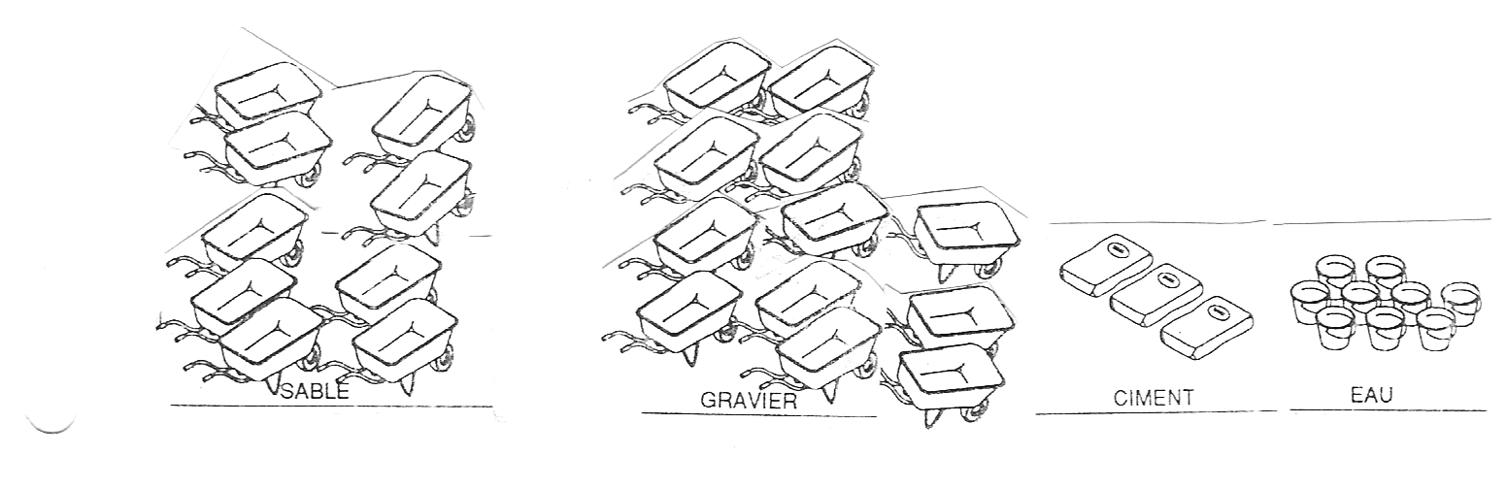
2. Concrete for exterior paving
It will be dosed at 300 kg/m³. A cubic meter of concrete dosed at 300 kg/m³ will have the theoretical composition of
• 0.400 m³ or 400 liters of sand, or 6.5 wheelbarrows
• 0.800 m³ or 800 liters of gravel, or 13 wheelbarrows
• 300 kg or 6 bags of cement, each 50 kg each (1 bag of cement has a volume of 20 liters),
• 0.180 m³ or 180 liters of water, or 18 buckets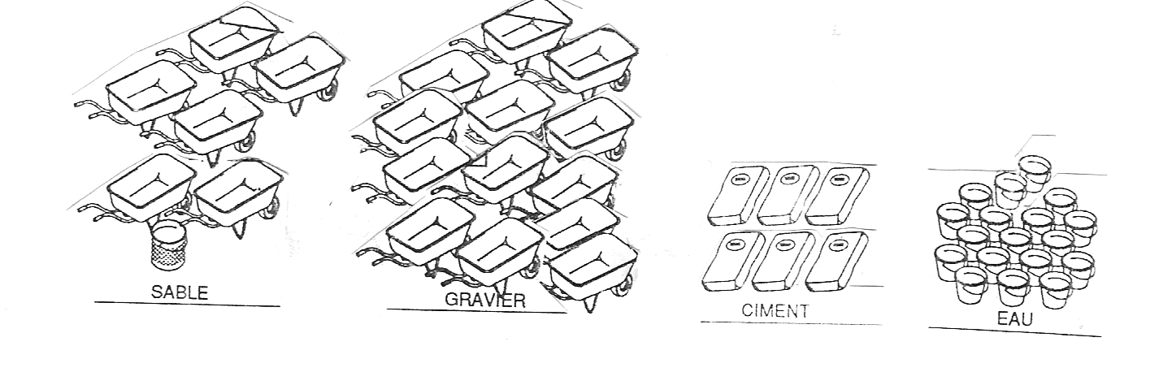
3. Concrete for footings, stringers, reinforced slabs, posts, chains, lintels, beams
It will be dosed at 350 kg/m³. Thus the cubic meter of concrete dosed at 350 kg/m³ will have the theoretical composition of:
• 0.420 m³ or 420 liters of sand, or 7 wheelbarrows
• 0.840 m³ or 840 liters of gravel, or 14 wheelbarrows
• 350 kg or 7 bags of cement, each weighing 50 kg (1 bag of cement has a volume of 20 liters),
• 0.200 m³ or 200 liters of water, or 20 buckets
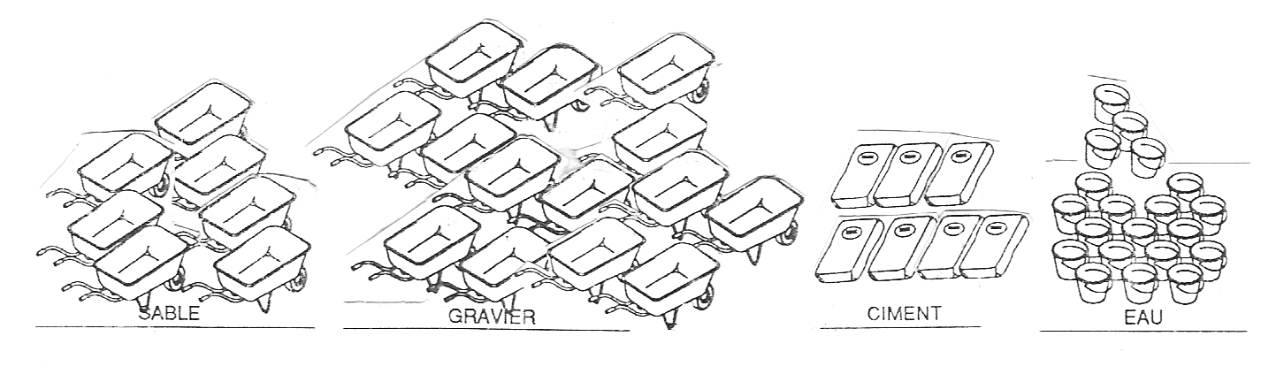
4. Béton for screeds
It will be dosed at 400 kg/m³. Thus the cubic meter of concrete dosed at 400 kg/m³ will have the theoretical composition of:
• 1.2 m³ or 1200 liters of sand, or 5 wheelbarrows
• 400 kg or 2 bags of cement, each 50 kg (1 bag of cement has a volume of 20 l),
• 0.200 m³ or 200 liters of water, or 5 buckets
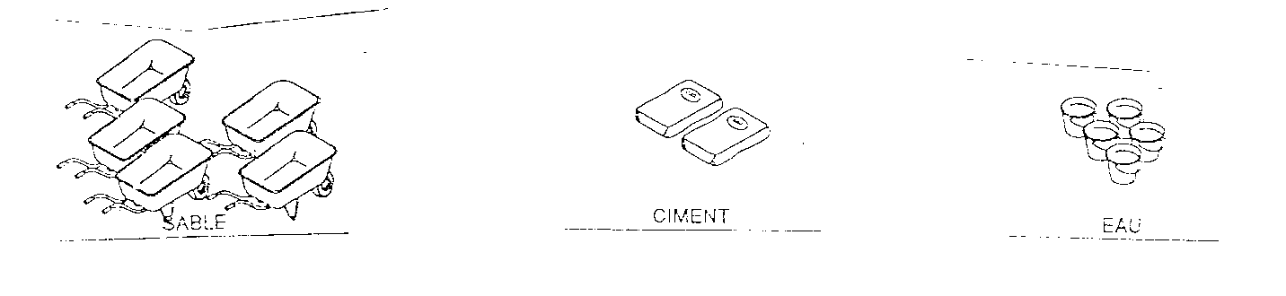
Note: It should be noted here that the wheelbarrow used for the measurements is the standard one which has the correct dimensions, with a capacity of 60 liters or approximately 1/16 m³. The bucket to be taken into consideration is the one like the mason's bucket with a capacity of 10 liters. It should also be noted that the quantity of water to be put in the concrete is generally determined by the quantity of cement used, i.e. approximately 30 liters of water for 50 kg of cement. Around these limits, the quantity of water can be varied depending on the type of concrete you want to obtain. But it should be remembered that the concrete becomes less solid, causing significant shrinkage which most often results in cracks when it is too fluid.

COMPOSITION OF MORTARS AND COATINGS
1. Mortar for laying and manufacturing agglomerates
The setting mortar is dosed at 250 kg/m³. This is a practical ratio of 3.5 wheelbarrows of medium sand, one bag of cement and approximately 40 liters of water.
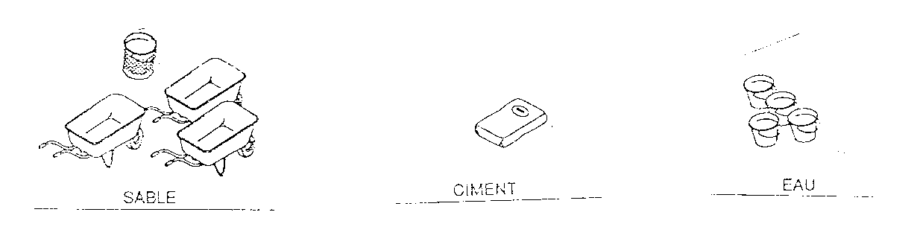
The mortar for the production of ordinary hand-compacted concrete blocks is dosed at 250 kg/m³. In practice, 1 bag of cement, 4 wheelbarrows of sand and approximately 40 liters of water are used to produce:

Type of concrete block Number of hollow concrete blocks | Type of concrete block Number of hollow concrete blocks
(20x20x40) cm | 25
(15x20x40) cm | 33
(10x20x40) cm | 36
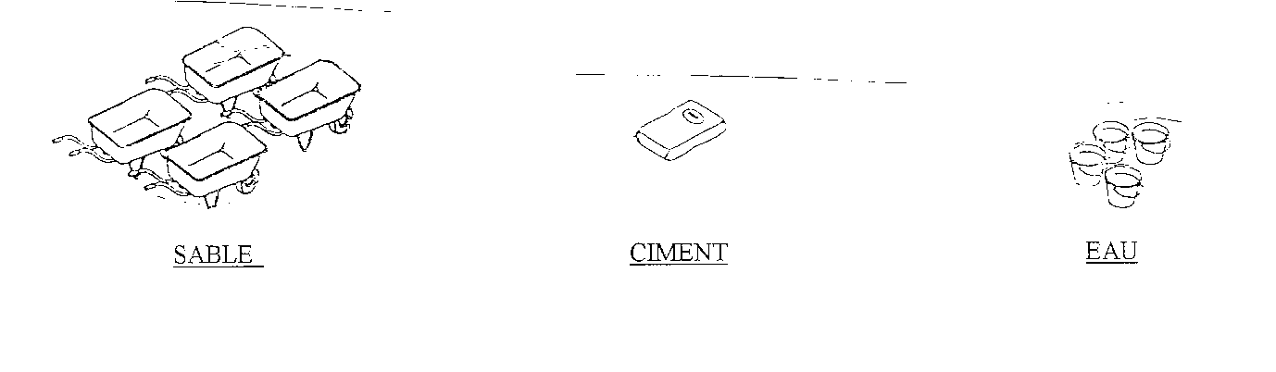

2. Mortars for standard coatings
Commonly, mortar dosed at 500 to 600 kg/m³ is used to carry out the first bonding layer (Grease). This is a practical ratio of 1.5 wheelbarrows of medium sand, a bag of cement and approximately 20 liters of water.


Finally, we use mortar dosed at 300 kg/m³ to carry out the coatings (2nd and 3rd layers). This translates into 3 wheelbarrows of sand, 1 bag of cement and 40 liters of water.

SUMMARY TABLE OF DOSAGES
1. Cement dosage in reinforced concrete structures
 | Dosage in kg/m³ | Ciment | Gravel | Coarse sand | Water
Clean concrete | 150 | 1 bag of 50 kg | 4 wheelbarrows | 3 wheelbarrows | 3 buckets  (30 liters)
Concrete for footings | 350 | 1 bag of 50 kg | 2 wheelbarrows | 1 wheelbarrows | 3 buckets  (30 liters)
Concrete for foundation posts | 350 | 1 bag of 50 kg | 2 wheelbarrows | 1 wheelbarrows | 3 buckets  (30 liters)
Concrete for stringers | 350 | 1 bag of 50 kg | 2 wheelbarrows | 1 wheelbarrows | 3 buckets  (30 liters)
Concrete for elevated posts | 350 | 1 bag of 50 kg | 2 wheelbarrows | 1 wheelbarrows | 3 buckets  (30 liters)
Concrete for chaining and lintels | 350 | 1 bag of 50 kg | 2 wheelbarrows | 1 wheelbarrows | 3 buckets  (30 liters)
Concrete for exterior paving | 300 | 1 bag of 50 kg | 2 wheelbarrows | 1,5 wheelbarrows | 3 buckets  (30 liters)
Cement dosage in mortars
 | Dosage in kg/m³ | Ciment | Fine sand | Water
Mortar for laying masonry | 250 | 1 bag of 50 kg | 3,5 wheelbarrows | 4 buckets  (40 litres)
Mortar for making concrete blocks (sizes 10, 15, and 20) | 250 | 1 bag of 50 kg | 4 wheelbarrows | 4 buckets  (40 litres)
Mortar for the primer coat of render (Gobest) | 500 à 600 | 1 bag of 50 kg | 1,5 wheelbarrows | 2 seaux  (20 litres)
Mortar for plaster body (first layer) | 300 | 1 bag of 50 kg | 3 wheelbarrows | 4 buckets  (40 litres)
Mortar for the body of render (first coat)  Mortar for finishing render | 300 | 1 bag of 50 kg | 3 wheelbarrows | 4 buckets  (40 litres)
Smooth screed (public premises) | 400 | 1 bag of 50 kg | 2,5 wheelbarrows | 2,5 buckets  (25 litres)

Manufacturing conditions to be strictly observed

Sieving of aggregates (sand) to separate plant matter, fine sand, and clay.
Production under a shelter covered with mats or straw. The production area must be kept clean and perfectly level.
The mortar will be mixed on a clean and sufficiently large mixing area.
Compaction of the mortar in the mold by staking and shaking.
Abundant watering of the aggregates for 15 days and the first five days of storage. Watering will be done at least twice a day before application to prevent dissection.
Protection of the aggregates from the effects of the sun by storing them under a shelter.
Mortar that has dried out or is beginning to set will not be used for the manufacture of aggregates.
Cinder blocks are manufactured on site. Only the controller, or the sectoral with the prior agreement of Plan Cameroon, can give the company permission to produce the concrete blocks in another location, the transport of which will be at its expense.

On site, the concrete blocks must be received by the inspector and the sector manager before any use for masonry.

The agglomerates will only be used after at least fifteen (15) days after manufacture. Otherwise, the project manager has the right to demolish the structure and have it rebuilt at the contractor's expense.

The agglomerates will be laid in a staggered pattern so as to avoid the overlapping of two vertical joints. Furthermore, the horizontal and vertical mortar joints must not be more than 2 cm thick.
All masonry will be laid with cement mortar containing 400 kg of cement. Reinforced concrete posts and stiffeners will be poured after the masonry has been assembled to ensure effective anchoring. The joints must be perfectly packed. The contractor must, according to professional standards and weather conditions, water the masonry for at least two weeks.

2.2 Taking into account socio-environmental aspects
To mitigate environmental impacts during and after the microproject, the following actions must be followed:

Socio-environmental Measures Management Plan
Before work actually begins, the company must prepare an environmental action plan detailing all environmental measures to be implemented, as well as internal regulations specifically mentioning safety rules, including the wearing of appropriate clothing and speed limits. In addition, these internal regulations must prohibit the consumption of alcohol during working hours and the misuse of firewood. They must also raise staff awareness of the dangers of STIs/HIVs and respect the customs and traditions of the region's local populations. These regulations must be posted within the company.
Furthermore, an information and awareness campaign for staff and local residents must be organized in advance, and their attention must be drawn to all these aspects, including the implementation schedule and employment opportunities. In particular, these stakeholders should be informed of the reasons for choosing the construction site, as well as the environmental action plan. This campaign must be repeated throughout the construction work.

The various socio-environmental measures to be taken into account during the implementation of this micro-project are::
- Reforestation;
- Hydrocarbon management;
- Safety of site personnel and users;
- Waste management;
- Solid and liquid waste management;
- Water resource management;
- Compensation for damage caused to third parties;
- Opening and operation of quarries and borrow pits
- Site restoration and site closure.

Reforestation
Nile trees will be planted on the microproject site, spaced at least 4 meters apart along the row and between the rows.
This will be carried out by the populations benefiting from the microproject.
Maintenance of the plants includes fencing them off after planting to protect them from stray animals, daily watering, which should be done early in the morning and in the evening, and replacing any plants that do not survive. Each plant will be enclosed by an individual screen made from local materials (thorns)..

Hydrocarbon management
It is the responsibility of the successful contractor. The company's personnel, in particular drivers or mechanics, must take the necessary precautions to avoid contact of hydrocarbons with the ground by using garbage bins. This task is the company's responsibility and is therefore not budgeted for. However, the works monitoring committee will ensure strict compliance with the recommended measures, such as the use of garbage bins.
Machine maintenance and washing areas must be concreted and equipped with a sump for collecting oils and grease. Used or drained oils must be stored in drums in a secure location while awaiting transport to specialized treatment centers. The same applies to oil filters, batteries and other toxic waste.

Safety of personnel on the construction site and users;
The safety measures to be observed for construction site personnel and users are those aimed at protecting the health of personnel working on the construction site as well as those of residents near the construction site. These measures include the wearing of safety equipment by company personnel on the construction site, dust control, and signage.
To prevent workplace accidents, everyone on the construction site must wear safety equipment such as gloves, helmets, and nose covers. The company is required to provide all of this equipment on the construction site in sufficient quantity, and the project manager is responsible for ensuring strict compliance with these safety measures.
Earthworks, in the presence of wind, are likely to cause the lifting of dust or other fine powders such as cement. In this case, despite wearing nose covers, which is a protective measure, workers must water the ground during their work.
The company will also ensure that the speeds of various vehicles and machinery are limited (less than 40 km/h). Similarly, it must ensure that all temporary diversions are identified in collaboration with local residents and do not affect sensitive areas.
In addition to the construction site signs bearing the project references, it is also the Company's responsibility to install safety signs such as those prohibiting access to the construction site by outsiders or those relating to traffic (truck exit, speed limit, caution work, etc.).
Water resource management
The contractor must avoid any conflict that may arise from the use of water resources.
Therefore, for these water needs, water withdrawals must be carried out after consultation with local residents.
In any case, the company must avoid large withdrawals from seasonal watercourses, which could interrupt the urgent water needs of local residents.
Furthermore, it must avoid operating in sensitive areas and introducing various forms of pollution that could result from washing or emptying vehicles and machinery.

Compensation for damage caused to third parties
It may happen that the company causes harm to an individual deliberately or accidentally (destruction of crops, habitat, etc.). This harm must be repaired at the company's expense and in a manner satisfactory to this third party. In return, the latter must issue a compensation certificate to the company, in order to avoid any further claims
Opening and operation of quarries and borrow areas
a) Opening and operation
The opening and use of quarries are regulated by:
- Law 64/LF/3 of April 6, 1964;
- Decree 64/LF-163 of May 26, 1964,
- Ordinance 74/2 of July 6, 1974,
- Law 76/14 of July 8, 1976, amended and supplemented by Law No. 90/021 of August 10, 1990,
- Decree 88/772 of May 16, 1988, amended by Decree 89/674 of April 13, 1989,
- Decree 90/1477 of November 9, 1990.
Quarries operated on public land are subject to authorization.
Quarries operated on private land are subject to declaration.
The contractor must apply for the authorizations required by the applicable laws and regulations and will bear all related costs, including any compensation costs to the owner.
The contractor must present a quarry operation program based on the volume to be extracted for the works and reserves.
In the event that quarry operations require blasting, local residents must be consulted regarding operating hours, and the noise generated must not exceed 90 decibels at the local level.
Disposal areas must be chosen so as not to impede water flow and must be protected against erosion. The contractor must obtain approval from the inspector for disposal areas.
Site restoration and construction site closure
Upon completion of the work, the site must be restored. To this end, the following necessary improvements must be made:
- Leveling of the exposed materials and then leveling of the topsoil to facilitate water percolation, and planting and planting if required,
- Restoring the natural drainage patterns of the site,
- Removing the dilapidated appearance of the site,
- Creating guard ditches to prevent erosion of the degraded land,
- Creating runoff water collection ditches and preserving the access ramp, if the quarry or borrow area can be used for other purposes, such as livestock, play areas for local residents, etc.
Regarding the site base, the contractor will carry out all work necessary to restore the site. The contractor must remove all equipment, machinery, and materials. No equipment or materials may be abandoned on the site or in the surrounding area. This restoration also applies to all diversions and contours set up during the work.
It is desirable that the sites be restored gradually.
Other environmental measures must also be respected by the contractor.
LABELING

At the end of the work and before provisional acceptance, a double large metal plaque bearing the labels of the Eastern Regional Council and PROLOG will be fixed in two places: on either side of the Djadombe River. Each plaque will have the following presentation and dimensions below:
The amount relating to this expense is included in the project equipment estimate.

120 cm
100 cm


MINDDEVEL

WABANE COUNCIL
LOCAL GOVERNANCE AND RESILIENT COMMUNITIES PROJECT
SWRA/PROLOG

PROJET DE CONSTRUCTION DE ..........................................
FINANCEMENT:

WABANE/PROLOG
Budget 2025/ FONDS IDA

Month and year of completion
Of the work

Sign Features:
- Dimensions: Length = 120 cm; Width = 100 cm; Height = 220 cm
- Background color: White
- Lettering color: Black
- Lettering size: Between 5 and 12 cm
- The sign is double-sided

Ground distance
30 cm

CHARACTERISTICS OF THE LABEL:

Dimensions: 120 x 100 cm
10/10 sheet metal
Rustproof color
Light background (white, light yellow)
Letters in black/green/red
Letter height: between 5 and 10 cm.

MODEL ENVIRONMENTAL AND SOCIAL SPECIFICATIONS (CCES)

LIST OF ACRONYMS AND ABBREVIATIONS
BIT | International Labour Office
CCES | Environmental and Social Clauses
CCTP | Special Technical Specifications
CGES | Environmental and Social Management Framework
CPPA | Planning Framework for Indigenous Peoples
CPR | Resettlement Policy Framework
E&S | Environmental and Social
EAS | Sexual Exploitation and Abuse
EPC | Collective Protection Equipment
PPE | Personal Protective Equipment
ESHS | Environmental, Social, Health and Safety
SDS | Safety Data Sheet
HIMO | High Labor Intensity
BROKEN | Sexual harassment
IST | Sexually transmitted infections
km/h | Kilometre/hour
MINEPDED | Ministry of the Environment, Nature Protection and Sustainable Development
MGP | Complaint Management Mechanism
MGPT | Worker Complaint Management Mechanism
STD | Sexually transmitted disease
NC | Nonconformity
NES | Environmental and Social Standards
WHO | World Health Organization
XXXX | Project Name
PCS | Social Communication Program
PEE | Environmental Engagement Plan
ESMPS | Environmental and Social Management Plan
PGMO | Workforce Management Plan
PPMP | Stakeholder Engagement Plan
PHSE | Health, Safety and Environment Plan
PMU | Project Management Unit
AIDS | Acquired immunodeficiency syndrome
SST | Occupational Health and Safety
HIV | Human Immunodeficiency Virus
VCE | Violence Against Children
GBV | Gender-Based Violence

INTRODUCTION
This model Environmental and Social Clauses is related to the construction of class rooms. The model will also be used to draw the Contractor's particular attention to the environmental, social, safety and health services to be implemented during the execution of the works.
The Contractor will be responsible for the execution of the works according to the requirements and good practices presented in the Environmental and Social (E&S) documents of the project which reflect not only the regulatory requirements of Cameroon but also the provisions of the Environmental and Social Standards (ESS) of the World Bank (Project Funder). In the event of any discrepancies or gaps between Cameroonian legislation and the World Bank's Environmental and Social Standards, the latter will prevail. These provisions list all the environmental and social obligations to be implemented by the Contractor from the service order for the start of the works to the final acceptance of the works by the Project Owner or his delegate.

The Contractor and the Principal Contractor shall ensure that this sample CCES is adapted to the context of the work corresponding to the contract in question, by adjusting to the environmental and social instruments of the project which may provide details on the state of play of the project area, as well as the risks and special situations not mentioned in this CCES.

GENERAL OBLIGATIONS

Contractor's Responsibilities (Contractor and Subcontractors)
The Contractor is solely and fully responsible for compliance with this CCES. The subcontracting of part of the work does not exempt it from full responsibility for compliance with these clauses before the Contractor. It therefore has the following environmental and social obligations:

1. It must prepare, before the actual start of the field work, the ESMP-Site in accordance with the obligations of the CCES and with the World Bank's Environmental and Social Standards;
2. He must implement the ESMP-Site during the entire period from the signing of the contract to the final acceptance of the works by the Project Owner or his delegate;
3. It must equip itself with a dedicated organisation and resources to ensure:
    - (I) the preparation of environmental and social documentation,
    - (ii) environmental and social monitoring of construction activities,
    - (iii) the definition of corrective actions in the event of non-compliance and the prevention of non-compliance,
    - (iv) adequate and timely communication between the various parties involved;
4. It must ensure compliance with Good Environmental, Social, Health and Safety (ESHS) practices including aspects relating to the prevention and management of GBV/EAS/HS incidents in the workplace and in communities, as well as the management of complaints and grievances related to the project;
5. He must know, comply with and ensure compliance with all regulations, laws, decrees, standards and other governmental provisions of a socio-environmental nature, including those corresponding to national and municipal areas which, in one way or another, are related to the works covered by the contract. In the absence of knowledge of one or more of these regulations, or others not specifically indicated and their corresponding updates, he is not exempt from the responsibility to comply with these regulations;
6. Without being exhaustive, the applicable regulations, laws, decrees, standards presented in the following environmental and social texts, subject to these specifications, are as follows:
    - Framework Law No. 96/12 of 5 August 1996 on environmental management, which provides in particular for the treatment of discharges by companies and the protection of receiving environments and penalties for damage to the environment;
    - Law No. 94/01 of 20 January 1994 on the regime of forests, wildlife and fisheries, which sets the framework and conditions for the felling of trees belonging to the permanent or non-permanent forest domain;
    - the 1998 law on establishments classified as dangerous such as quarries;
    - Law No. 98/005 of 14 April 1998 on the water regime;
    - Law No. 96/67 of 8 April 1996 on the protection of the national road heritage,
    - Law No. 2016/017 of 14 December 2016 on the Mining Code, which governs the conditions for the opening of quarry sites and laterite loans;
    - Act No. 85/09 of 4 July 1985 on expropriation in the public interest and the terms of compensation;
    - Act No. 92/007 of 14 August 1992 on the Labour Code, which lays down the conditions of employment, health and safety at work;
    - Decree No. 2013/00171/PM of 14/02/2013 on environmental impact studies, which may involve compensatory measures to be paid by entrepreneurs;
    - Decree No. 2012/2809/PM of 26 September 2012 laying down the conditions for sorting, collecting, storing, transporting, recovering, recycling, treating and final disposal of waste;
    - Decree No. 2011/2581 of 23 August 2011 regulating harmful and/or hazardous chemical substances;
    - Decree No. 2011/2582 of 23 August 2011 laying down the modalities for the protection of the atmosphere;
    - Decree No. 2011/2583 of 23 August 2011 regulating noise and odour pollution;
    - Decree No. 2003/418/PM of 25 February 2003 setting the compensation rates to be granted to owners who are victims of the destruction of cultivated crops and trees in the public interest. Can be used as a basis for the valuation of assets in the event of accidental destruction or occupation of temporary sites by contractors;
    - Decree No. 2022/5074/PM of July 4, 2022, setting out the procedures for controlling the social compliance of projects,
    - The World Bank's Environmental and Social Standards that are relevant to the project (See the Project's Environmental and Social Engagement Plan, available from the Project Management Unit).
8. It must draw up internal regulations and put in place codes of good conduct, applicable to all employees and subcontractors;
9. He must take responsibility for any claims related to the lack of respect for the environment.

Commitments of the project management
The Project Manager approves, approves and transmits to the Project Owner this CCES, including the ESMP-site, and ensures the follow-up of the rigorous application of the said CCES.
The Project Manager (a) may at any time have the means used to verify compliance with the regulations and environmental requirements indicated in the CCES carried out at any time; (b) collects the registration and monitoring documents provided for in the organizational plans; (c) prepares the compliance sheet and approves the monthly, quarterly or semi-annual technical reports of the contractor's activities; (d) prepare monthly, quarterly or semi-annual monitoring activity reports and the final evaluation report.

Internal rules of the contractor
The Contractor must display internal regulations in a visible manner in the various facilities of the remote site specifically prescribing: the prohibition of poaching; compliance with environmental requirements, hygiene rules and safety measures. The said regulation must be signed by the contractor and made available to the Labour Inspector with territorial jurisdiction. During recruitment; Each employee must be made aware of the main lines of these internal regulations.

Controls, notifications, management of non-conformities and sanctions

Monitoring the implementation of the environmental and social clauses of the CCES
The Contractor's compliance with and effectiveness of the implementation of the CCES is monitored by the Project Manager, as the case may be, through the advice of its environmental, social, health and safety manager or a qualified technical manager whose skills in the environmental and social field are proven. This control is carried out during site visits where corrective actions are directly addressed to the contractor. Depending on the nature of the activity implemented, this control can be daily, weekly or monthly. The findings are transcribed in monthly, quarterly and semi-annual monitoring reports.

II.4.2. Notification of non-conformities
The Project Manager shall notify the Contractor in writing of all cases of failure or non-performance of environmental and social measures. The Contractor must rectify any breach of the requirements duly notified to him by the Project Manager. The resumption of work or additional work resulting from non-compliance with the clauses is the responsibility of the Contractor.

II.4.3. Management of non-conformities
Non-conformities detected during inspections carried out by the Company or the Project Manager will be dealt with in a manner appropriate to the seriousness of the situation. Non-conformities will be defined as deviations from the requirements of the regulations in force, this CCES, the CGES, and the ESMP-projects. Non-conformities will be divided into 4 categories:
- The Observation Notification, for minor non-conformities such as the abandonment of household waste in the open air. This level only entails a verbal notification from the Project Manager to the Contractor's representative, with the signature of the Observation Notification prepared by the Project Manager. The multiplication of Observation Notifications on an Activity Zone, at least three (03) times or the failure to take into account the Observation Notification by the Contractor, within a period of six (06) working days raises the Observation Notification to the level of non-compliance of level 1.
- Level 1 non-conformance : for non-conformities that present a moderate and non-immediate environmental, social, health or safety risk, such as the non-constant wearing of full Personal Protective Equipment (PPE). The non-conformity shall be notified in writing to the Contractor and shall be resolved within five (5) business days. The Contractor will send the Project Manager proof of resolution of the problem. After a visit and a favourable opinion, the Project Manager validates in writing the closure of the non-conformity. In all cases, any Level 1 non-compliance not corrected within a period of more than five (5) business days will be elevated to Level 2.
- Level 2 non-compliance: applicable to any non-compliance that presents an immediate moderate risk or with significant consequences on the environment, social, health and safety at work such as the non-existent first-aid box and first aid kit, lack of awareness on the spread of STI/HIV/AIDS, storage of waste (batteries, filter, etc.) on non-waterproofed soil. The same procedure as that for level 1 non-conformities is applied. The resolution must be made within three (03) working days. Any Level 2 non-conformance not corrected within a period of more than three (03) working days will be elevated to Level 3. For non-compliances such as deforestation without authorization of valuable species, installation of parking areas within the distances prescribed in the CCTP, for which the planning of corrective measures requires more time, its non-correction within ten (10) days will result in its elevation to level 3;
- Level 3 non-compliance: applicable to major non-compliance presenting risks or having led to major environmental and/or social damage such as the spillage of hydrocarbons on the ground, the open burning of plastic and pneumatic materials, filters, batteries, etc. death or partial or complete loss of a person's physical abilities, loss of means and GBV incidents (EAS/HS/VCE). In the event of EAS/HS, the company's GBV focal point or the acting manager must immediately refer the matter to the GBV focal point of the project manager and the project owner. The GBV Manager of the project owner must notify the World Bank of the incident within 24 hours of receipt. A level 3 non-compliance results in the suspension of payment of the next statement until the non-compliance is resolved. If the situation so requires, the Project Manager may order the suspension of the work pending the resolution of the non-conformity.

II.4.4. Conditions for suspension of work
At the end of each month, the Project Manager will carry out an assessment of the environmental and social management of the site, based on the non-conformities notified during the period and on the contractor's responsiveness in resolving these non-conformities.
This evaluation will lead either to a favourable opinion or to reservations or even penalties, in the event of flagrant non-compliance with environmental and social obligations, or deliberate non-resolution of the non-compliances detected and notified.
In the event of a serious failure of the contractor (Level 3 Non-Conformity), the Owner will have the possibility to suspend activities at the site concerned without financial implication for the Owner until the corrective measures are properly implemented.

ARRANGEMENTS PRIOR TO THE EXECUTION OF THE WORKS

II.5.1. Resources allocated to environmental and social management
The Contractor, depending on the size of the work, must appoint an Environmental Manager, a Social Manager and on the basis of and after prior notice of no objection from the PMU and the Bank for the implementation of the ESMP on site. He/she will be permanently based in the Main Business Park for the entire duration of the work. This person must be at a sufficient hierarchical level in the Contractor's organization to stop the work if he deems it necessary in the event of level 2 or 3 non-conformity, and to mobilize the machinery, personnel and equipment to implement any corrective measures deemed necessary.
II.5.2. Environmental and Social Management Plan for the site (ESMP-SITE)
The Environmental and Social Management Plan for the site (ESMP-Chantier) is the single reference document where the Contractor defines in detail all the organisational and technical measures that it implements to meet the obligations of the CCES. The ESMP covers the entire period from the date of signature of the Contract to the date of issue of the Certificate of Good Completion issued by the Project Owner. It will be prepared by the Contractor upon receipt of the start-up service order.
The document in provisional form will be presented to the Contracting Authority, at the latest 30 days before the start of the work. The ESMP will be finalised by the Contractor after taking into account the observations of the Contracting Authority/Delegated Contracting Authority, which will be sent to him no later than 20 days after receipt of the provisional document and its final version will be submitted to the Contracting Authority no later than 10 days before the start of the works. The approved plan will constitute the charter for environmental and social issues throughout the construction period.
No physical work or activity shall commence on an Activity Zone until the ESMP has been approved by the Project Manager. During the execution of the work, each time the Project Manager gives the instruction, the ESMP-site will be updated by the Contractor and sent back for approval. The revised version should highlight the new elements introduced in the document.
The content of the ESMP-site to be prepared by the contractor will be structured in accordance with the size of the work and at least by the elements presented in Appendix 1 of this document.

EXECUTION OF THE WORK

III.1. Kick-off meeting
Before the start of the works, the Contractor and the Project Manager, under the supervision of the Project Owner, must organize meetings with the authorities, representatives of the populations, including women, located in the project area and the competent technical services, to inform them of the nature of the work to be carried out and its duration. of the routes concerned and the locations likely to be affected. This meeting will also allow the Project Owner to collect the observations of the population, to raise their awareness of environmental and social issues and their relations with the workers.

III.2. Access and installation of the site

III.2.1. Access
Access to the site for the needs of the site must be done in such a way as to limit disturbances and security risks. To this end, the Contractor must define the most optimal access route in view of the above-mentioned concerns.
The access roads will have to be maintained by the companies using them (sweeping possible at the request of the project manager).
Maintaining water flows in good permanent condition will be subject to increased vigilance.
The provision of equipment for watering the tracks and their maintenance may also be ordered by the project manager. It will be ensured, in each of their sectors and for all stakeholders, by the companies holding the various lots.
Each holder of a contract lot will have to take charge of the specific operations of securing and protecting the environmental site that concerns him.
Their offers will therefore include the expenses relating to these services to preserve access conditions.

III.2.2. TRAFFIC
In the event that the work passes near sensitive areas, precise identification and staking on the site of the latter will be carried out before the start of the work in the presence of the Project Manager, a representative of the earthmoving company and an environmental specialist.
These preventive measures will make it possible to limit the impact of the site on the environment as much as possible and thus avoid irreversible damage to the most sensitive natural environments.
No traffic is allowed in the wetland with high environmental stakes, materialized on the attached graphic document .
When removing machinery from the construction site area in an asphalt traffic area, all precautions must be taken by the contractor (cleaning basin for example) so as not to pollute these roads.

III.2.3. Installation
The Contractor shall submit to the project proponent an installation plan and the location of the site facilities. The size of its facilities is determined by the volume and nature of the work to be carried out, the site personnel, the number and type of machinery. The site installation plan must take into account the following developments and protection measures:
- The boundaries of the site selected must, if possible, be at least a distance of:
  - 30 m from the road;
  - 200 m from a lake, stream or swamp/flood zone;
  - 100 m from the houses.
  - Where it is not possible to meet these three requirements, the Contractor shall present the measures it intends to put in place to avoid any inconvenience on the elements considered for the approval of the Contractor Engineer.
- Clearing and felling trees should be avoided or limited. Useful or large trees (diameter greater than 50 cm) are preserved and protected.
- Traffic lanes must be compacted and watered periodically.
- The site must provide adequate drainage of rainwater over its entire surface by avoiding stagnation points.
- The right-of-way of the site facilities must be marked by a HERAS or similar type fence.
During the execution of the contract, the Contractor shall draw up and submit the following documents to the Project Manager within a period in accordance with the Special Administrative Clauses before the installation of the sites:
- the location of the land that will be used;
- a list of agreements made with the owners and current users of these areas and evidence that these users have been able to find similar areas to continue their activities;
- a detailed inventory of the various sites;
- a general plan indicating the different areas of the site, the planned locations and a description of the planned developments;
- a detailed site environmental protection plan for the remote site, before starting construction;
- the amended waste management plan;
- a description of the measures planned to avoid and combat pollution and accidents such as pollution of the soil, groundwater and surface water, fires and bush fires, road accidents;
- a description of the planned health infrastructure and its organization;
- a list of measures planned to ensure the supply of food (meat, fish,....) and wood to workers and those planned to promote the purchase of local products from the project area, with the exception of bushmeat, as well as a firm ban on the contractor's staff from interfering in the trafficking of wildlife and forest products;
- the plan for the redevelopment of the areas at the end of the work;
- articles of the site regulations dealing with respect for the environment, waste, actions planned in the event of an accident, obligations in terms of vehicle driving, vehicle repair and maintenance, etc.

III.2.4. Permit and authorisation before works
Any work must be subject to a prior information procedure and administrative authorisations. Before starting the work, the Contractor must obtain all the necessary permits for the execution of the planned work: authorizations issued by local authorities, forestry services (in the case of deforestation, pruning, etc.), mining or hydraulic services if necessary, labor inspectorate, network managers, environmental services, etc. Before the start of the work, the Contractor must consult with the local residents with whom he can make arrangements to facilitate the progress of the work.

III.3. Freeing up rights-of-way and identifying networks
The Contractor must be aware that the public utility perimeter related to the operation is the perimeter likely to be affected by the work. Work can only begin in the areas concerned by private rights-of-way when they are released following an acquisition procedure that is the responsibility of the Government/Borrower
Before the start of the work, the Contractor must instruct a procedure for identifying the concessionaires' networks (drinking water, electricity, telephone, sewer, etc.) on a plan which will be formalised by a Minutes signed by all parties (Contractor, Project Manager, concessionaires).

III.4. Provisions applicable to the installation of the site and throughout the execution of the work

III.4.1. Weekly environmental and social inspections
In addition to his own inspections, the E&S manager will also carry out joint E&S inspections of the Business Zones with the Project Manager. Each inspection will give rise to a written report in a form approved by the Project Manager, of the situations of non-compliance with the CCES observed in the Activity Zone. In these reports, non-conformances are visually illustrated by digital photograph captioned so that the location, date of inspection and degree of non-conformance illustrated are explicit.

III.4.2. Reporting
Monthly Reports:
The Contractor shall submit to the Contractor a monthly E&S activity report summarizing all the E&S actions implemented for the conduct of the works during the previous period.
Incidents and accidents. The company shall immediately notify the PMU of any incident or accident within 48 hours of becoming aware of the incident or accident, in accordance with the template provided in Annex XXXX.

Subsequently, a detailed report of the incident or accident within a time limit set by the Bank following the initial notification, which also proposes any measures to prevent its recurrence, will be drawn up (in accordance with the template provided by the Bank).
The E&S activity report will be submitted no later than 7 working days after the due date of the relevant month. It will contain at least the following information:
- A situation on the staff assigned to the work (status of contracts, representation (gender, local populations, indigenous peoples if applicable, etc.), regularization of remuneration, etc.),
- Presentation of the E&S staff present at the end of the month;
- Work carried out during the month;
- Inspections carried out (location and frequency);
- Non-conformities detected during the month, level of severity and description of the corresponding cause analysis and corrective actions implemented;
- Description of actions taken during the month to comply with the CCES;
- Description of the actions undertaken with the actors external to the work: local populations, local authorities, government agencies;
- Results of the monitoring of the following indicators:
- Availability and quality of drinking water;
- Management of hazardous and non-hazardous solid waste;
- Air and noise emission management;
- State of the Business Zones
- Statistics on the recruitment of contract workers and community workers: number and type of position, number of women recruited locally, number of young people, number of vulnerable people, number of hours worked by all of the Entrepreneur's community staff;
- Health & Safety statistics: number of fatal accidents, number of accidents with lost time, number of accidents without lost time, accident frequency rate, serious illnesses, serious misconduct by the Contractor's staff (sheet attached as an appendix to the activity report, including the analysis of the corresponding causes and the corrective measures applied.
- Follow-up of formal or informal complaints (negative media coverage, strikes or industrial disputes, protests, complaints from communities, NGOs or workers or formal notification from the authorities, etc.) relating to the E&S risks and impacts of the works; including the analysis of the corresponding causes and the corrective measures applied;
- Assessment of the training activities (subject, number and duration of sessions, number of participants;
- Provisional E&S action programme for the coming month.
- Monitoring of the implementation of the company's VBG/VCE/EAS/HS action plan resulting from the ESMP.
Quarterly Reports:
It will be integrated into the activity report for the construction or installation of infrastructure, summarizing the Environmental and Social activities of the past quarter on the basis of performance indicators identified in the ESMP - site. Quarterly reports are due no later than 14 days after the end of the quarter.
Regarding the notification of ESSS events, the project manager is informed, within one hour of the event, of (i) any serious bodily injury to a member of staff, a visitor or any other third party, caused by the conduct of the works or the behaviour of the Contractor's personnel, or (ii) any significant damage to private property, or (iii) any significant damage to the environment. He is also informed, as soon as possible, of any accident related to the conduct of the works which, under slightly different conditions, could have caused bodily injury to persons, damage to private property or to the environment.
Semi-Annual Report
The semi-annual reports on the implementation of the ESMP must be drawn up and submitted to the Ministry of the Environment, Nature Protection and Sustainable Development (MINEPDED) and to the Departmental Monitoring Committees for ESMPs established by the regulations in force.

III.5. Health and Safety Management
The Contractor describes its Health and Safety management system in the ESMP-site, at the level of the Health & Safety Plan section. The said plan identifies and characterizes:
- All safety and health risks related to the conduct of the work;
- The measures for the prevention and protection against risks provided for the conduct of the work, distinguishing, where appropriate, measures concerning men and women;
- The human and material resources involved;
- Work requiring work permits, and emergency plans to be implemented in the event of an accident.
- The following risks will need to be given special attention:
  - Risks related to exposure to nuisances;
  - Risks related to traffic accidents;
  - Risks related to the opening of trenches for the laying of foundations and pipes;
  - Risks related to manual and mechanical handling;
  - Risks related to lack of hygiene;
  - Risk of falls;
  - Toxic risks;
  - Risks of not taking measures to protect against COVID19
  - Risks of electrification/electrocution.
- Weekly and daily health and safety meetings
The Contractor organises, at least once a week or at another frequency approved by the Project Manager, a health and safety meeting on the site where an activity is carried out, with all the employees assigned to this Activity Zone. Accidents and incidents in the past week are described and feedback is valued. Improvement actions are identified, documented, and evaluated until they are resolved. The project manager is the recipient of their reports.
The Entrepreneur organises, in teams, daily before the start of activities, a health and safety update on all the Activity Zones where an activity takes place. The meeting establishes the health and safety risks associated with the tasks and activities of the day and the prevention and protection measures. These meetings give rise to reports.

III.6. Information, Awareness and Capacity Building
The works covered by the contract will give rise to an information and awareness-raising campaign for local populations and stakeholders on:
- The nature and schedule of the work;
- The people to be recruited and the procedures to be implemented for recruitment;
- STDs and STI HIV-AIDS;
- Prevention of GBV/AES/HS/VCE
- The participation of local residents in the various meetings;
- The protection of road heritage;
- The durability of the structure to be built.
- Health and safety risks during the post-work period
The Contractor will conduct its information and awareness-raising and capacity building activities under the supervision of the Project Manager and the approval of the Project Owner. These activities will include, but are not limited to:
- Prepare a communication plan to be submitted to the Project Manager for approval,
- Organize at least one training of trainers workshop on the fight against poaching, illegal logging, unsanitary conditions and pollution of waterways, the fight against STDs and HIV/AIDS.
- Prevention of GBV/AES/HS/VCE
- Produce communication materials,
- Prepare reports.

ENVIRONMENTAL PROTECTION: REQUIREMENTS TO MITIGATE ENVIRONMENTAL IMPACTS

IV.1. Maintenance and waste management
During the duration of the project, the Contractor will ensure that the entire site and its surroundings are kept in a good state of cleanliness and that the waste generated is properly managed by taking the following measures:
- Follow appropriate procedures for the storage, collection, transportation and disposal of hazardous waste. For waste such as used oil, it is essential to collect it and hand it over to approved buyers;
- Clearly identify and delineate disposal areas and specify what materials may be deposited in each area;
- Control the placement of all construction waste (including ground excavations) in approved disposal sites (>300 m from rivers, streams, lakes or wetlands);
- Place all waste, metals, used oil, and excess materials produced during construction in authorized areas by incorporating recycling systems and material separation;
- The Contractor shall take the necessary measures to avoid dispersion by wind or rainwater, for example, before the disposal of waste;
- The products of the stripping of the Earthworks rights-of-way will be deposited and possibly reused,
- The transport of soil within the land to the sites to be backfilled or its evacuation to public landfills;
- Minimize waste generation during construction and reuse construction waste where possible;

The following measures must be taken for the maintenance of the site:
- Identify and delineate areas for maintenance equipment (away from rivers, streams, lakes or swamps);
- Ensure that all maintenance equipment activities are carried out within the delineated maintenance areas;
- Never dispose of oil or pour it on the ground, in waterways, low-lying areas, cavities in disused quarries.
The Contractor must avoid any discharge of wastewater, waste water, hydrocarbons, and pollutants of any kind, into surface or groundwater. The discharge and drain points will be indicated by the Contractor.
The Contractor must deposit household waste in waterproof bins that must be emptied periodically. In the event of evacuation by the site trucks, the skips must be watertight so as not to let waste escape. For hygiene reasons, and to avoid attracting vectors, daily collection is recommended, especially during hot periods. The Contractor must dispose of or recycle waste in an environmentally sound manner. The Contractor must direct the waste, if possible, to existing disposal sites.

Particular attention will have to be developed for the management of specific waste, whether solid or liquid. The contractor will have to identify the treatment channels for the said waste and sign agreements with approved service providers in the sector. The PMU will give itself the right to visit the operator's facilities to be sure of their ability to properly manage this electrical and electronic waste. At the end of each month, a report on the quantities of waste will have to be produced.

IV.2. Preventive measures against noise pollution and dust emissions
The Contractor will pay particular attention to limit any noise nuisances. To this end, he must comply with the noise thresholds prescribed by law.
He will ensure that the use of noisy equipment is limited to what is strictly necessary and will stop those that are not in use (generators for example). Except in cases of emergency, noise pollution (machinery, vehicles, etc.) near homes will be prohibited from 7 p.m. to 8 a.m. as well as on weekends and public holidays.
Contractor's personnel working at workplaces where noise levels are above the acceptable standard must undergo hearing tests at frequencies defined by the occupational physician and in case of concern, the employees concerned must be medically cared for at the Contractor's expense. These tests must also be done before the termination of the contracts.
During the execution of the works, to combat dust and inconvenience, the contractor must limit the speed of traffic related to the construction to 24 km/h in the streets, within a radius of 200 meters around the construction site and limit the speed of all vehicles on the site to 16 km/h.

IV.3. Storage and use of potentially polluting substances
In general, the storage and handling of potentially polluting or dangerous substances (oils, fuel, etc.) must comply with the following principles:
- limitation of stored quantities;
- organised storage, on a site or in a manner that does not allow access to a person outside the site;
- handling by responsible personnel equipped with PPE;
- the storage site is marked by a sign indicating the nature of the hazard.
- The storage of liquid chemicals will be done on retention to prevent accidental spills and soil pollution;
- The chemicals used must be equipped with a safety data sheet (SDS) to be displayed at the storage site.

IV.4. Fuels and lubricants
In the event that the contractor uses fuels and lubricants in the yard, the lubricants shall be stored in watertight containers placed on level, clean and stable ground. The containers will be isolated from the ground by plastic sheeting or absorbent material (sand or sawdust) to allow the recovery of any accidental discharges. As for fuels, they will be stored in tanks in a space set up according to standards. The tank must be placed in a watertight drip tank, the volume of which is at least 2/3 of that of the tank, in order to be able to contain the liquid in the event of an accidental spill. The whole must be covered and associated with fire-fighting devices (fire extinguishers, sandboxes). At the end of the work, the site will be cleared of all traces or by-products.

IV.5. Other potentially polluting substances
The use of other potentially polluting substances will be reported to the project manager before their use. The company will provide proof of the legal nature of their use and the project manager will notify the competent technical services for authorisation and possibly the prescription of precautionary instructions.

IV.6. Management of accidental pollution
In the event of accidental pollution, the Contractor shall notify the project manager without delay. Depending on the component of the environment affected by the pollution, the competent technical services will be notified. The Contractor will take all necessary measures to put an end to the cause of the problem and to proceed with the treatment of the pollution. The prescribed precautionary instructions must be implemented quickly. Buffers will need to be available at sites to absorb small spills.

IV.7. Principle of intervention following accidental pollution
In the event of an accidental spill of polluting substances, the following measures must be taken:
- Avoid contamination of the soil by sprinkling specific absorbent products;
- In the event of proximity to a water source (wells, rivers, etc.), avoid contamination of water by blockage, dam, earthen dike, at first;
- Excavate the polluted soil at the right of the infiltration surface;
- Treat polluted parts in an environmentally sound manner (landfilling, burial, incineration, depending on the nature of the pollution).

IV.8. Protection of natural areas against fire

The regulations in force (Forest Code) will be strictly applied. In general, the use of fire is prohibited on the site unless an express derogation is granted by the project manager within the limits of the permissions laid down by the national regulations in force. In this case, the Contractor will observe the following minimum instructions:
- Burning allowed only in light winds;
- Site previously cleared over a radius of twenty metres;
- Fire under constant supervision by a competent person armed with fire-fighting equipment;
- In the event of a spread, rapid alert of the emergency services and the project manager by any means;
- Total extinguishing of the fireplace at the end of the burning. Covering with earth is prohibited.

IV.9. Conservation of the landscape integrity of the site

No damage will be made to vegetation located outside the right-of-way of the structures, accesses or planned work or storage areas. In addition, protective measures on protected or rare species should be taken.
Only the felling of trees authorised by the forestry service is tolerated (comply with the provisions of the forestry code in the event of tree felling or deforestation). Penalties are incurred in the event of unauthorized felling of trees or the destruction of the site's vegetation. In the event of deforestation, the felled trees must be cut down and stored The local populations must be informed of the possibility they have of being able to dispose of this wood at their convenience. Trees that have been felled must not be left in place, burned or fled under the earthworks.
The Contractor should carry out a compensation planting after the work in the event of deforestation or felling of trees.
The materials used for the work (sand and gravel in particular) must come from quarries and sand pits authorised and controlled by the mining service. In accordance with the provisions of the mining code, quarries and loan sites must be rehabilitated. The restoration of the premises before the site is withdrawn may be imposed in the event of significant modification of the site.
Any area of environmental sensitivity must be bypassed by the project (e.g. seasonal flood zones). Also, all precautions must be taken to preserve water points (wells, springs, fountains, ponds, etc.).

IV.10. Protection of biodiversity
In addition to complying with the resolutions of the Biodiversity Management Plan that will be developed and made available to the Contractor, the Contractor must take the following initial steps during the execution of the work:
Prohibit construction site facilities and remote sites in the vicinity of the two parks, outside the buffer zones;
- Prohibit the opening of borrowing areas and deposit areas in the area of the said parks;
- Prohibit the search for timber (boards, stakes and stakes) in the area of the said parks as well as their buffer zones;
- Prohibiting the consumption, hunting and transport of bushmeat by site personnel;
- Avoid the installation of certain road equipment, in particular rest areas, toll booths and weighing stations within national parks and their buffer zones;
- Obtain authorizations to search for borrowed cottages in the domains and buffer zones according to the park's zoning plan;
- Collaborate with park conservators in the choice of areas that can be dedicated to the exploitation of borrowing areas, even in critical situations of lack of materials;
- Plan, in collaboration with the conservators of the national parks, work in the vicinity of the parks, taking into account the places and periods of passage of the animals during their seasonal migrations;
- To build tunnels or footbridges, as the case may be, for the crossing of wild animals with the collaboration of the curators who control the crossing points of these animals;
- Install signage by physical materialization at the entrances and exits of the parks, as well as at the crossing points of the animals;
- Facilities such as speed bumps can be made at these points in order to reduce the speed of motorists.
- Develop communication plans, and training/awareness sheets/posters in conjunction with conservationists for the direct and indirect beneficiaries of the road. The said documents must highlight the protected species of the project, the repressive and regulatory provisions. Awareness campaigns will be carried out by the safeguarding team for the benefit of the work staff, and by a local NGO for the benefit of the local populations
- Adopt education and awareness-raising measures for staff and subcontractors, as well as project management to preserve the resources of the parks.

MANAGEMENT OF SOCIAL RISKS AND IMPACTS: PLAN/ PROGRAM/ MEASURES TO MANAGE SOCIAL RISKS AND IMPACTS
The Contractor must establish a detailed program for the social management of the site. The said detailed programme must contain the following Plan/Programme/measures:

V.1. Manpower Management Plan/Programme/Measures
In its ESMP-Site, the Contractor will have to describe its workforce management procedures adapted to the work and activities, and in accordance with the Project Work Management Procedures Manual (if the Project does not have it, the Contractor will have to prepare them). These procedures will describe how the Contractor's workers will be managed, in accordance with the requirements of national law and the World Bank's NES No. 2. They will indicate how this SEN will apply to the different categories of workers of the contractor.
The principles to be followed in the development of procedures are as follows:
- All workers will be informed of the terms and conditions of employment and employment upon hiring;
- All workers, even temporary workers, will benefit from an employment contract and certificates of completion/certificate of service. The Contractor must document and provide each worker when hired, in a clear and understandable manner, with information regarding his or her rights under the labour law, including rights to wages and benefits;
- The law is explicit on the remuneration system, working hours and rights of the worker (including promotions, paid leave, sick leave, etc.), the freedom to join a legally constituted trade union organisation;
- The Contractor's employees will be informed of all withholdings and deductions at source that are made from their remuneration in accordance with the provisions of the laws and regulations in force;
- The Contractor shall provide all newly recruited workers with all the necessary information and inform the staff of any changes that may occur during the course of the contract;
- Wages, working hours and other specific provisions are recorded in the employment contract;
- Occupational health and safety measures will be applied to the project. The Contractor is responsible for their implementation;
- The Contractor shall keep complete and accurate records of the employment of labour on the project. The records must include the names, ages, gender, number of hours worked, and wages paid of all workers. These records must be summarized on a monthly basis and submitted to the Contractor.
- Project workers will have access to facilities that are appropriate to their working conditions, including adequate canteens and rest areas (where applicable), gender-segregated and well-lit sanitation facilities. In the event that accommodation services are provided to them, policies on the management and quality of housing will be developed to protect and promote their health, safety and well-being and to provide or provide access to them that take into account their physical, psychosocial, gender and cultural needs and measures to prevent SEA/HS risks, such as separate spaces for men and women, the location of changing rooms and/or latrines in separate, well-lit areas, which can be locked from the inside, etc.
- Workers' organizations: In accordance with national law, the right of workers to form an association, to join an organization of their choice and to bargain collectively without any interference;
- Aspects relating to the protection of the workforce, in particular, child labour (girls and boys) and minimum age and forced labour; A complaint management mechanism will be made available to all workers. The Contractor's Personnel shall be informed of the grievance mechanism at the time of their hiring for the purposes of the Contract and of the measures put in place to protect them from retaliation in the event of recourse to this mechanism. Measures will be put in place to make the grievance mechanism easily accessible to all Contractor Personnel;
- Subcontracting: the Contractor shall include equivalent provisions and redress mechanisms in the event of non-compliance in their contractual agreements with the Subcontractors;
- Social protection conditions (social security, insurance if applicable, etc.);
- Employability (career profile and training);
- The supply of drinking water and water for domestic purposes, taking into account local conditions for workers.

V.2. Plan/Programme/Measures to Manage the Influx of Labour
The Contractor must provide for measures to manage the risks of labour influx into the host community This includes the risks of social conflicts between the local community and workers from elsewhere, which may be related to religious, cultural or ethnic differences, or based on competition for local resources; unlawful and criminal behaviour; impacts on community dynamics based on the number of workers entering and their engagement with the host community; Increased burden and competition for the provision of public services: the presence of workers can generate additional demand for water, electricity, medical services, transport, education and social services. communicable diseases and burden on local health services; an increase in incidents of gender-based violence; increased traffic and related accidents; inter alia.
including, for example, the recruitment of local labour, thus reducing the number of workers from outside the region and, at the same time, reducing the structure supporting the work (housing, sanitation, waste, etc.) and also avoiding the transmission of the goods passed on and minimising the problems of increased prostitution and violence, inter alia.
The Contractor will provide training to (i) minimize the potential for community spread or exposure to water-borne or vector-borne diseases and infectious diseases due to project activities that may be associated with the influence of the project's temporary or permanent workforce; and (ii) on the code of conduct for workers with the definition of acceptable and appropriate behaviour with communities, as well as disciplinary measures.
The Contractor shall not, except as permitted by applicable law, import, sell, give, or otherwise distribute alcoholic beverages or drugs, or permit or permit the importation, sale, gift, exchange, or assignment thereof by the Contractor's Personnel.

V.3. Plan/Programme/Measures for the Prevention and Response to Gender-Based Violence: Sexual Exploitation and Abuse (SEA) and Sexual Harassment (HS)
Workplace SEAS/HS are the types of GBV most likely to occur or be exacerbated by the implementation of investment projects. Given the low probability of completely eliminating the risk of SEA/HS, the Bank's environmental and social framework recommends the prevention and mitigation of SEA/HS risks related to the project.
The company's contract will be accompanied by the codes of conduct, the models of which are provided in the appendices to this specification. The codes of conduct will be signed and implemented by the company. In addition, the company will implement measures and actions to prevent and address GBV/EAS/HS/VCE (gender-based violence, sexual exploitation and abuse, sexual harassment, violence against children) risks within the workplaces as well as the communities impacted by the company's work.
Three codes of conduct are recommended: a code of conduct for companies, an individual code of conduct and the code of conduct for managers. These codes commit companies (with their subcontractors, possibly) and their employees to GBV issues.
The action plan to be implemented for the company will be based mainly on the Project's GBV Action Plan, which includes, among other things, community awareness-raising, training of company employees and subcontractors and other stakeholders and the implementation of a complaint management mechanism with a mechanism for complaints related to GBV/AES/SHS in line with the survivor-centred approach.
Contractor Personnel shall be informed at the time of engagement, of the SEA/HS Response Mechanism which includes the principles, practices, roles and responsibilities for the mitigation and management of gender-based violence cases for the Market. Also, he must be informed of the GBV:EAS/HS complaint management mechanism and the measures put in place to protect him against any reprisals for his use. For all other persons (including Owner's Personnel and affected communities), information about this SEA/HS Response Mechanism, including how to submit an allegation or concern as well as measures to protect against retaliation, must be posted, in languages understandable to Contractor's Personnel, the Owner's Staff and the affected communities, in locations that are easily accessible to them.
The MGP's GBV/EAS/HS framework should mainly be used to:
(i) refer the survivor to a GBV Service Provider. Immediately after learning of the complaint, the complaint management mechanism should assist the complaint by referring them to GBV support services for management. To this end, the company must ensure that it is in possession of a reference list made available by the project or identified by the said company. The support structures identified by the company must be validated by the GBV manager of the project.
(ii) record the resolution of the complaint. The information kept by the MGP will be documented but will remain absolutely confidential, especially when it relates to the identity of the complainant.
The SEA/HS Response Mechanism should allow for the submission of allegations or concerns in writing, in person or by telephone, with appropriate provisions for confidentiality, and allow for the submission of anonymous allegations. The Contractor must have in place a dedicated person with the appropriate skills, experience and training to receive and investigate such allegations or concerns.
As part of the SEA/HS response mechanism, the Contractor shall maintain and implement ethical and safe processes to investigate and address allegations of SEA and/or HS. These measures should determine the appropriate responses to the allegations of the EAS and/or HS, including the measures set out in Article 5.10 and other appropriate disciplinary measures in the case of the Contractor's Personnel.
Any allegation of SA&A and/or HS received by the Contractor (including through Subcontractor), the Owner or the Project Manager shall be documented and promptly submitted to the other Party and the Project Manager. While maintaining confidentiality regarding the person who suffered the alleged incident, if applicable, documentation and presentation should include the type of alleged incident (sexual exploitation, sexual abuse or sexual harassment), the relationship to the project, gender, age and psycho-medical care of the person who suffered the alleged incident.
Upon receipt of any allegation of SEA and/or HS described above, the Contractor shall immediately apply the SEA/HS Response Mechanism, as described by the Project GBV: SEAS/HS Action Plan which is available at the project management unit level.

V.4. Plan/Programme/Measures to Prevent Damage to People and Property
The safety measures for personnel on the site and users to be observed are those aimed at ensuring that the health of the personnel working on the site as well as those of the residents living near the site of the site are safe. In this sense, the entrepreneur will have to comply not only with NES No. 2 (Employment and working conditions), but also with NES No. 4 (Health and safety of the population). Among the measures are the wearing of safety equipment by the company's staff on the site, dust control and signage. In order to avoid work accidents, the wearing of PPE such as gloves, helmets, safety shoes, nose covers, and other types of PPE depending on the workshop, is mandatory for anyone on the site. The company is required to provide all these materials on the site in sufficient numbers and the project manager is responsible for ensuring strict compliance with these safety measures.
The Contractor will ensure that any release (liquid, gaseous and solid) that may harm the health of local populations is limited. Similarly, awareness campaigns for the population and employees must be carried out by the company (or a service provider) on health issues (COVID 19, prevention and management of STI/HIV/AIDS, GBV/AES/HS, occupational diseases, malaria, unwanted pregnancies, etc.).
The Contractor will also ensure that the speed limits of the various vehicles and machines (less than 40 km/h). Similarly, it will have to ensure that all temporary diversions are identified in collaboration with local residents, and do not affect sensitive areas. In addition to the signs indicating the site bearing the project references, it is also the responsibility of the Company to install safety signs such as those prohibiting access to the site by strangers or those relating to traffic (exit of trucks, speed limit, attention to works, etc.).
- The following measures must also be taken: Ensure the safety of traffic, pedestrians, livestock farmers and their herds on all sites of work and installations, by means of signage, installation of protections and guardrails, temporary passages, etc. by transferring their traffic to the least dangerous side of the roads under construction;
- Train its staff, especially drivers, to respect pedestrians and herds of animals;
- The trenches will be surrounded by strong barriers if necessary;
- Lighting of the barriers and footbridges will be provided during the night;
- Ensure the imposed signage and guarding;
- Report the work appropriately.
- Ensure the passage of vehicles, unless absolutely impossible;
- The roads shall not be cut off at the same time for more than half of their width;
- Trenches along the roads and engaging the right-of-way of the latter shall not be opened for a length of more than 200 m;
- To protect from any deterioration the walls of local residents, public road structures, such as curbs, bollards, etc., electricity or telephone lines and pipes and cables of all kinds encountered in the ground;
- Maintain in working order, throughout the duration of the work, the existing cables and the existing pipes and installations ensuring the distribution of drinking water or the evacuation of wastewater.
- The Contractor shall not give, barter or otherwise transfer any arms or ammunition of any kind, to anyone, or permit its personnel to do so.

V.5. Plan/Program/measures for the management of the occupancy of persons of the right-of-way: restriction of access by residents to their residences or businesses and/or easements of way or transit (See also Relocation Plan of sub-projects as applicable)
The Contractor must be aware that the public utility perimeter related to the operation is the perimeter likely to be affected by the work. Work can only begin in the areas affected by private rights-of-way when they are released following an acquisition procedure that is the responsibility of the Government/Borrower
Before the start of the work, the Contractor must instruct a procedure for identifying the concessionaires' networks (drinking water, electricity, telephone, sewer, etc.) on a plan which will be formalised by a Minutes signed by all parties (Contractor, Project Manager, concessionaires).
The Contractor must take all necessary precautions to avoid any kind of damage to persons or property of any kind, including properties adjacent to the work, being solely and exclusively responsible for the repair of damage and injury caused by and/or its work.
The Contractor may only commence work in areas where it is necessary to permanently restrict access to the land once the dispossession or physical displacement has been completed and the subsequent release of the areas for the performance of the work has been completed, which is the responsibility of the Contractor. To this end, the Contractor will present the details of the schedule for the execution of the work. The areas to be available for this project are described in the Work Relocation Plan, on the basis of these specifications.
In order to ensure the maintenance of existing services in the areas of direct influence, before the start of the works, the Contractor must ask the Contractor to make formal communication with the entities or concessionaires of services (telephony, sanitation, water, distribution and gas) so that they proceed with the relocation of the infrastructures likely to be affected by the works, so as not to harm the user population or the development of the works. At the request of the Contractor, the Contractor shall provide communication assistance to the bodies, entities or services related to the project's area of influence.
The Contractor may not restrict the access of pedestrians and vehicles to their homes and/or businesses during the work, avoiding or not as much as possible. Where the restriction cannot be avoided, a management plan including adequate temporary access and previously agreed with the parties concerned shall be prepared for approval by the Contracting Party. The contractor will implement the plan, once approved by the contractor.
For works requiring a temporary interruption of traffic, the Contractor shall submit to the Contractor at least one (1) month in advance its detailed program of work. After approval, the Contractor will be responsible for posting this interruption program wherever necessary, with official information from local authorities and populations (by radio for example). Under no circumstances may traffic interruptions exceed four (4) consecutive hours during the day and eight (8) consecutive hours at night.
The Contractor shall inform the Contractor if, during the course of the works, it is verified that there is a need for transit or transit services for the works, including information on the type and dimensions in order for the Contractor to proceed with the request to stop the passage.
The contractor is required, throughout the duration of the project and along the entire length of the sections included in his contract, to maintain traffic at his own expense if necessary by carrying out diversions and temporary structures for crossing rivers and watercourses. He may, always at his own expense, and under his responsibility, set up rain barriers to preserve his work. He remains liable until provisional acceptance for any damage, whether caused by his own machines or by a third party.

V.6. Cultural Heritage Management Plan/Programme/Measures
To enable the project to generate positive effects on the host social environment, the Contractor is required to hire (apart from its technical management staff) the most workforce in the area where the work is carried out, in order to promote local socio-economic benefits and reduce the risks of GBV, SBS/SHD and the spread of STDs/AIDS due to the failure to find qualified personnel on site, It is allowed to hire the workforce outside the work area. He will have to comply with the project's workforce management procedure
The Contractor will ensure that:
- Prevent the project from modifying historical, archaeological, or cultural sites;
- Addressing women's concerns and promoting their involvement in decision-making;
- Recruit unskilled labour from the local population as a priority.
The following measures should be taken in the event that objects of cultural or religious value are uncovered during excavations:
- To stop the work immediately following the discovery of any material of possible archaeological, historical, paleontological or other cultural value, to make the finds known to the promoter and to notify the competent authorities;
- Protect objects as much as possible by using plastic covers and take measures to stabilize the area if necessary to properly protect objects;
- Resume work only after receiving permission from the competent authorities.

V.7. Social Communication Plan/Programme/Measures
The Contractor will prepare a Social Communication Program (SCP) that will aim to inform the surrounding population about the aspects inherent to the work before it begins. The PCS will inform the communities (i) of the schedule for the execution of the works and their needs (e.g. restrictions on access times, etc.); (ii) the progress of the works and the scheduling of the opening of new fronts, the need to stop the works or the interruption of traffic; (iii) preventive measures to be adopted to ensure the protection of the environment and the local populations; and (iv) channels and means of communication through which the population can express their doubts, complaints and suggestions.
The SCP will include the production and printing of posters, pamphlets, brochures and other graphic materials, which will be distributed to the community and placed in places where information is accessible to all. Such material must receive the prior approval of the Contractor prior to its distribution.

V.8. Complaint Management Plan/Program/Measures: The Complaint Management Mechanism (PMM)
The Contractor will organize and manage a claims management system for cases that may arise during the execution of the work. The Contractor shall be responsible for registering the complaint in accordance with the PMM of the Project, including the day on which it is carried out, the response and date to the complainant or the derivation of the complaint to the Contractor, if it is not within its area of competence. Likewise, the Contractor will have to provide a mechanism for easy access to the complaints of workers and their organizations, independent of other legal remedies, so that they can express their concerns about working conditions, with a guarantee of return to the plaintiffs, without any retaliation. This mechanism should be linked to the MGPT set up by the Project for Transparency and Efficiency in the Response and Resolution of Grievances/Grievances. To this end, the PMU will be involved in the collection, processing and archiving of complaints/grievances at all levels, in accordance with the MGP and MGPT.
A spreadsheet containing the cases that have arisen with information on treatment and resolution will be presented to the project manager and the project owner on a monthly basis.
Complaints, in accordance with the PMM of the Project, can be made in person at the construction site, by means of the telephone provided by the contractor, the telephone and the channels activated by the Project.
The Contractor will disclose the channels for receiving complaints by means of signs to be installed at least on the site and in graphic documents that are easily understandable by all, produced as part of the communication program. On the sites of the works, the information panels on the MGP will be removable for temporary sites and for permanent sites depending on the duration of the work, they will be fixed and placed in frequently visited places and easily accessible to all people with access to the sites (example: the entrance to the construction sites and remote sites, site notice boards, etc.). etc.)
Complaints will be analyzed and resolved according to their nature and complexity. Complaints that will be handled by the Contractor typically include elements related to the risks and direct impacts of the work, inappropriate conduct with communities, risks to the health and safety of the community that could be caused by the project's activities, equipment and infrastructure, potential exposure of the community to disease.
The Contractor will systematically record all referrals made to the project owner for cases that do not fall within its scope of resolution coverage. A plan containing the cases that have arisen with the process and resolution information will be submitted to the project manager on a monthly basis.
The Contracting Authority or the Delegated Contracting Authority shall be liable for complaints which are not within the Contractor's remit.

SITE WITHDRAWALS AT THE END OF THE WORK
At the end of the work, the Contractor must carry out all the work necessary to restore the premises. The Contractor collects all his equipment, machinery and materials. He may not leave any equipment or materials on the site or in the surrounding area. The concrete areas are demolished and the demolition materials deposited on a suitable site approved by the engineer. At the time of withdrawal, the facility's drains are cleaned to prevent accelerated erosion of the site.
If it is in the interest of the Contracting Authority to recover the fixed installations for future use, the Administration may ask the Contractor to transfer to it without compensation the installations subject to demolition during a withdrawal.
After the equipment has been removed, a report recording the restoration of the site must be drawn up and attached to the report of acceptance of the work.

ANNEXES

Appendix 1: Content of the ESMP-site
- Description of the activities likely to generate environmental and social risks and impacts for the sub-project in question ;
- Description in the light of the receiving environments, of the environmental and social risks and impacts, hygiene, health and safety at work, of the EAS/HS aspects (This description of the activity zones must present the inventory supported by a photo before the start of operation) to be managed.
- The Contractor documents the situation of all the areas, from a constant point of view and from a constant angle, with the help of colour, dated and georeferenced photographs, before the start of the work, at each considerable progress of the work, and until its provisional acceptance.
  - 4) E&S Risk and Impact Mitigation Measures: procedures and plans to be postponed (frequency) as follows:
  - appropriate procedures for the storage, collection, transport and disposal of hazardous wastes;
  - Preventive measures against noise pollution and dust emissions;
  - Principles of storage and use of potentially polluting substances;
  - Measures to protect natural areas against fire;
  - Procedure for managing non-conformities;
  - Solid Waste Management Plan;
  - Incident investigation procedures;
  - Hygiene, health and safety plan. A health and safety plan will be an integral part of the ESMP-Chantier for the safe deployment of activities on the site; as such, in the said plan, the Contractor shall:
- Identification of safety, hygiene and health hazards including exposure of personnel to chemicals, biological hazards, physical hazards, etc. ;
- A description of work methods to minimize hazards and control risks;
- A list of the types of work that are the subject of a work permit;
- A description of the appropriate personal protective equipment at each workstation;
- A description of collective protective equipment in the workplace;
- A presentation of the medical device in the area of activity (medical equipment, medical staff, care center, Emergency Medical Evacuation Procedure);
- A description of the internal organization and actions to be taken in the event of an accident or incident.

  - Workforce Management Plan/Programme/Measures;
  - Plan/Programme/Measures for the Management of the Influx of Labour;
  - Plan/Programme/Measures for the Prevention and Response to Gender-Based Violence: Sexual Exploitation and Abuse (SEA) and Sexual Harassment (HS);
  - Plan/Programme/Measures for the Prevention of Damage to People and Property;
  - Plan/Programme/measures to manage the occupancy of persons on the right-of-way: restriction of access by local residents to their residences or businesses and/or easements of way or transit (See also Resettlement Plan for sub-projects as applicable);
  - Cultural Heritage Management Plan/Programme/Measures;
  - Social Communication Plan/Programme/Measures;
  - Complaint Management Plan: The Complaint Management Mechanism (CMM)
  - Fines and penalties;
5) Responsibilities for the implementation of the site ESMP
The responsibility for the implementation of the ESMP must:
  - provide a clear description of the entity responsible for carrying out the mitigation and follow-up measures
  - Identify staff training and any additional measures that may be required to support the implementation of mitigation measures and any other recommendations of environmental and social significance.
6) Timeline and cost estimate.
A timetable for the implementation of the measures to be taken within the framework of the project, indicating the different stages and coordination with the overall implementation plans of the project. An estimate of its investment cost and recurrent costs as well as the sources of financing for the implementation of the ESMP.
7) Monitoring plan

The GGP will need to define the objectives of the monitoring and indicate the nature of the actions taken in this regard, linking them to the effects considered in the environmental and social assessment and the mitigation measures described. They will have to provide:
(a) a detailed and technical description of the follow-up actions, including the parameters to be measured, the methods to be used, the sampling locations, the frequency of the measurements, the detection limits (if applicable), and a definition of the thresholds that will indicate the need for corrective actions; and
(b) monitoring and reporting procedures to: (i) ensure early detection of conditions that require specific mitigation actions, and (ii) provide information on the status and results of mitigation actions.
(c) an estimate of its investment cost and recurrent costs as well as the sources of financing for its implementation.
ANNEX 2: Quotation Forms

Contractor Quotation Form

From: | [Insert Contractor’s name; in case of a joint venture, specify the name of the joint venture]
Contractor’s Representative: | [Insert name of Contractor’s Representative]
Title/Position: | [Insert Representatives title or position]
Address: | [Insert Contractor’s address]
Email: | [Insert Contractor’s email address]

To: | Administration: WABANE COUNCIL (PROLOG COMMUNITY INVESTMENT SUPPORT GRANT AGREEMENT - WABANE COUNCIL, LEBIALEM DIVISION, SOUTH-WEST REGION)  Attention of: The Mayor of WABANE Council  Town: WABANE  PO. Box:  Located at :  Country: Cameroon  Cell phone:  Mail : ________________ copy to leotabeako@minddevel.gov.cm, e.abdoul2025@minddevel.gov.cm
Employer’s Representative: | Mayor of WABANE Council
Title/Position: | Mayor of WABANE Council
RFQ Ref No.: | N°016/RFQ/WC/WCTB/2025 OF 04/12/2025
Date of Quotation: | 04/12/2025

Mr Mayor of Wabane Council

SUBMISSION OF QUOTATION
- Conformity and No Reservations
In response to the above named RFQ, we offer to execute the Works as per this Quotation and in conformity with the RFQ, Delivery and Completion Schedules and Technical Specifications. We confirm that we have examined and have no reservations to the RFQ, including the Contract.
- Eligibility
We meet the eligibility requirements and have no conflict of interest, in accordance with the RELAUNCH OF REQUEST FOR QUOTATIONS.
- Suspension and Debarment
We, along with any of our subcontractors, suppliers, consultants, manufacturers, or service providers for any part of the contract, are not subject to, and not controlled by any entity or individual that is subject to, a temporary suspension or a debarment imposed by the World Bank Group or a debarment imposed by the World Bank Group in accordance with the Agreement for Mutual Enforcement of Debarment Decisions between the World Bank and other development banks. Further, we are not ineligible under the Employer’s Country laws or official regulations or pursuant to a decision of the United Nations Security Council.
- Quotation Price
The total price of our offer is: Total price is: [insert the total price including VAT of the quotation in figures and letters, indicating the various amounts and the respective currencies]
- Quotation Validity
Our Quotation shall be valid until the date specified in the RFQ, and it shall remain binding upon us and may be accepted at any time before it expires.
- Performance Security (Non applicable)
If we are awarded the Contract, we commit to obtain a Performance Security in accordance with the RFQ.
- Commissions, gratuities, fees
We have paid, or will pay the following commissions, gratuities, or fees with respect to this Quotation
[Indicate the full name of each beneficiary, their full address, the reason for the payment of each commission, benefit or fee, the amount and currency, if applicable].
[If none has been paid or is to be paid, indicate “none.”]
Name of Recipient | Address | Reason | Amount
- Not Bound to Accept
We understand that you reserve the right to:
- accept or reject any Quotation and are not bound to accept the lowest evaluated cost Quotation, or any other Quotation that you may receive, and
- annul the RFQ process at any time prior to the award of the Contract without incurring any liability to Contractors.
- Fraud and Corruption

We hereby certify that we have taken steps to ensure that no person acting for us, or on our behalf, engages in any type of Fraud and Corruption.

On behalf of the Contractor:
Name of the person duly authorized to sign the Quotation on behalf of the Contractor: [insert complete name of person duly authorized to sign the Quotation]*
Title of the person signing the Quotation: [insert complete title of the person signing the Quotation]
Signature of the person named above: [insert signature of person whose name and capacity are shown above]
Date signed [insert date of signing] day of [insert month], [insert year]

*The power of attorney shall be attached to the Quotatio
ANNEX
PLAN
Construction of a block of two equipped classrooms
Construction of a block of two equipped classrooms
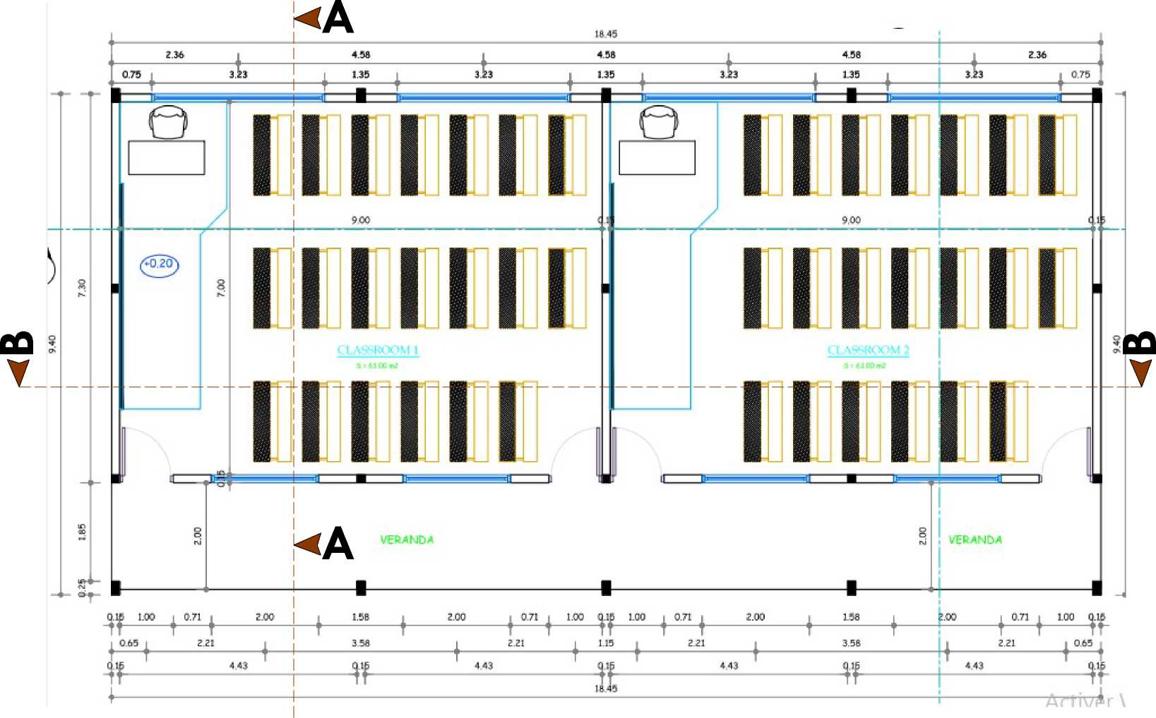

DISTRIBUTION PLAN - DISTRIBUTION PLAN

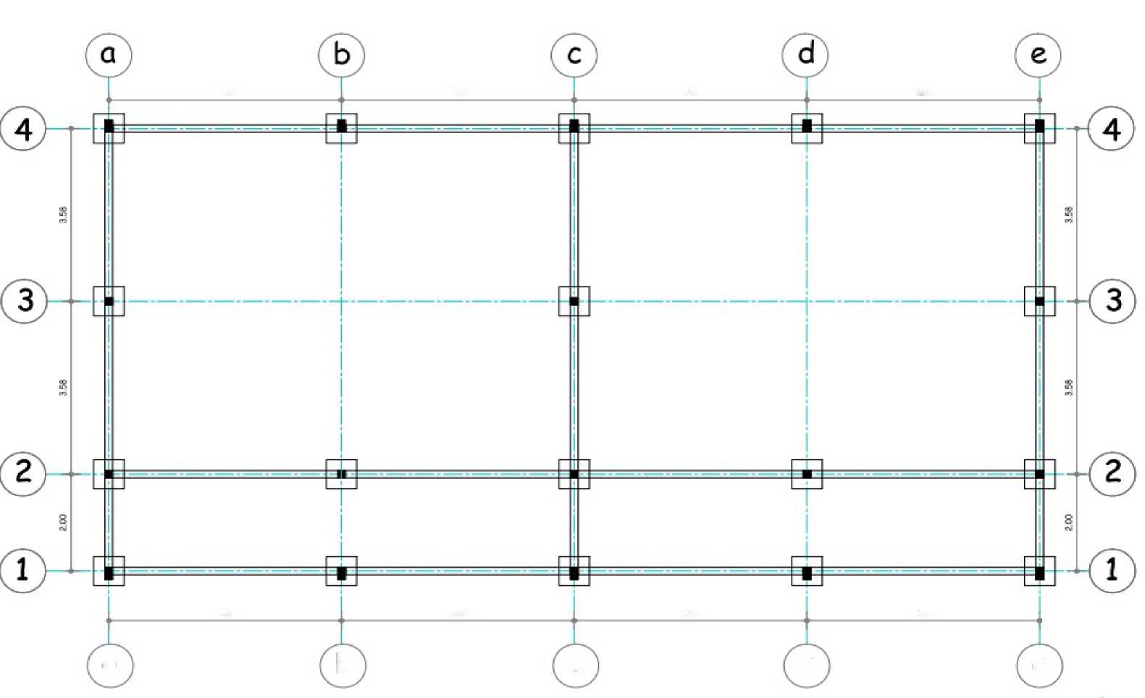

FOUNDATION PLAN - FOUNDATION PLAN

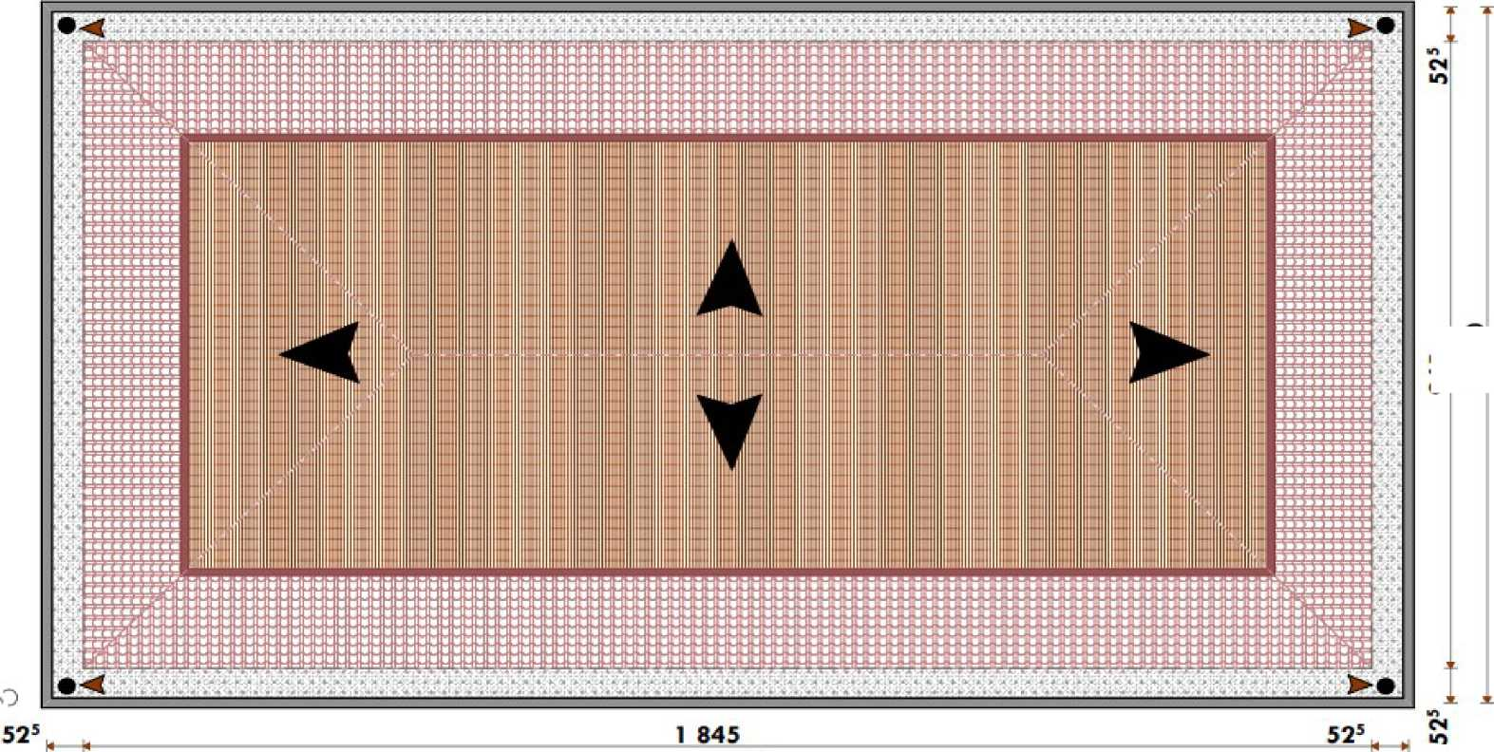

ROOF PLAN - ROOF PLAN
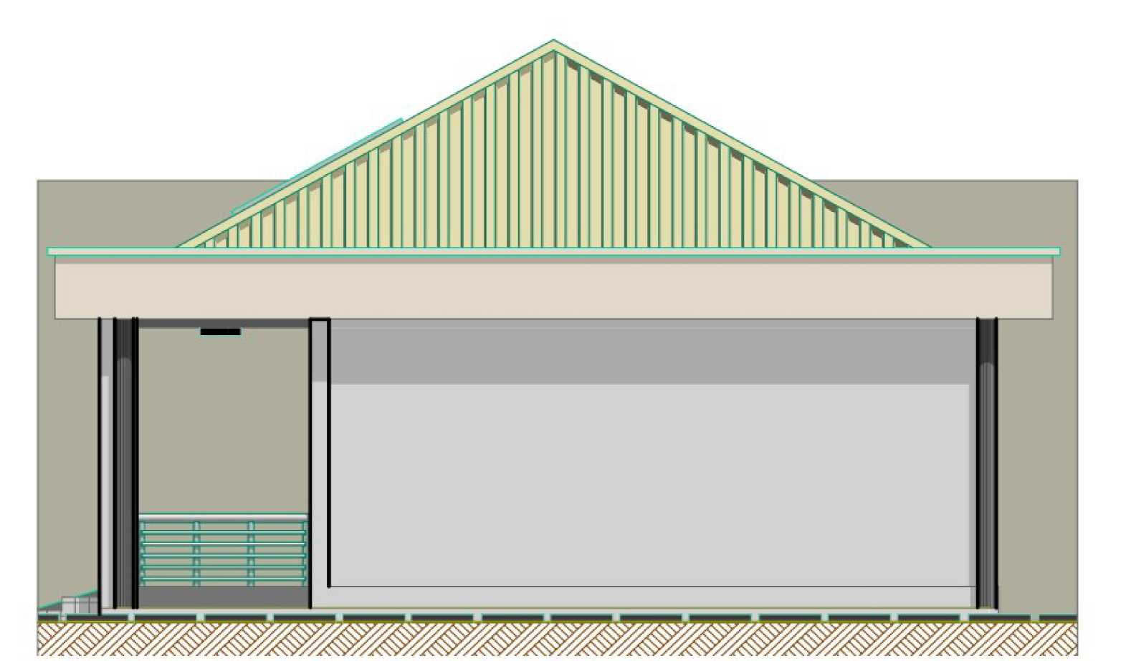

RIGHT FACADE - RIGHT ELEVATION
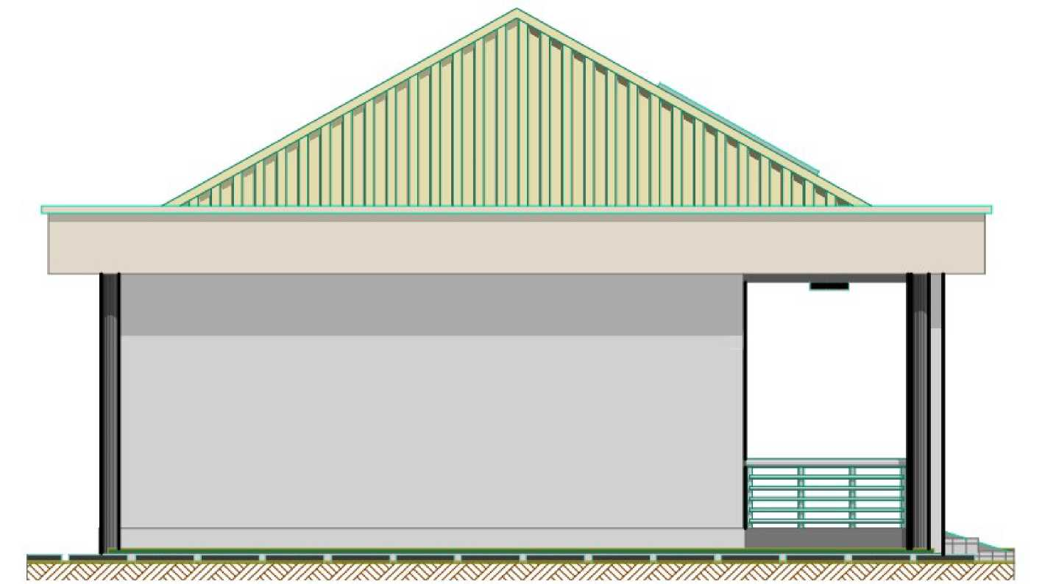

LEFT FACADE - LEFT ELEVATION

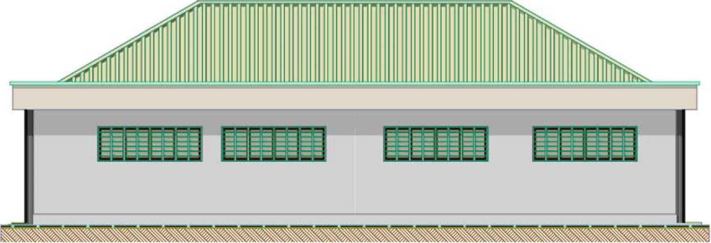

REAR FACADE - BACK ELEVATION

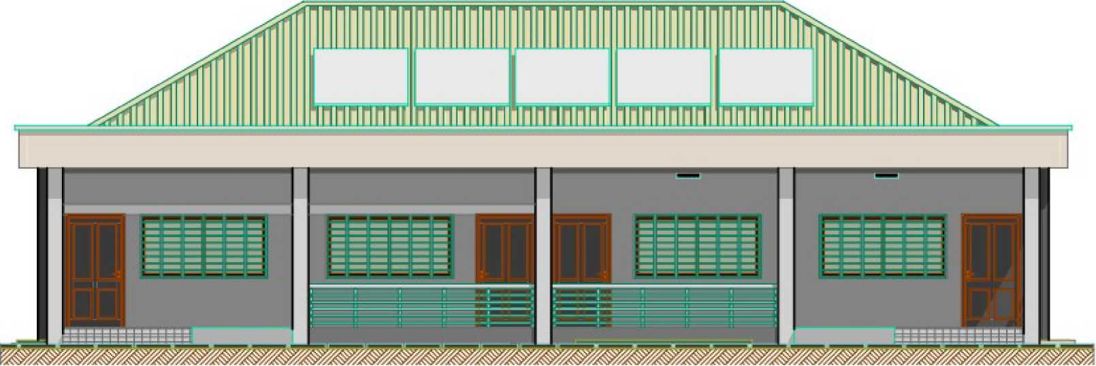

MAIN FACADE - FRONT ELEVATION
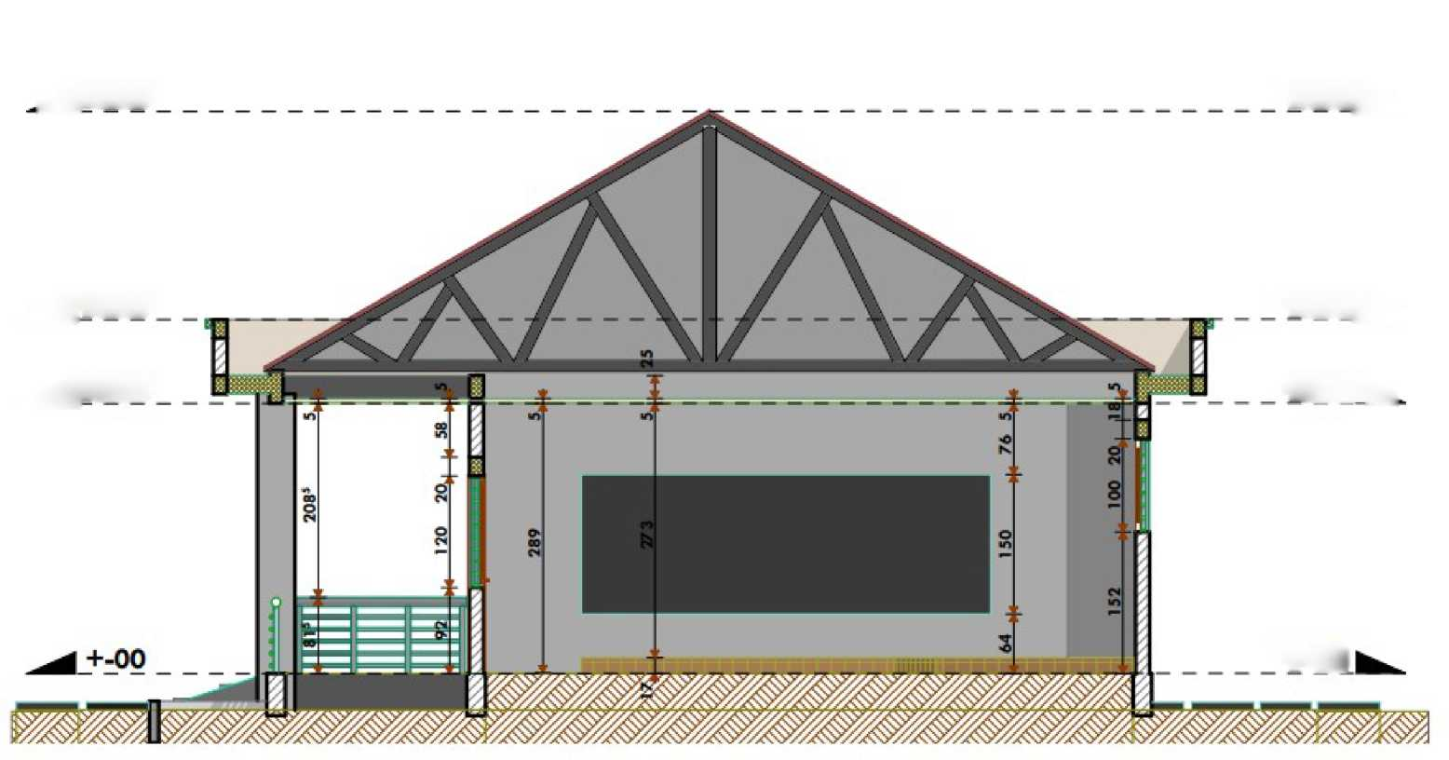

AA CUT - AA SECTION

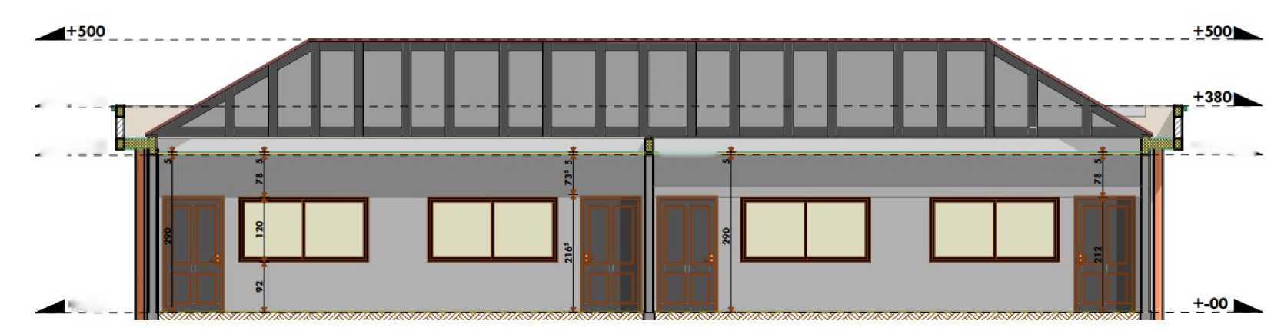

BB CUT - BB SECTION





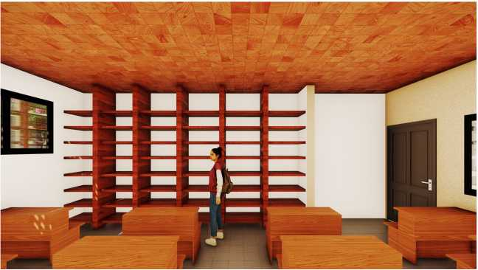



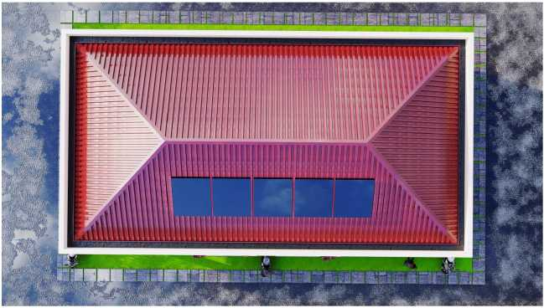
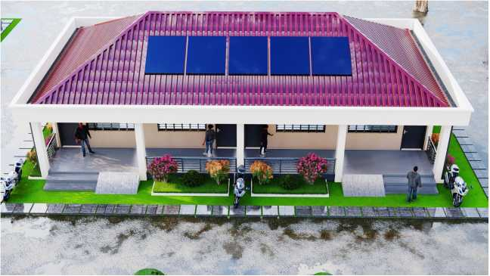
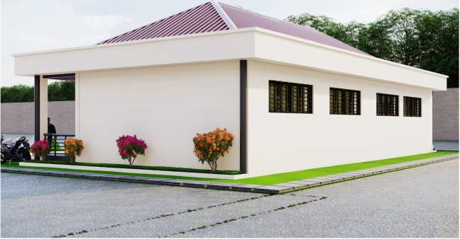
LATRINE BLOCK

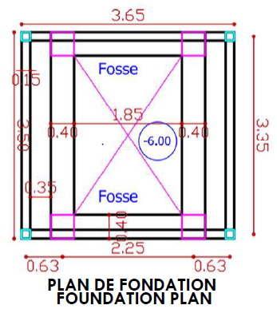
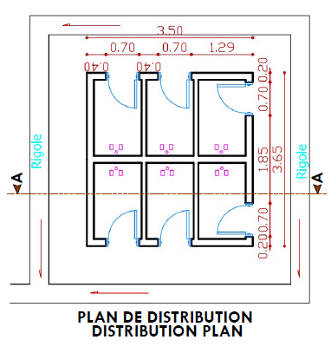

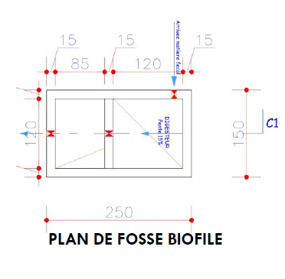
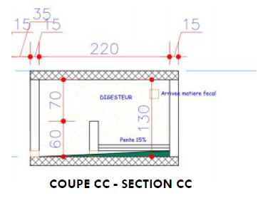

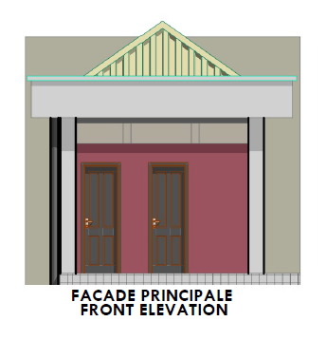
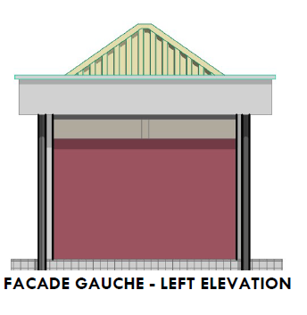
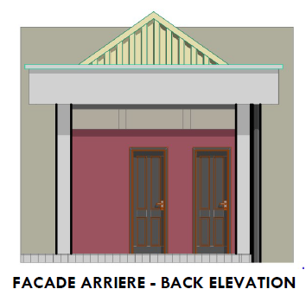
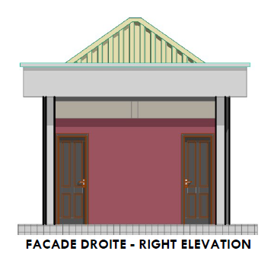
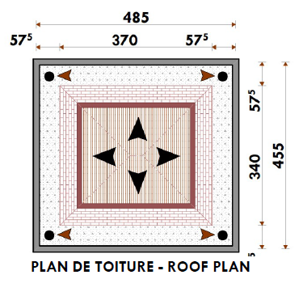
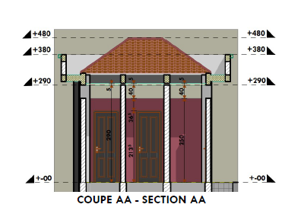
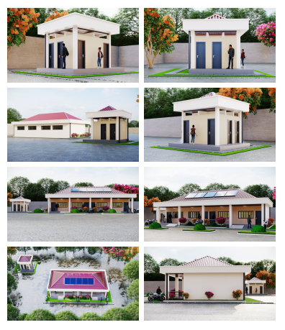



Price Schedule and Detailed Specifications forms
1. Sample Bill of Quantities (Local Currency)
F2 UNIT PRICE SCHEDULE (UPS)
Classroom block
N° | DESIGNATIONS | UNIT | Unit price in numbers | Unit price in numbers
 | Lot 100: PREPARATORY WORK
101 | Clearing the site | m²
102 | Site studies and installation | FF
 | Lot 200: EARTHWORK
201 | Leveling the platform (stripping the topsoil) | m²
202 | Excavation in trenches and pits under posts | m³
203 | Backfilling with lateritic earth or sand | m³
 | LOT 300: FOUNDATION
301 | 5 cm thick concrete base, dosed at 150 kg/m³ | m³
302 | 20x20x40 concrete blocks filled with concrete | m²
303 | Reinforced concrete for footings, posts, and anchors, dosed at 350 kg/m³ | m³
304 | Lightly reinforced concrete for paving (8 cm thick) dosed at 300 kg/m³ | m²
 | Lot 400: MASONRY - ELEVATION
401 | Hollow blocks measuring 15x20x40 | m²
402 | Cement mortar coating at a dosage of 350 kg/m³ | m²
403 | Reinforced concrete for posts, lintels, ties, and beams at a dosage of 350 kg/m³ | m³
404 | Smoothed screed at a dosage of 350 kg/m³ for paving and platforms | m²
405 | Supply and installation of 30x30 tiles | m²
406 | Supply and installation of 15x30 skirting boards | m²
 | Lot 500: MASONRY ACROTERE - FRAMEWORK - ROOFING - WATERPROOFING - CEILING
501 | Truss lined with 3x15 hardwood treated with Xylamon or carbonyl | U
502 | 8x8 rafter purlins and carbonyl-treated gable end battens | m³
503 | White plywood ceiling on 4x8 Xylamon-treated joists | m²
504 | Xylamon-treated fascia boards | ml
505 | 6m 6/10ths aluminum sheet metal | m²
506 | 50cm wide ridge plate | ml
507 | Aluminum sheet metal gable end fixed to fascia board | ml
508 | Reinforced concrete for pouring the guttering, dosed at 350 kg/m³ | m³
509 | 12x20x40 blocks for elevation on the guttering | m²
510 | Bituminous membrane for waterproofing treatment | m²
511 | Guttering | ml
 | Lot 600: METAL CARPENTRY
601 | 97x220 solid metal door | U
602 | Angled sills (veranda and platforms) | ml
603 | Sliding-style window | m²
604 | Wrought iron on the windows | m²
605 | Wrought iron on the veranda | m²
 | Lot 700: ELECTRICITY
701 | 13mm orange flexible tubing | Roll
702 | 1.5mm² high voltage cables in the ceiling | Roll
703 | 2.5mm² high voltage wire | Roll
704 | 120 Mazda or Le Grand strips (6 per room) | U
705 | Round portholes in the veranda | U
706 | Recessed switches and electrical outlets | U
707 | Fasteners, terminal blocks, junction boxes, all safety requirements, connection to the existing network in the establishment | Ens
708 | Solar energy supply | Ens
 | Lot 800: PAINT
801 | Application of two coats of acrylic paint such as Pantex 800 or similar to the ceiling | m²
802 | Application of two coats of acrylic paint such as Pantex 1300 or similar to the exterior walls | m²
803 | Application of two coats of acrylic paint such as Pantex 800 or similar to the interior walls | m²
804 | Application of two coats of glycerophthalic paint to the wood and metal joinery and baseboards | m²
 | LOT 900: VRD
901 | Perimeter gutter | ml
902 | Paving around the building, stairs, and ramp for disabled people | m³
903 | Green spaces | m²
904 | Planting trees around the building | u
 | LOT 1000 : EQUIPMENT
1001 | Supply and installation of desks and benches | ml
1002 | Supply of complete teacher's desks | m²
1003 | Supply and installation of student and teacher cupboards | u
1004 | Triptich-style school board with aluminum frame, 120x90/240 cm | u
 | LOT 1100 : SOCIO-ENVORONMENTAL ASPECTS
1101 | Taking into account social and environmental impacts | FF
 | LOT 1200 : EQUIPMENT FOR THE TEACHER
1201 | Supply and installation of desks and benches | ml
1202 | Supply of complete teacher's desks | m²
1203 | Supply and installation of student and teacher cupboards | u

LATRINE BLOCK WITH SIX (06) COMPARTMENTS
N° | DESIGNATIONS | UNIT | nit price in figures | Unit price in letters
 | Lot 100: PREPARATORY WORK
101 | Site Clearing | m²
102 | Study and Site Installation | FF
 | Lot 200: Earthworks
201 | Leveling the platform (stripping the topsoil) | m²
202 | Excavation for a biofil pit | m³
203 | Ditch excavation for a foundation wall | m³
204 | Lateritic earth or sand backfill | m³
 | LOT 300: Foundation
301 | 5cm clean concrete dosed at 150kg/m³ | m³
302 | 20x20x40 blocks filled with concrete | m²
303 | Reinforced concrete for foundations, posts, slabs on pits and anchors dosed at 350 kg/m³ | m³
304 | Lightly reinforced concrete for surrounding paving (8 cm thick) dosed at 300 kg/m3 | m³
 | Lot 400: MASONRY - ELEVATION
401 | Hollow blocks 15x20x40 | m²
402 | Hollow agglomerates of 10x20x40 | m²
402 | Cement mortar coating dosed at 350kg/m³ | m²
403 | Reinforced concrete for posts, lintels, chains and beams dosed at 350 kg/m³ | m³
407 | Supply and installation of 20x20 non-slip floor tiles | m²
407 | Supply and installation of 20x40 wall tiles | m²
 | Lot 500: MASONRY ACROTERE - FRAMEWORK - ROOFING - WATERPROOFING - CEILING
501 | Farm lined with 3x15 hardwood treated with Xylamon or carbonyl | U
502 | Purlins and gable edge in 4x8 carbonyl-treated slats | m³
503 | White plywood ceiling on 4x8 slatted joists treated with Xylamon | m²
504 | Xylamon-treated fascia boards | ml
505 | 6/10ths aluminum tray sheet of 6m | m²
506 | Ridge sheet 50 cm wide | ml
507 | Gable edge in aluminum sheet metal fixed on edge board | ml
508 | Reinforced concrete for casting the chainaux dosed at 350 kg/m³ | m³
509 | 12x20x40 agglomerates for elevation on the chainaux | m²
510 | Bituminous membrane for waterproofing treatment | m²
511 | 100mm PVC pipe water downspout | ml
 | Lot 600: METAL CARPENTRY
601 | Porte métallique pleine de 80x210 | U
 | Lot 700: ELECTRICITY
701 | 13 orange flexible tube | Roll
702 | 1.5 mm² V.G.V. cables in ceiling | Roll
705 | Round portholes | U
706 | Recessed switches | U
707 | Fasteners, dominoes, junction boxes, all safety requirements, connection with the existing network in the Establishment | Ens
 | Lot 800: PAINT
801 | Application of two coats of acrylic paint such as Pantex 800 or similar to the ceiling | m²
804 | Application of two coats of glycerophthalic paint to the metalwork and exterior walls | m²
 | Lot 900: VRD
901 | Peripheral gutter | ml
902 | Paving of disabled ramps | m³
903 | Green spaces | m²
904 | Planting trees around the building | U
 | LOT 1100 : SOCIO-ENVORONMENTAL ASPECTS
1101 | Taking into account social and environmental impacts | FF
 | LOT 1000 : PLOMBING
1001 | Supply and installation of Turkish toilets | u

Name of Bidder:
Signature:
Date:

FRAMEWORK OF QUANTITATIVE AND ESTIMATED DETAIL
N° | DESIGNATIONS | UNIT | QUANTITY | UNIT PRICE | TOTAL AMOUNT
 | Lot 100: PREPARATORY WORK
101 | Clearing the site | m² | 1698
102 | Site studies and installation | FF | 1
 | Sub-Total lot 100
 | Lot 200: EARTHWORK
201 | Leveling the platform (stripping the topsoil) | m² | 555
202 | Excavation in trenches and pits under posts | m³ | 32,8
203 | Backfilling with lateritic earth or sand | m³ | 62
 | Sub-Total lot 200
 | LOT 300: FOUNDATION
301 | 5 cm thick concrete base, dosed at 150 kg/m³ | m³ | 2,3
302 | 20x20x40 concrete blocks filled with concrete | m² | 67,5
303 | Reinforced concrete for footings, posts, and anchors, dosed at 350 kg/m³ | m³ | 6,9
304 | Lightly reinforced concrete for paving (8 cm thick) dosed at 300 kg/m³ | m² | 12,96
 | Sub-Total lot 300
 | Lot 400: MASONRY - ELEVATION
401 | Hollow blocks measuring 15x20x40 | m² | 149,3
402 | Cement mortar coating at a dosage of 350 kg/m³ | m² | 318
403 | Reinforced concrete for posts, lintels, ties, and beams at a dosage of 350 kg/m³ | m³ | 7,19
404 | Smoothed screed at a dosage of 350 kg/m³ for paving and platforms | m² | 165,6
405 | Supply and installation of 30x30 tiles | m² | 169.7
406 | Supply and installation of 15x30 skirting boards | m² | 9
 | Sub-Total lot 400
 | Lot 500: MASONRY ACROTERE - FRAMEWORK - ROOFING - WATERPROOFING - CEILING
501 | Truss lined with 3x15 hardwood treated with Xylamon or carbonyl | U | 7
502 | 8x8 rafter purlins and carbonyl-treated gable end battens | m³ | 2
503 | White plywood ceiling on 4x8 Xylamon-treated joists | m² | 220
504 | Xylamon-treated fascia boards | ml | 63
505 | 6m 6/10ths aluminum sheet metal | m² | 234
506 | 50cm wide ridge plate | ml | 19,5
507 | Aluminum sheet metal gable end fixed to fascia board | ml | 24
508 | Reinforced concrete for pouring the guttering, dosed at 350 kg/m³ | m³ | 4,1
509 | 12x20x40 blocks for elevation on the guttering | m² | 48
510 | Bituminous membrane for waterproofing treatment | m² | 27
511 | Guttering | ml | 20,4
 | Sub-TOTAL LOT 500
 | Lot 600: METAL CARPENTRY
601 | 97x220 solid metal door | U | 4
602 | Angled sills (veranda and platforms) | ml | 35,8
603 | Sliding-style window | m² | 13,31
604 | Wrought iron on the windows | m² | 13,31
605 | Wrought iron on the veranda | m² | 6,88
 | Sub-TOTAL LOT 600
 | Lot 700: ELECTRICITY
701 | 13mm orange flexible tubing | Rleau | 1
702 | 1.5mm² high voltage cables in the ceiling | Rleau | 1
703 | 2.5mm² high voltage wire | Rleau | 2
704 | 120 Mazda or Le Grand strips (6 per room) | U | 12
705 | Round portholes in the veranda | U | 2
706 | Recessed switches and electrical outlets | U | 8
707 | Fasteners, terminal blocks, junction boxes, all safety requirements, connection to the existing network in the establishment | Ens | 1
708 | Solar energy supply | Ens | 1
 | Sub-Total LOT 700
 | Lot 800: PAINT
801 | Application of two coats of acrylic paint such as Pantex 800 or similar to the ceiling | m² | 220
802 | Application of two coats of acrylic paint such as Pantex 1300 or similar to the exterior walls | m² | 164,8
803 | Application of two coats of acrylic paint such as Pantex 800 or similar to the interior walls | m² | 156,2
804 | Application of two coats of glycerophthalic paint to the wood and metal joinery and baseboards | m² | 45
 | Sub-Total LOT 800
 | LOT 900: VRD
901 | Perimeter gutter | ml | 66
902 | Paving around the building, stairs, and ramp for disabled people | m3 | 4,3
903 | Green spaces | m2 | 60
904 | Planting trees around the building | u | 10
 | Sub-total Lot 900
 | LOT 1000 : EQUIPMENT
1001 | Supply and installation of desks and benches | ml | 60
1002 | Supply of complete teacher's desks | m² | 2
1003 | Supply and installation of student and teacher cupboards | u | 65
1004 | Triptich-style school board with aluminum frame, 120x90/240 cm | u | 2
 | Sous total Lot 1000
 | LOT 1100: SOCIO-ENVORONMENTAL ASPECTS
1101 | Taking into account social and environmental impacts | FF | 1
 | Sub-total Lot 1100
 | LOT 1200 : EQUIPEMENTS
1201 | Supply and installation of table and benches | u | 60
1202 | Supply of complete teacher's desks (table and three chairs) | Ens | 1
1203 | Supply and installation of student and teacher cupboards | u | 2
 | Sous total 1200
 | Amount without taxes
 | TVA 19,25%
 | AIR (2,2% ou 5,5%)
 | Montant TTC
 | Montant net à payer

LATRINE BLOCK WITH SIX (06) COMPARTMENTS
N° | DESIGNATIONS | UNITE | QUANTITE | PRIX UNITAIRE | MONTANT
 | Lot 100: PREPARATORY WORK
101 | Site Clearing | m² | 100,00
102 | Study and Site Installation | FF | 1,00
 | Sub-Total lot 100
 | Lot 200: Earthworks
201 | Leveling the platform (stripping the topsoil) | m² | 49,00
202 | Excavation for a biofil pit | m³ | 5,63
203 | Ditch excavation for a foundation wall | m³ | 2,68
204 | Lateritic earth or sand backfill | m³ | 1,79
 | Sub-Total lot 200
 | LOT 300: Foundation
301 | 5cm clean concrete dosed at 150kg/m³ | m³ | 0,46
302 | 20x20x40 blocks filled with concrete | m² | 19,00
303 | Reinforced concrete for foundations, posts, slabs on pits and anchors dosed at 350 kg/m³ | m³ | 1,78
304 | Lightly reinforced concrete for surrounding paving (8 cm thick) dosed at 300 kg/m3 | m³ | 0,90
 | Sub-Total lot 300
 | Lot 400: MASONRY - ELEVATION
401 | Hollow blocks 15x20x40 | m² | 51,62
402 | Hollow agglomerates of 10x20x40 | m² | 21,17
402 | Cement mortar coating dosed at 350kg/m³ | m² | 14,00
403 | Reinforced concrete for posts, lintels, chains and beams dosed at 350 kg/m³ | m³ | 1,01
407 | Supply and installation of 20x20 non-slip floor tiles | m² | 12,78
407 | Supply and installation of 20x40 wall tiles | m² | 104,11
 | Sub-Total lot 400
 | Lot 500: MASONRY ACROTERE - FRAMEWORK - ROOFING - WATERPROOFING - CEILING
501 | Farm lined with 3x15 hardwood treated with Xylamon or carbonyl | U | 1,00
502 | Purlins and gable edge in 4x8 carbonyl-treated slats | m³ | 0,20
503 | White plywood ceiling on 4x8 slatted joists treated with Xylamon | m² | 12,58
504 | Xylamon-treated fascia boards | ml | 14,20
505 | 6/10ths aluminum tray sheet of 6m | m² | 18,87
506 | Ridge sheet 50 cm wide | ml | 10,65
507 | Gable edge in aluminum sheet metal fixed on edge board | ml | 14,20
508 | Reinforced concrete for casting the chainaux dosed at 350 kg/m³ | m³ | 1,13
509 | 12x20x40 agglomerates for elevation on the chainaux | m² | 11,28
510 | Bituminous membrane for waterproofing treatment | m² | 24,44
511 | 100mm PVC pipe water downspout | ml | 13,60
 | Sub-TOTAL LOT 500
 | Lot 600: METAL CARPENTRY
601 | Porte métallique pleine de 80x210 | U | 6,00
 | Sub-TOTAL LOT 600
 | Lot 700: ELECTRICITY
701 | 13 orange flexible tube | Rleau | 0,50
702 | 1.5 mm² V.G.V. cables in ceiling | Rleau | 0,50
705 | Round portholes | U | 2,00
706 | Recessed switches | U | 2,00
707 | Fasteners, dominoes, junction boxes, all safety requirements, connection with the existing network in the Establishment | Ens | 1,00
 | Sub-Total LOT 700
 | Lot 800: PAINT
801 | Application of two coats of acrylic paint such as Pantex 800 or similar to the ceiling | m² | 12,95
804 | Application of two coats of glycerophthalic paint to the metalwork and exterior walls | m² | 51,84
 | Sub-Total LOT 800
 | LOT 900: VRD
901 | Peripheral gutter | ml | 19,00
902 | Paving of disabled ramps | m3 | 0,23
903 | Green spaces | m² | 30
904 | Planting trees around the building | U | 50
 | Sous total Lot 900
 | LOT 1000 : PLOMBERIE
1001 | Supply and installation of Turkish toilets | u | 6,00
 | Sub total Lot 1000
 | Montant hors taxes
 | TVA 19,25%
 | AIR (2,2%)
 | Montant TTC
 | Montant net à payer

Closed this cost estimate all taxes inclusive at the sum of :___________________

……………………………………………ATI
Signature
Name of Bidder:
Date:

NB : ce devis reprensente la construction d’un bloc de deux salles de classe équipées dans une seule école publique. Prévoir dans le tableau récaptitulatif le montant pour l’ensemble.
RECAPITULATIF
DESIGNATIONS | AMOUNTS
Quote for a two-classroom block in a public school
Quote for a six (06) compartment latrine block
Amount excluding tax
VAT 19.25%
AIR (2.2% or 5.5%)
Amount including tax
Net amount to pay

This estimate has been approved for the sum of _________ including tax: FCFA

Signature
Name of Bidder:
Date:

Arrêté le présent devis estimatif à la somme de _________ T.T.C.: FCFA

Closed this cost estimate all taxes inclusive at the sum of :___________________

……………………………………………ATI
Signature
Name of Bidder:
Date:

Technical Proposal
The Contractor shall provide:
- the names and details of the suitably qualified key personnel to perform the Contract
Staff quality
- Mission manager
Copy of the Mission manager’s diploma (Civil engineer) (Copy of the diploma)
Curriculum Vitae of the Mission Manager, dated and signed
≥ 3 years' experience in a similar field
- Site manager
Site manager's diploma (at least Civil/Rural Engineering Technician level), dated and signed
Curriculum Vitae of the Site Manager, dated and signed
Seniority ≥ 3 years in a similar field
- Electrician
HND in electricity (Copy of the diploma),
Curriculum Vitae of the electriian, dated and signed
Seniority ≥ 3 years in a similar field

- adequate information to demonstrate clearly that it has the capability to meet the requirements for the key equipment for the Contract
Construction equipment
List of small items of equipment relevant to the tasks (produce photocopies of purchase invoices or rental invoices)

- information on Site organization
- its method statement on the execution of the works
- mobilization and construction schedule
- A summary of other information, if any, that the Contractor considers relevant

ANNEX 3: Contract Forms
Contract Agreement

THIS AGREEMENT

Made the . . . . . .day of . . . . . . . . . ,

Between

WABANE COUNCIL (PROLOG COMMUNITY INVESTMENT SUPPORT GRANT AGREEMENT - WABANE COUNCIL, LEBIALEM DIVISION, SOUTH-WEST REGION) PO. Box:__________, Cell phone:_____________ Mail : ________________ (hereinafter “the Employer”),

Of the one part, and

[name of the Contractor] .(hereinafter “the Contractor”), of the other part:

WHEREAS the Employer invited a Quotation for the execution of Works, concerning the construction and equipping (60 benches) of two classrooms at GS Marita, WABANE Council, Lebialem Division, South-West Region, and has accepted the Quotation by the Contractor for the Works for an amount equal to [insert the Market Price expressed in the Market settlement currency(ies)] (hereinafter referred to as the ‘Market Price’):
The Employer and the Contractor agree as follows:
  - In this Agreement words and expressions shall have the same meanings as are respectively assigned to them in the Contract documents referred to.
  - The following documents shall be deemed to form and be read and construed as part of this Agreement. This Agreement shall prevail over all other Contract documents.
- the Letter of Award of Contract
- the Contractor’s Quotation
- the Conditions of Contract, including Appendices
- the Specifications
- the Drawings
- Bill of Quantities; and
- any other document listed in the CC as forming part of the Contract.
  - In consideration of the payments to be made by the Employer to the Contractor as specified in this Agreement, the Contractor hereby covenants with the Employer to execute the Works and to remedy defects therein in conformity in all respects with the provisions of the Contract.
  - The Employer hereby covenants to pay the Contractor in consideration of the execution and completion of the Works and the remedying of defects therein, the Contract Price or such other sum as may become payable under the provisions of the Contract at the times and in the manner prescribed by the Contract.
IN WITNESS whereof the parties hereto have caused this Agreement to be executed in accordance with the laws in force in the Republic of Cameroon on the day, month and year specified above.

Signed by: |  | Signed by:
for and on behalf of the Employer |  | for and on behalf the Contractor
in the presence of: |  | in the presence of:
Witness, Name, Signature, Address, Date |  | Witness, Name, Signature, Address, Date

Conditions of Contract

Table of Clauses

A. General 13

1. Definitions 13

2. Contract Specific Information 16

3. Interpretation 20

4. Prohibitions 21

5. Project Manager’s Decisions 21

6. Subcontracting 21

7. Cooperation 21

8. Personnel and Equipment 21

9. Employer’s and Contractor’s Risks 24

10. Employer’s Risks 24

11. Contractor’s Risks 25

12. Insurance 25

13. Site Data 25

14. Contractor to Construct the Works 26

15. Approval by the Project Manager 26

16. Health, Safety and Protection of the Environment 26

17. Archaeological and Geological Findings 26

18. Possession of the Site 27

19. Access to the Site 27

20. Instructions, Inspections and Audits 27

21. Appointment of the Adjudicator 27

22. Procedure for Disputes 28

23. Fraud and Corruption 29

24. Security of the Site 29

B. Time Control 29

25. Program and Progress Reports 29

26. Extension of the Completion Date 30

27. Acceleration 30

28. Delays Ordered by the Project Manager 30

29. Management Meetings 30

30. Early Warning 31

C. Quality Control 31

31. Identifying Defects 31

32. Tests 31

33. Correction of Defects 31

34. Uncorrected Defects 31

D. Cost Control 31

35. Contract Price 31

36. Changes in the Contract Price 32

37. Variations 32

38. Payment Certificates 33

39. Payments 33

40. Compensation Events 34

41. Tax 35

42. Price Adjustment 35

43. Retention 35

44. Liquidated Damages and Bonuses 35

45. Advance Payment 36

46. Performance Security 36

47. Dayworks 37

48. Cost of Repairs 37

E. Finishing the Contract 37

49. Completion 37

50. Taking Over 38

51. Final Account 38

52. Operating and Maintenance Manuals 38

53. Termination 38

54. Payment upon Termination 39

55. Property 40

56. Release from Performance 40

57. Suspension of Bank Loan or Credit 40

Conditions of Contract
A. General

- Definitions | - The following words and expressions shall have the meanings hereby assigned to them. Boldface type is used to identify defined terms.  - The Accepted Contract Amount means the amount accepted in the Letter of Award of Contract for the execution and completion of the Works and the remedying of any defects.  - The Activity Schedule is a schedule of the activities comprising the construction, installation, testing, and commissioning of the Works in a lump-sum contract. It includes a lump-sum price for each activity, which is used for valuations and for assessing the effects of Variations and Compensation Events.  - The Adjudicator is the person appointed jointly by the Employer and the Contractor to resolve disputes in the first instance, as provided for in CC 21.  - “Bank” means the World Bank and refers to the International Bank for Reconstruction and Development (IBRD) or the International Development Association (IDA).  - Bill of Quantities means the priced and completed Bill of Quantities forming part of the Contractor’s Quotation.  - Compensation Events are those defined in CC 40.  - The Completion Date is the date of completion of the Works as certified by the Project Manager, in accordance with CC 49.1.  - The Contract is the Contract between the Employer and the Contractor to execute, complete, and maintain the Works. It consists of the documents listed in CC 3.3 below.  - The Contractor is the party whose Quotation to carry out the Works has been accepted by the Employer.  - The Contractor’s Quotation is the completed quotation document submitted by the Contractor to the Employer.  - The Contract Price is the Accepted Contract Amount stated in the Letter of Award of Contract and thereafter as adjusted in accordance with the Contract.  - Days are calendar days; months are calendar months.  - Dayworks are varied work inputs subject to payment on a time basis for the Contractor’s employees and Equipment, in addition to payments for associated Materials and Plant.  - A Defect is any part of the Works not completed in accordance with the Contract.  - The Defects Liability Certificate is the certificate issued by Project Manager upon correction of defects by the Contractor.  - The Defects Liability Period is the period specified in CC 2.12 and calculated from the Completion Date.  - Drawings means the drawings of the Works, as included in the Contract, and any additional and modified drawings issued by (or on behalf of) the Employer in accordance with the Contract, include calculations and other information provided or approved by the Project Manager for the execution of the Contract.  - The Employer is the party who employs the Contractor to carry out the Works, as specified in CC 2.1.  - Equipment is the Contractor’s machinery and vehicles brought temporarily to the Site to construct the Works.  - “In writing” or “written” means hand-written, type-written, printed or electronically made, and resulting in a permanent record.  - The Intended Completion Date is the date on which it is intended that the Contractor shall complete the Works as specified in CC 2.1.  - Materials are all supplies, including consumables, used by the Contractor for incorporation in the Works.  - Plant is any integral part of the Works that shall have a mechanical, electrical, chemical, or biological function.  - The Project Manager is the person named in CC 2.1 (or any other competent person appointed by the Employer and notified to the Contractor, to act in replacement of the Project Manager) who is responsible for supervising the execution of the Works and administering the Contract.  - The Site is the area defined as such in the CC 2.1.  - Site Investigation Reports are those, if any, that were included in the RELAUNCH OF REQUEST FOR QUOTATIONS documents and are factual and interpretative reports about the surface and subsurface conditions at the Site.  - Specifications means the Specifications of the Works included in the Contract and any modification or addition made or approved by the Project Manager.  - The Start Date is given in CC 2.1. It is the latest date when the Contractor shall commence execution of the Works.  - A Subcontractor is a person or corporate body who has a Contract with the Contractor to carry out a part of the work in the Contract, which includes work on the Site.  - Temporary Works are works designed, constructed, installed, and removed by the Contractor that are needed for construction or installation of the Works.  - A Variation is an instruction given by the Project Manager which varies the Works.  - The Works are what the Contract requires the Contractor to construct, install, and turn over to the Employer, as defined in the CC 2.1.  - “Contractor’s Personnel” refers to all personnel whom the Contractor utilizes on the Site or other places where the Works are carried out, including the staff, labor and other employees of each Subcontractor.  - “Key Personnel” means the positions (if any) of the Contractor’s personnel that are included in the contract.  - “Sexual Exploitation and Abuse” “(SEA)” means the following:  Sexual Exploitation is defined as any actual or attempted abuse of position of vulnerability, differential power or trust, for sexual purposes, including, but not limited to, profiting monetarily, socially or politically from the sexual exploitation of another;  Sexual Abuse is defined as the actual or threatened physical intrusion of a sexual nature, whether by force or under unequal or coercive conditions;  - “Sexual Harassment” “(SH)” is defined as unwelcome sexual advances, requests for sexual favors, and other verbal or physical conduct of a sexual nature by the Contractor’s Personnel with other Contractor’s or Employer’s Personnel; and  - “Employer’s Personnel” refers to the Project Manager and all other staff, labor and other employees (if any) of the Project Manager and of the Employer engaged in fulfilling the Employer’s obligations under the Contract; and any other personnel identified as Employer’s Personnel, by a notice from the Employer or the Project Manager to the Contractor.
- Contract Specific Information | - General  - The Employer is: The Mayor of WABANE Council, he shall ensure that the originals of the Contract documents are kept and that copies are forwarded to MINMAP and ARMP by the focal point appointed for this purpose.  - The Intended Completion Date for the whole of the Works shall be: sixty (60) days from notification of the start-up order  - The Project Manager is the Responsible for the preparation and development of local authority projects of WABANE Council, which coordinates the operations required for the proper execution of the various phases of the project and provides the project owner with general technical, administrative and financial assistance at all phases of the project. It also ensures compliance with the administrative, technical and financial clauses and contractual deadlines.  The contract engineer is the Divisional Delegate for water and energy, It is responsible for monitoring the performance of the contract and ensuring that sectoral standards are taken into account when carrying out the work.  The Environmental Expert is the Head of the Environment and Communal Forestry Department of the Commune of ____________. He is responsible for monitoring the environmental performance of the contract and ensuring that environmental standards relating to the contract are taken into account.  The contractor is responsible for carrying out the work according to the rules of the trade and in compliance with the specifications. He must ensure that the project team has free access to the site where the work is being carried out, and that they have every facility to perform their duties.  - The Site is located in WABANE Council.  - The Start Date shall be: upon notification of the start-up order.  - The Works consist of:  - preliminary work ;  - Earthwork ;  - Foundation ;  - Mansory Elévation ;  - Mansory acrotere ;  - Metal carpentry;  - Electricity;  - Paint ;  -Equipment :  - Environnemental and social safeguards  Any notice given by one Party to the other pursuant to the Contract shall be in writing to the address hereafter using the quickest available method such as electronic mail with proof of receipt.  Address for notices to the Employer:  WABANE Council  The Mayor of the WABANE Council  LEBIALEM Division  [address]  [Electronic mail address]  Address for notices to the Contractor:  [insert the name of officer authorized to receive notices]  [title/position]  [department/work unit]  [address]  [Electronic mail address]  Service orders:  - The service order to start work is signed by the Mayor of WABANE (Employer) and notified to the Co-contractor by the head of the contract department with a copy to the DDMINMAP-LEBIALEM and the Contract Engineer.  - On the proposal of the Contract Engineer, service orders that have an impact on the objective, the deadline for execution and/or the cost of the contract will be signed by the Mayor of WABANE (Employer), after obtaining the opinion of the Contract Engineer and the Head of the Contract Department and notified to the Co-contractor by the Head of the Contract Department with a copy to the DDMINMAP-LEBIALEM, the Contract Engineer, etc.  - Service orders of a technical nature relating to the normal running of the worksite will be signed, notified and distributed directly by the Mayor of WABANE (Employer) to the Contract Manager, the Co-contractor, DDMINMAP-LEBIALEM and the Project Manager.  - Service orders for formal notice will be signed by the Mayor of WABANE (Employer), after consultation with the Contract Engineer and the Head of the Contract Department and notified to the Co-contractor by the Head of the Contract Department with a copy to DDMINMAP-LEBIALEM, the Contract Engineer and the Project Manager.  - The service orders for the suspension and resumption of work, due to bad weather or any other case of force majeure, will be signed by the Mayor of WABANE (Employer), after a report has been drawn up by the Contract Engineer, the Head of the Contract Department and the Project Manager and notified by the Head of the Contract Department to the Co-contractor with a copy to the DDMINMAP-LEBIALEM, the Contract Engineer and the Project Manager.  - The service orders prescribing the work required to remedy any defects not arising from normal use that appear in the works during the guarantee period will be signed by the Mayor of WABANE, on the proposal of the Engineer, and notified to the Co-contractor by the Engineer.  - The Co-contractor has a period of fifteen (15) days in which to express reservations about any service order received. The fact that reservations are expressed does not exempt the Co-contractor from carrying out the service orders received.  - In accordance with CC 3.2, Sectional Completions are: N/A  - The language of the contract is enlish  - The contract is governed by the law in force in the State of Cameroon.  The contract specific information for the listed Conditions of Contract (CC) clauses follows:  - CC 12: The minimum insurance amounts and excesses will be as follows: The Co-contractor must provide evidence that it holds an individual ‘civil liability’ insurance policy as well as an ‘all-risks worksite’ insurance policy for damage of any kind caused to third parties by its salaried employees at work, by the equipment it uses and as a result of the work carried out before acceptance.  - CC 13: Site Data are: [list Site Data].(N/A)  - CC 18: Site Possession Date(s) shall be: the locality of Marita in WABANE Council  - CC 21: Appointing Authority of Adjudicator: Managing Director of ARMP  - CC 25.1: A Program for the Works shall be submitted within: deux weeks from the date of the Letter of Award of Contract.  - CC 25.2: The period for submission of progress reports is:every two weeks  - CC 33: The Defects Liability Period shall be: six (06) months from the date of Completion.  - CC 43: The retention amount shall be 10% of the value of the contract including all taxes.  - CC 44.1: The liquidated damages for the whole of the Works shall be:  - 1/2000th of the total price excluding VAT of the contract per calendar day of delay from the first to the thirtieth day beyond the contractual deadline and,  - 1/1000th of the total contract price excluding VAT per calendar day of delay beyond the thirtieth day.  SPECIAL PENALTIES  In addition to the penalties for exceeding the deadline, the contractor is liable to special penalties of CFAF 50,000 for failure to comply with the provisions of the contract, in particular:  - Late submission of the final bond within 15 days of notification of the Letter of Contract;  - Late submission of insurance 15 days from notification of the DSO;  - Delay of one month in fixing the site sign from the date of notification of the service order to start work;  - Absence of the site log within 15 days of notification of the DSO;  - Late submission of the execution project provided that the delay is the fault of the co-contractor within 15 days of notification of the Letter of Contract.  - CC 44.1: The maximum amount of liquidated damages for the whole of the Works is: 10% of the final Contract Price.  - CC 44.3: the Bonus for the whole of the Works is: [insert percentage] of the final Contract Price per day. The maximum amount of Bonus for the whole of the Works is [insert percentage] of the final Contract Price. [If early completion would provide benefits to the Employer, this clause should remain; otherwise delete. The Bonus is usually numerically equal to the liquidated damages.] (Not applicale)  - CC 45: The Advance Payment shall be: 20% of the Accepted Contract Amount and shall be paid to the Contractor no later than 30 days after the Contractor submits an acceptable Bank Guarantee.
- Interpretation | - In interpreting these CC, words indicating one gender include all genders. Words indicating the singular also include the plural and words indicating the plural also include the singular. Headings have no significance. Words have their normal meaning under the language of the Contract unless specifically defined. The Project Manager shall provide instructions clarifying queries about these CC.  - If sectional completion is specified in CC 2.3, references in the CC to the Works, the Completion Date, and the Intended Completion Date apply to any Section of the Works (other than references to the Completion Date and Intended Completion Date for the whole of the Works).  - The documents forming the Contract shall be interpreted in the following order of priority:  - the Contract Agreement,  - The Letter of Award of Contract  - The Contractor’s Quotation,  - the Conditions of Contract, including Appendices  - the Specifications,  - the Drawings,  - the Bill of Quantities, and  - any other document
- Prohibitions | - Throughout the execution of the Contract, the Contractor shall comply with the import of goods and services prohibitions in the Employer’s country when  - as a matter of law or official regulations, the Borrower’s country prohibits commercial relations with that country; or  - by an act of compliance with a decision of the United Nations Security Council taken under Chapter VII of the Charter of the United Nations, the Borrower’s Country prohibits any import of goods from that country or any payments to any country, person, or entity in that country.
- Project Manager’s Decisions | - Except where otherwise specifically stated, the Project Manager shall decide contractual matters between the Employer and the Contractor in the role representing the Employer.
- Subcontracting | - The Contractor may subcontract with the approval of the Project Manager but may not assign the Contract without the approval of the Employer in writing. Subcontracting shall not alter the Contractor’s obligations.
- Cooperation | - The Contractor shall cooperate with and allow appropriate opportunities for other contractors, public authorities, utilities, and the Employer, to carry out on or near the Site work, if any, not included in the Contract.
- Personnel and Equipment | - The Contractor shall employ the Key Personnel and use the Equipment identified in its quotation, to carry out the Works or other personnel and Equipment approved by the Project Manager. The Project Manager shall approve any proposed replacement of Key Personnel and Equipment only if their relevant qualifications or characteristics are substantially equal to or better than those proposed in the quotation.  - The Project Manager may require the Contractor to remove (or cause to be removed) any person employed on the Site or Works, including the Key Personnel (if any), who:  - persists in any misconduct or lack of care;  - carries out duties incompetently or negligently;  - fails to comply with any provision of the Contract;  - persists in any conduct which is prejudicial to safety, health, or the protection of the environment;  - engages in Sexual Harassment, Sexual Exploitation, Sexual Abuse or in any form of sexual activity with individuals under the age of 18 except in case of pre-existing marriage;  - based on reasonable evidence, is determined to have engaged in Fraud and Corruption during the execution of the Works; or  - has been recruited from the Employer’s Personnel.  As appropriate, the Contractor shall then promptly appoint (or cause to be appointed) a suitable replacement with equivalent skills and experience.  - Labor  8.3.1 Engagement of Staff and Labor. The Contractor shall provide and employ on the Site for the execution of the Works such skilled, semi-skilled and unskilled labor as is necessary for the proper and timely execution of the Contract. The Contractor is encouraged, to the extent practicable and reasonable, to employ staff and labor with appropriate qualifications and experience from sources within the Country.  8.3.2 Labor Laws. The Contractor shall comply with all the relevant labor laws applicable to the Contractor’s Personnel, including laws relating to their employment, health, safety, welfare, immigration and emigration, and shall allow them all their legal rights.:  8.3.3 Facilities for Staff and Labor. [if facilities for staff and labor are to be provided by the Contractor, insert this sub-clause; otherwise delete] The Contractor shall provide and maintain all necessary accommodation and welfare facilities for the Contractor’s Personnel.  8.3.4 Supply of Foodstuffs. [if food to its personnel is to be provided by the Contractor, insert this sub-clause; otherwise delete] The Contractor shall arrange for the provision of a sufficient supply of suitable food at reasonable prices for the Contractor’s Personnel for the purposes of or in connection with the Contract.  8.3.5 Supply of Water. [if water to its personnel is to be provided by the Contractor, insert this sub-clause; otherwise delete] The Contractor shall, having regard to local conditions, provide on the Site an adequate supply of drinking and other water for the use of the Contractor’s Personnel.  8.3.6 Forced Labor. The Contractor, including its Subcontractors, shall not employ or engage forced labor. Forced labor consists of any work or service, not voluntarily performed, that is exacted from an individual under threat of force or penalty, and includes any kind of involuntary or compulsory labor, such as indentured labor, bonded labor or similar labor-contracting arrangements.  No persons shall be employed or engaged who have been subject to trafficking. Trafficking in persons is defined as the recruitment, transportation, transfer, harboring or receipt of persons by means of the threat or use of force or other forms of coercion, abduction, fraud, deception, abuse of power, or of a position of vulnerability, or of the giving or receiving of payments or benefits to achieve the consent of a person having control over another person, for the purposes of exploitation.  8.3.7 Child Labor. The Contractor, including its Subcontractors, shall not employ or engage a child under the age of 14 unless the national law specifies a higher age (the minimum age).  The Contractor, including its Subcontractors, shall not employ or engage a child between the minimum age and the age of 18 in a manner that is likely to be hazardous, or to interfere with, the child’s education, or to be harmful to the child’s health or physical, mental, spiritual, moral, or social development.  The Contractor including its Subcontractors, shall only employ or engage children between the minimum age and the age of 18 after an appropriate risk assessment has been conducted by the Contractor with the Project Manager’s approval. The Contractor shall be subject to regular monitoring by the Project Manager that includes monitoring of health, working conditions and hours of work.  Work considered hazardous for children is work that, by its nature or the circumstances in which it is carried out, is likely to jeopardize the health, safety, or morals of children. Such work activities prohibited for children include work:  - with exposure to physical, psychological or sexual abuse;  - underground, underwater, working at heights or in confined spaces;  - with dangerous machinery, equipment or tools, or involving handling or  - transport of heavy loads;  - in unhealthy environments exposing children to hazardous substances, agents, or processes, or to temperatures, noise or vibration damaging to health; or  - under difficult conditions such as work for long hours, during the night or in confinement on the premises of the employer.  8.3.8 Employment Records of Workers. The Contractor shall keep complete and accurate records of the employment of labor at the Site.  8.3.9 Non-Discrimination and Equal Opportunity. The Contractor shall not make decisions relating to the employment or treatment of Contractor’s Personnel on the basis of personal characteristics unrelated to inherent job requirements. The Contractor shall base the employment of Contractor’s Personnel on the principle of equal opportunity and fair treatment, and shall not discriminate with respect to any aspects of the employment relationship.  8.3.10 Contractor’s Personnel Grievance Mechanism. The Contractor shall have a proportionate grievance mechanism for Contractor’s Personnel.  8.3.11 Awareness of Contractor’s Personnel. The Contractor shall provide appropriate awareness to relevant Contractor’s Personnel on any applicable environmental and social aspects of the Contract, including on health, safety and prohibition of SEA and SH.
- Employer’s and Contractor’s Risks | - The Employer carries the risks which this Contract states are Employer’s risks, and the Contractor carries the risks which this Contract states are Contractor’s risks.
- Employer’s Risks | - From the Start Date until the Defects Liability Certificate has been issued, the following are Employer’s risks:  - The risk of personal injury, death, or loss of or damage to property (excluding the Works, Plant, Materials, and Equipment), which are due to  - use or occupation of the Site by the Works or for the purpose of the Works, which is the unavoidable result of the Works or  - negligence, breach of statutory duty, or interference with any legal right by the Employer or by any person employed by or contracted to him except the Contractor.  - The risk of damage to the Works, Plant, Materials, and Equipment to the extent that it is due to a fault of the Employer or in the Employer’s design, or due to war or radioactive contamination directly affecting the country where the Works are to be executed.  - From the Completion Date until the Defects Liability Certificate has been issued, the risk of loss of or damage to the Works, Plant, and Materials is an Employer’s risk except loss or damage due to  - a Defect which existed on the Completion Date,  - an event occurring before the Completion Date, which was not itself an Employer’s risk, or  - the activities of the Contractor on the Site after the Completion Date.
- Contractor’s Risks | - From the Starting Date until the Defects Liability Certificate has been issued, the risks of personal injury, death, and loss of or damage to property (including, without limitation, the Works, Plant, Materials, and Equipment) which are not Employer’s risks are Contractor’s risks.
- Insurance | - The Contractor shall provide, in the joint names of the Employer and the Contractor, insurance cover from the Start Date to the end of the Defects Liability Period, in the amounts and deductibles specified in CC 2.6, for listed events which are due to the Contractor’s risks:  - Policies and certificates for insurance shall be delivered by the Contractor to the Project Manager for the Project Manager’s approval before the Start Date. All such insurance shall provide for compensation to be payable in the types and proportions of currencies required to rectify the loss or damage incurred.  - If the Contractor does not provide any of the policies and certificates required, the Employer may effect the insurance which the Contractor should have provided and recover the premiums the Employer has paid from payments otherwise due to the Contractor or, if no payment is due, the payment of the premiums shall be a debt due.  - Alterations to the terms of an insurance shall not be made without the approval of the Project Manager.  - Both parties shall comply with any conditions of the insurance policies.
- Site Data | - The Contractor shall be deemed to have examined any Site Data referred to in CC 2.7, supplemented by any information available to the Contractor.
- Contractor to Construct the Works | - The Contractor shall construct and install the Works in accordance with the Specifications and Drawings.
- Approval by the Project Manager | - The Contractor shall submit Specifications and Drawings showing the proposed Temporary Works to the Project Manager, for his approval.  - The Contractor shall be responsible for design of Temporary Works.  - The Project Manager’s approval shall not alter the Contractor’s responsibility for design of the Temporary Works.  - The Contractor shall obtain approval of third parties to the design of the Temporary Works, where required.  - All Drawings prepared by the Contractor for the execution of the temporary or permanent Works, are subject to prior approval by the Project Manager before this use.
- Health, Safety and Protection of the Environment | - The Contractor shall be responsible for the safety of all activities on the Site, and for taking care of the health and safety of all persons entitled to be on the Site and any other place where the Works are being executed.  - The Contractor shall comply with all applicable health and safety regulations and laws.  - Protection of the environment  - The Contractor shall take all necessary measures to: protect the environment (both on and off the Site); and  - limit damage and nuisance to people and property resulting from pollution, noise and other results of the Contractor’s operations and/ or activities.  In the event of damage to the environment, property and/or nuisance to people, on or off Site as a result of the Contractor’s operations, the Contractor shall agree with the Project Manager the appropriate actions and time scale to remedy, as practicable, the damaged environment to its former condition. The Contractor shall implement such remedies at its cost to the satisfaction of the Project Manager.
- Archaeological and Geological Findings | - All fossils, coins, articles of value or antiquity, structures, groups of structures, and other remains or items of geological, archaeological, paleontological, historical, architectural or religious interest found on the Site shall be placed under the care and custody of the Employer.
- Possession of the Site | - If possession of a part is not given by the date stated in CC 2.8, the Employer shall be deemed to have delayed the start of the relevant activities, and this shall be a Compensation Event.
- Access to the Site | - The Contractor shall allow the Project Manager and any person authorized by the Project Manager access to the Site and to any place where work in connection with the Contract is being carried out or is intended to be carried out.
- Instructions, Inspections and Audits | - The Contractor shall carry out all instructions of the Project Manager which comply with the applicable laws where the Site is located.
 | - The Contractor shall keep and shall make all reasonable efforts to cause its Subcontractors and subconsultants to keep, accurate and systematic accounts and records in respect of the Works in such form and details as will clearly identify relevant time changes and costs.
  - Inspections & Audit by the Bank
Pursuant to paragraph 2.2 e. of Appendix A to the CC- Fraud and Corruption, the Contractor shall permit and shall cause its agents (where declared or not), subcontractors, subconsultants, service providers, suppliers, and personnel, to permit, the Bank and/or persons appointed by the Bank to inspect the site and/or the accounts, records and other documents relating to the procurement process, selection and/or contract execution, and to have such accounts, records and other documents audited by auditors appointed by the Bank. The Contractor’s and its Subcontractors’ and subconsultants’ attention is drawn to CC 23.1 (Fraud and Corruption) which provides, inter alia, that acts intended to materially impede the exercise of the Bank’s inspection and audit rights constitute a prohibited practice subject to contract termination (as well as to a determination of ineligibility pursuant to the Bank’s prevailing sanctions procedures).
- Appointment of the Adjudicator | - The Employer and the Contractor shall jointly appoint an adjudicator with relevant experience, within 7 (seven) days of contract signature. In case of disagreement between the Employer and the Contractor on the appointment of the Adjudicator within this period, either party will request the Appointing authority stated in CC 2.9, to appoint the Adjudicator within 7 (seven) days of receipt of such request.  - Should the Adjudicator resign or die, or should the Employer and the Contractor agree that the Adjudicator is not functioning in accordance with the provisions of the Contract, a new Adjudicator shall be jointly appointed by the Employer and the Contractor. In case of disagreement between the Employer and the Contractor, within 14 (fourteen) days, the Adjudicator shall be designated by the Appointing Authority stated in CC 2.9, at the request of either party, within 7 (seven) days of receipt of such request.
- Procedure for Disputes | - If the Contractor believes that a decision taken by the Project Manager was either outside the authority given to the Project Manager by the Contract or that the decision was wrongly taken, the decision shall be referred to the Adjudicator within 14 (fourteen) days of the notification of the Project Manager’s decision.  - The Adjudicator shall give a decision in writing within 14 (fourteen) days of receipt of a notification of a dispute. The adjudicator’s cost (hourly fee and reimbursable expenses) shall be divided equally between the Employer and the Contractor, whatever decision is reached by the Adjudicator.  - Both parties shall attempt to settle the dispute amicably before commencement of arbitration. If the dispute is not settled amicably within 14 (fourteen) days of the Adjudicator’s written decision, either party may refer a decision of the Adjudicator to an Arbitrator. If neither party refers the dispute to arbitration within 28 (twenty eight) days of the Adjudicator’s written decision, the Adjudicator’s decision shall be final and binding. The arbitration shall be conducted in accordance with the following arbitration procedures. [For smaller contracts, the institution is usually from the Employer’s Country. For larger contracts, and contracts that are likely to be awarded to international contractors, it is recommended that the arbitration procedure of an international institution is used]  [CC 22.3(a) shall be retained in the case of a Contract with a foreign Contractor and CC 22.3 (b) shall be retained in the case of a Contract with a national of the Employer’s Country.]  - Contract with foreign Contractor:  [unless the Employer chooses the commercial arbitration rules of another international arbitral institution, the following sample clause should be inserted:]  All disputes arising out of or in connection with the present contract shall be finally settled under the Rules of Arbitration of the International Chamber of Commerce by one or more arbitrators appointed in accordance with the said Rules.  - Contracts with Contractor national of the Employer’s Country:  In the case of a dispute between the Employer and a Contractor who is a national of the Employer’s Country, the dispute shall be referred to adjudication or arbitration in accordance with the laws of the Employer’s Country.]
- Fraud and Corruption | - The Bank requires compliance with the Bank’s Anti-Corruption Guidelines and its prevailing sanctions policies and procedures as set forth in the WBG’s Sanctions Framework, as set forth in Appendix A to the CC.  - The Employer requires the Contractor to disclose any commissions or fees that may have been paid or are to be paid to agents or any other party with respect to the to the RELAUNCH OF REQUEST FOR QUOTATIONS or execution of the Contract. The information disclosed must include at least the name and address of the agent or other party, the amount and currency, and the purpose of the commission, gratuity or fee.
- Security of the Site | - [Insert the following where the Contractor is responsible for the security of the Site] The Contractor shall be responsible for the security of the Site, and:  - for keeping unauthorized persons off the Site;  - authorized persons shall be limited to the Contractor’s Personnel, the Employer’s Personnel, and to any other personnel identified as authorized personnel (including the Employer’s other contractors on the Site), by a notice from the Employer or the Project Manager to the Contractor.  The Contractor shall require the security personnel to act within the applicable Laws.
B. Time Control
- Program and Progress Reports | - The Contractor shall submit for approval a Program for the Works, within the period stated in CC 2.10. The Contractor may revise the Program and submit it to the Project Manager again at any time. A revised Program shall show any effect of Variations and Compensation Events.  - The Contractor shall monitor progress of the Works and submit progress reports to the Project manager at intervals no longer than the period stated in CC 2.11.  - In addition to the progress reports stated in CC 2.11, the Contractor shall inform the Project Manager immediately of any allegation, incident or accident in the Site, which has or is likely to have a significant adverse effect including, but is not limited to, any incident or accident causing fatality or serious injury; significant adverse effects or damage to private property; or any allegation of SEA and/or SH.  The Contractor shall provide full details of such incidents or accidents to the Project Manager within the timeframe agreed with the Project Manager.
- Extension of the Completion Date | - The Project Manager shall extend the Intended Completion Date if a Compensation Event occurs or a Variation is issued which makes it impossible for Completion to be achieved by the Intended Completion Date without the Contractor taking steps to accelerate the remaining work, which would cause the Contractor to incur additional cost.  - If the Contractor has failed to give early warning of a delay or has failed to cooperate in dealing with a delay, the delay by this failure shall not be considered in assessing the new Intended Completion Date.
- Acceleration | - When the Employer wants the Contractor to finish before the Intended Completion Date, the Project Manager shall obtain priced proposals for achieving the necessary acceleration from the Contractor. If the Employer accepts these proposals, the Intended Completion Date shall be adjusted accordingly and confirmed by both the Employer and the Contractor.  - If the Contractor’s priced proposals for an acceleration are accepted by the Employer, they are incorporated in the Contract Price and treated as a Variation.
- Delays Ordered by the Project Manager | - The Project Manager may instruct the Contractor to delay the start or progress of any activity within the Works.
- Management Meetings | - Either the Project Manager or the Contractor may require the other to attend a management meeting. The business of a management meeting shall be to review the plans for remaining work and to deal with matters raised in accordance with the early warning procedure.
- Early Warning | - The Contractor shall warn the Project Manager at the earliest opportunity of specific likely future events or circumstances that may adversely affect the quality of the work, increase the Contract Price, or delay the execution of the Works.  - The Contractor shall cooperate with the Project Manager in making and considering proposals for how the effect of such an event or circumstance can be avoided or reduced by anyone involved in the work and in carrying out any resulting instruction of the Project Manager.
C. Quality Control
- Identifying Defects | - The Project Manager shall check the Contractor’s work and notify the Contractor of any Defects that are found. Such checking shall not affect the Contractor’s responsibilities. The Project Manager may instruct the Contractor to search for a Defect and to uncover and test any work that the Project Manager considers may have a Defect.
- Tests | - If the Project Manager instructs the Contractor to carry out a test not specified in the Specifications to check whether any work has a Defect and the test shows that it does, the Contractor shall pay for the test and any samples. If there is no Defect, the test shall be a Compensation Event.
- Correction of Defects | - The Project Manager shall give notice to the Contractor of any Defects before the end of the Defects Liability specified in CC 2.12. The Defects Liability Period shall be extended for as long as Defects remain to be corrected.  - Every time notice of a Defect is given, the Contractor shall correct the notified Defect within the length of time specified by the Project Manager’s notice.
- Uncorrected Defects | - If the Contractor has not corrected a Defect within the time specified in the Project Manager’s notice, the Project Manager shall assess the cost of having the Defect corrected, and the Contractor shall pay this amount.
D. Cost Control
- Contract Price | - The Bill of Quantities shall contain priced items for the Works to be performed by the Contractor. The Bill of Quantities is used to calculate the Contract Price. The Contractor will be paid for the quantity of the work accomplished at the rate in the Bill of Quantities for each item.
- Changes in the Contract Price | - If the final quantity of the work done differs from the quantity in the Bill of Quantities for the particular item by more than 25 percent, provided the change exceeds 1 percent of the Accepted Contract Amount, the Project Manager shall adjust the rate to allow for the change. The Project Manager shall not adjust rates from changes in quantities if thereby the Accepted Contract Amount is exceeded by more than 15 percent, except with the prior approval of the Employer.  - If requested by the Project Manager, the Contractor shall provide the Project Manager with a detailed cost breakdown of any rate in the Bill of Quantities.
- Variations | - All Variations shall be included in updated Programs produced by the Contractor.  - The Contractor shall provide the Project Manager with a quotation for carrying out the Variation when requested to do so by the Project Manager. The Project Manager shall assess the quotation, which shall be given within 7 (seven) days of the request or within any longer period stated by the Project Manager and before the Variation is ordered.  - If the Contractor’s quotation is unreasonable, the Project Manager may order the Variation and make a change to the Contract Price, which shall be based on the Project Manager’s own forecast of the effects of the Variation on the Contractor’s costs.  - If the Project Manager decides that the urgency of varying the work would prevent a quotation being given and considered without delaying the work, no quotation shall be given and the Variation shall be treated as a Compensation Event.  - The Contractor shall not be entitled to additional payment for costs that could have been avoided by giving early warning.  - If the work in the Variation corresponds to an item description in the Bill of Quantities and if, in the opinion of the Project Manager, the quantity of work above the limit stated in CC 36.1 or the timing of its execution do not cause the cost per unit of quantity to change, the rate in the Bill of Quantities shall be used to calculate the value of the Variation. If the cost per unit of quantity changes, or if the nature or timing of the work in the Variation does not correspond with items in the Bill of Quantities, the quotation by the Contractor shall be in the form of new rates for the relevant items of work.
- Payment Certificates | - The Contractor shall submit to the Project Manager monthly statements of the estimated value of the work executed less the cumulative amount certified previously.  - The Project Manager shall check the Contractor’s monthly statement and certify the amount to be paid to the Contractor.  - The value of work executed shall be determined by the Project Manager.  - The value of work executed shall comprise the value of the quantities of work in the Bill of Quantities that have been completed.  - The value of work executed shall include the valuation of Variations and Compensation Events.  - The Project Manager may exclude any item certified in a previous certificate or reduce the proportion of any item previously certified in any certificate in the light of later information.
- Payments | - Payments shall be adjusted for deductions for advance payments and retention. The Employer shall pay the Contractor the amounts certified by the Project Manager within 28 (twenty eight) days of the date of each certificate. If the Employer makes a late payment, the Contractor shall be paid interest on the late payment in the next payment. The interest rate shall be at the prevailing rate of interest for commercial borrowing for each of the currencies in which payments are made.  - Items of the Works for which no rate or price has been entered in shall not be paid for by the Employer and shall be deemed covered by other rates and prices in the Contract.
- Compensation Events | - The following shall be Compensation Events:  - The Employer does not give access to a part of the Site by the Site Possession Date pursuant to CC 2.8.  - The Project Manager orders a delay or does not issue Drawings, Specifications, or instructions required for execution of the Works on time.  - The Project Manager instructs the Contractor to uncover or to carry out additional tests upon work, which is then found to have no Defects.  - The Project Manager unreasonably does not approve a subcontract to be let.  - Ground conditions are substantially more adverse than could reasonably have been assumed before issuance of the Letter of Award of Contract from the information issued to Contractors (including the Site Investigation Reports), from information available publicly and from a visual inspection of the Site.  - The Project Manager gives an instruction for dealing with an unforeseen condition, caused by the Employer, or additional work required for safety or other reasons.  - Other contractors, public authorities, utilities, or the Employer does not work within the dates and other constraints stated in the Contract, and they cause delay or extra cost to the Contractor.  - The advance payment is delayed.  - The effects on the Contractor of any of the Employer’s Risks.  - The Project Manager unreasonably delays issuing a Certificate of Completion.  - If a Compensation Event would cause additional cost or would prevent the work being completed before the Intended Completion Date, the Contract Price shall be increased and/or the Intended Completion Date shall be extended. The Project Manager shall decide whether and by how much the Contract Price shall be increased and whether and by how much the Intended Completion Date shall be extended.  - As soon as information demonstrating the effect of each Compensation Event upon the Contractor’s forecast cost has been provided by the Contractor, it shall be assessed by the Project Manager, and the Contract Price shall be adjusted accordingly. If the Contractor’s forecast is deemed unreasonable, the Project Manager shall adjust the Contract Price based on the Project Manager’s own forecast. The Project Manager shall assume that the Contractor shall react competently and promptly to the event.  - The Contractor shall not be entitled to compensation to the extent that the Employer’s interests are adversely affected by the Contractor’s not having given early warning or not having cooperated with the Project Manager.
- Tax | - The Project Manager shall adjust the Contract Price if taxes, duties, and other levies are changed between the date of submission of quotations for the Contract and the date of the last Completion certificate. The adjustment shall be the change in the amount of tax payable by the Contractor.
- Price Adjustment | - Prices shall not be adjusted for any fluctuations in the cost of inputs.
- Retention | - The Employer shall retain from each payment due to the Contractor the proportion stated in CC 2.13 until Completion of the whole of the Works.  - Upon the issue of a Certificate of Completion of the Works by the Project Manager, in accordance with CC 49.1, half the total amount retained shall be repaid to the Contractor and half when the Defects Liability Period has passed and the Project Manager has certified that all Defects notified by the Project Manager to the Contractor before the end of this period have been corrected. The Contractor may substitute retention money with an “on demand” Bank guarantee.
- Liquidated Damages and Bonuses | - The Contractor shall pay liquidated damages to the Employer at the rate per day stated in CC 2.14 for each day that the Completion Date is later than the Intended Completion Date. The total amount of liquidated damages shall not exceed the amount defined in CC 2.15. The Employer may deduct liquidated damages from payments due to the Contractor. Payment of liquidated damages shall not affect the Contractor’s liabilities.  - If the Intended Completion Date is extended after liquidated damages have been paid, the Project Manager shall correct any overpayment of liquidated damages by the Contractor by adjusting the next payment certificate. The Contractor shall be paid interest on the overpayment, calculated from the date of payment to the date of repayment, at the rates specified in CC 39.1.  - The Contractor shall be paid a Bonus calculated at the rate per calendar day stated in CC 2.16 for each day (less any days for which the Contractor is paid for acceleration) that the Completion is earlier than the Intended Completion Date. The Project Manager shall certify that the Works are complete, although they may not be due to be complete
- Advance Payment | - The Employer shall make advance payment to the Contractor in the amount specified in CC 2.17, against provision by the Contractor, if required in CC 2.17, of an Unconditional Bank Guarantee in a form and by a bank acceptable to the Employer in amounts and currencies equal to the advance payment. The Guarantee shall remain effective until the advance payment has been repaid, but the amount of the Guarantee shall be progressively reduced by the amounts repaid by the Contractor.  - The Contractor is to use the advance payment only to pay for Equipment, Plant, Materials, and mobilization expenses required specifically for execution of the Contract. The Contractor shall demonstrate that advance payment has been used in this way by supplying copies of invoices or other documents to the Project Manager.  - The advance payment shall be repaid by deducting proportionate amounts from payments otherwise due to the Contractor, following the schedule of completed percentages of the Works on a payment basis. No account shall be taken of the advance payment or its repayment in assessing valuations of work done, Variations, price adjustments, Compensation Events, Bonuses, or Liquidated Damages.
- Performance Security (N/A) | - The Performance Security, if required in CC 2.18, shall be provided to the Employer no later than the date specified in the Letter of Acceptance and shall be issued in an amount specified in CC 2.18, by a bank or surety acceptable to the Employer, and denominated in the types and proportions of the currencies in which the Contract Price is payable. The Performance Security shall be valid until a date 28 days from the date of issue of the Certificate of Completion in the case of a Bank Guarantee, and until one year from the date of issue of the Certificate of Completion in the case of a Performance Bond.
- Dayworks | - If applicable, the Dayworks rates in the Contractor’s Quotations shall be used only when the Project Manager has given written instructions in advance for additional work to be paid for in that way.  - All work to be paid for as Dayworks shall be recorded by the Contractor on forms approved by the Project Manager. Each completed form shall be verified and signed by the Project Manager within two days of the work being done.  - The Contractor shall be paid for Dayworks subject to obtaining signed Dayworks forms.
- Cost of Repairs | - Loss or damage to the Works or Materials to be incorporated in the Works between the Start Date and the end of the Defects Correction periods shall be remedied by the Contractor at the Contractor’s cost if the loss or damage arises from the Contractor’s acts or omissions.
E. Finishing the Contract
- Completion | - The Contractor shall request the Project Manager to issue a Certificate of Completion of the Works, and the Project Manager shall do so upon deciding that the whole of the Works is completed.  - The provisional and final acceptance Committee is composed as follows :  - The President: The Mayor of Wabane or his representative  - The reporter: The engineer from WABANE Council (market engineer)  - The members:  - The Southwest Regional Coordinator of PROLOG or his representative;  - The person in charge of the school or his representative;  - MINTP Departmental Delegate for LEBIALEM or his/her representative  - The observer: MINMAP Departmental Delegate for LEBIALEM or his/her representative  - The Contractor  Any other person invited by the Chairman of the Reception Committee for their expertise.  - The guarantee period is 12 months
- Taking Over | - The Employer shall take over the Site and the Works within 7 (seven) days of the Project Manager’s issuing a Certificate of Completion.
- Final Account | - The Contractor shall supply the Project Manager with a detailed account of the total amount that the Contractor considers payable under the Contract before the end of the Defects Liability Period. The Project Manager shall issue a Defects Liability Certificate and certify any final payment that is due to the Contractor within 56 (fifty six) days of receiving the Contractor’s account if it is correct and complete. If it is not, the Project Manager shall issue within 56 (fifty six) days a schedule that states the scope of the corrections or additions that are necessary. If the Final Account is still unsatisfactory after it has been resubmitted, the Project Manager shall decide on the amount payable to the Contractor and issue a payment certificate.
- Operating and Maintenance Manuals | - If “as built” Drawings and/or operating and maintenance manuals are required, the Contractor shall supply them by the dates stated in CC 2.19.  - If the Contractor does not supply the Drawings and/or manuals by the dates stated in CC 2.19, or they do not receive the Project Manager’s approval, the Project Manager shall withhold the amount stated in CC 2.20 from payments due to the Contractor.
- Termination | - The Employer or the Contractor may terminate the Contract if the other party causes a fundamental breach of the Contract.  - Fundamental breaches of Contract shall include, but shall not be limited to, the following:
- the Contractor stops work for 28 (twenty eight) days when no stoppage of work is shown on the current Program and the stoppage has not been authorized by the Project Manager;
- the Project Manager instructs the Contractor to delay the progress of the Works, and the instruction is not withdrawn within 28 (twenty eight) days;
- the Employer or the Contractor is made bankrupt or goes into liquidation other than for a reconstruction or amalgamation;
- a payment certified by the Project Manager is not paid by the Employer to the Contractor within 84 (eighty four) days of the date of the Project Manager’s certificate;
- the Project Manager gives Notice that failure to correct a particular Defect is a fundamental breach of Contract and the Contractor fails to correct it within a reasonable period of time determined by the Project Manager;
- the Contractor does not maintain a Security, which is required;
- the Contractor has delayed the completion of the Works for which the maximum amount of liquidated damages can be paid, as specified in CC 2.15; or
- if the Contractor, in the judgment of the Employer has engaged in Fraud and Corruption, as defined in paragraph 2.2 a of the Appendix A to the CC, in competing for or in executing the Contract, then the Employer may, after giving 14 (fourteen) days written notice to the Contractor, terminate the Contract and expel him from the Site.
  - Notwithstanding the above, the Employer may terminate the Contract for convenience.
 | - If the Contract is terminated, the Contractor shall stop work immediately, make the Site safe and secure, and leave the Site as soon as reasonably possible.
 | - When either party to the Contract gives notice of a breach of Contract to the Project Manager for a cause other than those listed under CC 53.2 above, the Project Manager shall decide whether the breach is fundamental or not.
- Payment upon Termination | - If the Contract is terminated because of a fundamental breach of Contract by the Contractor, the Project Manager shall issue a certificate for the value of the work done and Materials ordered less advance payments received up to the date of the issue of the certificate and less the percentage specified in CC 2.21 to apply to the value of the work not completed. Additional Liquidated Damages shall not apply. If the total amount due to the Employer exceeds any payment due to the Contractor, the difference shall be a debt payable to the Employer.  - If the Contract is terminated for the Employer’s convenience or because of a fundamental breach of Contract by the Employer, the Project Manager shall issue a certificate for the value of the work done, Materials ordered, the reasonable cost of removal of Equipment, repatriation of the Contractor’s personnel employed solely on the Works, and the Contractor’s costs of protecting and securing the Works, and less advance payments received up to the date of the certificate.
- Property | - All Materials on the Site, Plant, Equipment, Temporary Works, and Works shall be deemed to be the property of the Employer if the Contract is terminated because of the Contractor’s default.
- Release from Performance | - If the Contract is frustrated by the outbreak of war or by any other event entirely outside the control of either the Employer or the Contractor, the Project Manager shall certify that the Contract has been frustrated. The Contractor shall make the Site safe and stop work as quickly as possible after receiving this certificate and shall be paid for all work carried out before receiving it and for any work carried out afterwards to which a commitment was made.
- Suspension of Bank Loan or Credit | - In the event that the Bank suspends the Loan or Credit to the Employer, from which part of the payments to the Contractor are being made:  - The Employer is obligated to notify the Contractor of such suspension within 7 (seven) days of having received the Bank’s suspension notice.  - If the Contractor has not received sums due to it within the 28 (twenty eight) days for payment provided for in CC 39.1, the Contractor may immediately issue a 14 (fourteen)-day termination notice.
Various provisions | Publication and distribution of this Contract  Fifteen (15) copies of this Contract shall be printed by the Employer and supplied to the Contract Manager.
Stamps and registration
The present contract will be registered in 07 copies by the Service Provider, at its own expense and within the deadlines prescribed by the regulations in force. 05 copies will be returned to the Employer for distribution.
Entry into force of the Contract Letter
This Contract Letter will only become definitive once it has been signed by the Delegated Project Owner. It will come into force as soon as it is notified to the contractor by the latter.

APPENDIX A
TO CONTRACT CONDITIONS
Fraud and Corruption
(Text in this Appendix shall not be modified)
- Purpose
  - The Bank’s Anti-Corruption Guidelines and this annex apply with respect to procurement under Bank Investment Project Financing operations.
- Requirements
- The Bank requires that Borrowers (including beneficiaries of Bank financing); bidders (applicants/proposers),consultants, contractors and suppliers; any sub-contractors, sub-consultants, service providers or suppliers; any agents (whether declared or not); and any of their personnel, observe the highest standard of ethics during the procurement process, selection and contract execution of Bank-financed contracts, and refrain from Fraud and Corruption.
- To this end, the Bank:
- Defines, for the purposes of this provision, the terms set forth below as follows:
- “corrupt practice” is the offering, giving, receiving, or soliciting, directly or indirectly, of anything of value to influence improperly the actions of another party;
- “fraudulent practice” is any act or omission, including misrepresentation, that knowingly or recklessly misleads, or attempts to mislead, a party to obtain financial or other benefit or to avoid an obligation;
- “collusive practice” is an arrangement between two or more parties designed to achieve an improper purpose, including to influence improperly the actions of another party;
- “coercive practice” is impairing or harming, or threatening to impair or harm, directly or indirectly, any party or the property of the party to influence improperly the actions of a party;
- “obstructive practice” is:
- deliberately destroying, falsifying, altering, or concealing of evidence material to the investigation or making false statements to investigators in order to materially impede a Bank investigation into allegations of a corrupt, fraudulent, coercive, or collusive practice; and/or threatening, harassing, or intimidating any party to prevent it from disclosing its knowledge of matters relevant to the investigation or from pursuing the investigation; or
- acts intended to materially impede the exercise of the Bank’s inspection and audit rights provided for under paragraph 2.2 e. below.
- Rejects a proposal for award if the Bank determines that the firm or individual recommended for award, any of its personnel, or its agents, or its sub-consultants, sub-contractors, service providers, suppliers and/ or their employees, has, directly or indirectly, engaged in corrupt, fraudulent, collusive, coercive, or obstructive practices in competing for the contract in question;
- In addition to the legal remedies set out in the relevant Legal Agreement, may take other appropriate actions, including declaring misprocurement, if the Bank determines at any time that representatives of the Borrower or of a recipient of any part of the proceeds of the loan engaged in corrupt, fraudulent, collusive, coercive, or obstructive practices during the procurement process, selection and/or execution of the contract in question, without the Borrower having taken timely and appropriate action satisfactory to the Bank to address such practices when they occur, including by failing to inform the Bank in a timely manner at the time they knew of the practices;
- Pursuant to the Bank’s Anti- Corruption Guidelines and in accordance with the Bank’s prevailing sanctions policies and procedures, may sanction a firm or individual, either indefinitely or for a stated period of time, including by publicly declaring such firm or individual ineligible (i) to be awarded or otherwise benefit from a Bank-financed contract, financially or in any other manner; (ii) to be a nominated sub-contractor, consultant, manufacturer or supplier, or service provider of an otherwise eligible firm being awarded a Bank-financed contract; and (iii) to receive the proceeds of any loan made by the Bank or otherwise to participate further in the preparation or implementation of any Bank-financed project;
- Requires that a clause be included in bidding/request for proposals documents and in contracts financed by a Bank loan, requiring (i) bidders(applicants/proposers), consultants, contractors, and suppliers, and their sub-contractors, sub-consultants, service providers, suppliers, agents personnel, permit the Bank to inspect all accounts, records and other documents relating to the procurement process, selection and/or contract execution, and to have them audited by auditors appointed by the Bank.
Sample Letter of Award of Contract
[modify as appropriate]
[use letterhead paper of the Employer]

[date]. . . . . . .

To: . . . . . . . . . . [ name and address of the Contractor] . . . . . . . . . .

Subject: . . . . . . . . . . [Notification of Award Contract No]. . . . . . . . . . .

This is to notify you that your Quotation dated . . . . [insert date] . . . . for execution of the . . . . . . . . . . [insert name of the contract and identification number, as given in the CC] . . . . . . . . . . for the Accepted Contract Amount of . . . . . . . . .[insert amount in numbers and words and name of currency], as corrected and modified in accordance with the RELAUNCH OF REQUEST FOR QUOTATIONS is hereby accepted by our Agency.

Please find enclosed herewith the Contract. You are requested to sign the contract within [insert no of days].

[Insert the following only if Performance Security is required:] “You are also requested to furnish a Performance Security within [insert no of days] in accordance with the Conditions of the Contract, using for that purpose one of the Performance Security Forms attached to the Contract.

Authorized Signature:
Name and Title of Signatory:
Name of Agency:

Attachment: Contract
[Delete if not applicable]
[If Performance Security applies, this is recommended]
Performance Security - Bank Guarantee
[Guarantor letterhead or SWIFT identifier code]
Beneficiary: [insert name and Address of Employer]
Date: _ [Insert date of issue]
PERFORMANCE GUARANTEE No.: [Insert guarantee reference number]
Guarantor: [Insert name and address of place of issue, unless indicated in the letterhead]
We have been informed that _ [insert name of Contractor, which in the case of a joint venture shall be the name of the joint venture] (hereinafter called "the Applicant") has entered into Contract No. [insert reference number of the contract] dated [insert date] with the Beneficiary, for the execution of _ [insert name of contract and brief description of Works] (hereinafter called "the Contract").
Furthermore, we understand that, according to the conditions of the Contract, a performance guarantee is required.
At the request of the Applicant, we as Guarantor, hereby irrevocably undertake to pay the Beneficiary any sum or sums not exceeding in total an amount of [insert amount in figures] (______) [insert amount in words],1 such sum being payable in the types and proportions of currencies in which the Contract Price is payable, upon receipt by us of the Beneficiary’s complying demand supported by the Beneficiary’s statement, whether in the demand itself or in a separate signed document accompanying or identifying the demand, stating that the Applicant is in breach of its obligation(s) under the Contract, without the Beneficiary needing to prove or to show grounds for your demand or the sum specified therein.
This guarantee shall expire, no later than the …. Day of ……, 2… 2, and any demand for payment under it must be received by us at this office indicated above on or before that date.
This guarantee is subject to the Uniform Rules for Demand Guarantees (URDG) 2010 Revision, ICC Publication No. 758, except that the supporting statement under Article 15(a) is hereby excluded.
_____________________
[signature(s)]

Note: All italicized text (including footnotes) is for use in preparing this form and shall be deleted from the final product.

[Delete if not applicable]
Performance Security - Performance Bond
By this Bond [insert name of Principal] as Principal (hereinafter called “the Contractor”) and [insert name of Surety] as Surety (hereinafter called “the Surety”), are held and firmly bound unto [insert name of Employer] as Obligee (hereinafter called “the Employer”) in the amount of [insert amount in words and figures], for the payment of which sum well and truly to be made in the types and proportions of currencies in which the Contract Price is payable, the Contractor and the Surety bind themselves, their heirs, executors, administrators, successors and assigns, jointly and severally, firmly by these presents.

WHEREAS the Contractor has entered into a written Agreement with the Employer dated the day of , 20 , for [name of contract and brief description of Works] in accordance with the documents, plans, specifications, and amendments thereto, which to the extent herein provided for, are by reference made part hereof and are hereinafter referred to as the Contract.

NOW, THEREFORE, the Condition of this Obligation is such that, if the Contractor shall promptly and faithfully perform the said Contract (including any amendments thereto), then this obligation shall be null and void; otherwise, it shall remain in full force and effect. Whenever the Contractor shall be, and declared by the Employer to be, in default under the Contract, the Employer having performed the Employer’s obligations thereunder, the Surety may promptly remedy the default, or shall promptly:

(1) complete the Contract in accordance with its terms and conditions; or

(2) obtain a Bid or Bids from qualified Bidders for submission to the Employer for completing the Contract in accordance with its terms and conditions, and upon determination by the Employer and the Surety of the lowest responsive Bidder, arrange for a Contract between such Bidder and Employer and make available as work progresses (even though there should be a default or a succession of defaults under the Contract or Contracts of completion arranged under this paragraph) sufficient funds to pay the cost of completion less the Balance of the Contract Price; but not exceeding, including other costs and damages for which the Surety may be liable hereunder, the amount set forth in the first paragraph hereof. The term “Balance of the Contract Price,” as used in this paragraph, shall mean the total amount payable by Employer to Contractor under the Contract, less the amount properly paid by Employer to Contractor; or

(3) pay the Employer the amount required by Employer to complete the Contract in accordance with its terms and conditions up to a total not exceeding the amount of this Bond.

The Surety shall not be liable for a greater sum than the specified penalty of this Bond.

Any suit under this Bond must be instituted before the expiration of one year from the date of issue of the Certificate of Completion.

No right of action shall accrue on this Bond to or for the use of any person or corporation other than the Employer named herein or the heirs, executors, administrators, successors, and assigns of the Employer.

In testimony whereof, the Contractor has hereunto set his hand and affixed his seal, and the Surety has caused these presents to be sealed with his corporate seal duly attested by the signature of his legal representative, this day of 20 .

SIGNED ON on behalf of

By in the capacity of

In the presence of

SIGNED ON on behalf of

By in the capacity of

In the presence of

Note: All italicized text (including footnotes) is for use in preparing this form and shall be deleted from the final product.
Advance Payment Security
Demand Guarantee
[Guarantor letterhead or SWIFT identifier code]
Beneficiary: [Insert name and Address of Employer]
Date: [Insert date of issue]
ADVANCE PAYMENT GUARANTEE No.: [Insert guarantee reference number]
Guarantor: [Insert name and address of place of issue, unless indicated in the letterhead]
We have been informed that [insert name of Contractor, which in the case of a joint venture shall be the name of the joint venture] (hereinafter called “the Applicant”) has entered into Contract No. [insert reference number of the contract] dated [insert date] with the Beneficiary, for the execution of [insert name of contract and brief description of Works] (hereinafter called "the Contract").
Furthermore, we understand that, according to the conditions of the Contract, an advance payment in the sum [insert amount in figures] () [insert amount in words] is to be made against an advance payment guarantee.
At the request of the Applicant, we as Guarantor, hereby irrevocably undertake to pay the Beneficiary any sum or sums not exceeding in total an amount of [insert amount in figures]
( ) [insert amount in words]1 upon receipt by us of the Beneficiary’s complying demand supported by the Beneficiary’s statement, whether in the demand itself or in a separate signed document accompanying or identifying the demand, stating either that the Applicant:
    - has used the advance payment for purposes other than the costs of mobilization in respect of the Works; or
    - has failed to repay the advance payment in accordance with the Contract conditions, specifying the amount which the Applicant has failed to repay.
A demand under this guarantee may be presented as from the presentation to the Guarantor of a certificate from the Beneficiary’s bank stating that the advance payment referred to above has been credited to the Applicant on its account number [insert number] at [insert name and address of Applicant’s bank]..
The maximum amount of this guarantee shall be progressively reduced by the amount of the advance payment repaid by the Applicant as specified in copies of interim statements or payment certificates which shall be presented to us. This guarantee shall expire, at the latest, upon our receipt of a copy of the interim payment certificate indicating that ninety (90) percent of the Accepted Contract Amount, less provisional sums, has been certified for payment, or on the [insert day] day of [insert month], 2 [insert year],2 whichever is earlier. Consequently, any demand for payment under this guarantee must be received by us at this office on or before that date.
This guarantee is subject to the Uniform Rules for Demand Guarantees (URDG) 2010 Revision, ICC Publication No. 758, except that the supporting statement under Article 15(a) is hereby excluded.
____________________
[signature(s)]
Note: All italicized text (including footnotes) is for use in preparing this form and shall be deleted from the final product.

LIST OF BANKS AND FINANCIAL INSTITUTIONS AUTHORISED TO ISSUE GUARANTEES
TO ISSUE GUARANTEES IN CONNECTION WITH PUBLIC CONTRACTS

- Afriland First Bank
- Bank Of Africa Cameroun (BOA Cameroun
- Banque Camerounaise des Petites et Moyennes Entreprises (BC-PME)
- Banque Gabonaise pour le Financement International (BGFIBANK)
- Banque Internationale du Cameroun pour l’Epargne et le Crédit (BICEC)
- Citibank Cameroun (CITIGROUP)
- Commercial Bank-Cameroun (CBC)
- Crédit Communautaire d'Afrique – Bank (CCA-BANK)
- ECOBANK CAMEROON (ECOBANK)
- National Financial Credit-Bank (NFC-Bank)
- Société Commerciale de Banques-Cameroun (SCB-Cameroun)
- Société Générale Cameroun (SGC)
- Standard Chatered Bank Cameroon (SCBC)
- Union Bank of Cameroon (UBC)
- United Bank for Africa (UBA)

INSURANCE COMPANIES
- ACTIVA ASSURANCES S.A
- AREA ASSURANCES S.A
- ATLANTIQUE ASSURANCES S.A
- BENEFICIAL GENERAL INSURANCES S.A
- CHANAS ASSURANCES S.A
- CPA S.A
- NSIA ASSURANCES S.A
- PRO ASSUR S.A
- SAAR S.A
- SAHAM ASSURANCES S.A
- ZENITH ASSURANCES S.A

In case of Lump-sum Contract, use Sample Activity Schedule.
In lump-sum contracts, delete “Bill of Quantities” and replace with “Activity Schedule.”
In lump-sum contracts, delete “Bill of Quantities” and replace with “Activity Schedule.”
In lump-sum contracts, replace CC 35.1 as follows: 35.1 The Contractor shall provide updated Activity Schedules within 7 (seven) days of being instructed to by the Project Manager. The Activity Schedule shall contain the priced activities for the Works to be performed by the Contractor. The Activity Schedule is used to monitor and control the performance of activities on which basis the Contractor will be paid. If payment for materials on site shall be made separately, the Contractor shall show delivery of Materials to the Site separately on the Activity Schedule.
In lump-sum contracts, replace entire CC 36 with new CC 36.1, as follows: 36.1 The Activity Schedule shall be amended by the Contractor to accommodate changes of Program or method of working made at the Contractor’s own discretion. Prices in the Activity Schedule shall not be altered when the Contractor makes such changes to the Activity Schedule.
In lump-sum contracts, add “and Activity Schedules” after “Programs.”
In lump-sum contracts, delete this paragraph.
In lump-sum contracts, replace this paragraph with the following: “The value of work executed shall comprise the value of completed activities in the Activity Schedule.”
For the avoidance of doubt, a sanctioned party’s ineligibility to be awarded a contract shall include, without limitation, (i) applying for pre-qualification, expressing interest in a consultancy, and bidding, either directly or as a nominated sub-contractor, nominated consultant, nominated manufacturer or supplier, or nominated service provider, in respect of such contract, and (ii) entering into an addendum or amendment introducing a material modification to any existing contract.
A nominated sub-contractor, nominated consultant, nominated manufacturer or supplier, or nominated service provider (different names are used depending on the particular bidding document) is one which has been: (i) included by the bidder in its pre-qualification application or bid because it brings specific and critical experience and know-how that allow the bidder to meet the qualification requirements for the particular bid; or (ii) appointed by the Borrower.
Inspections in this context usually are investigative (i.e., forensic) in nature. They involve fact-finding activities undertaken by the Bank or persons appointed by the Bank to address specific matters related to investigations/audits, such as evaluating the veracity of an allegation of possible Fraud and Corruption, through the appropriate mechanisms. Such activity includes but is not limited to: accessing and examining a firm's or individual's financial records and information, and making copies thereof as relevant; accessing and examining any other documents, data and information (whether in hard copy or electronic format) deemed relevant for the investigation/audit, and making copies thereof as relevant; interviewing staff and other relevant individuals; performing physical inspections and site visits; and obtaining third party verification of information.
1 The Guarantor shall insert an amount representing the percentage of the Accepted Contract Amount specified in the Letter of Award of Contract less provisional sums, if any, and denominated either in the currency(ies) of the Contract or a freely convertible currency acceptable to the Beneficiary.
2 Insert the date twenty-eight days after the expected completion date as described in CC 49.1. The Employer should note that in the event of an extension of this date for completion of the Contract, the Employer would need to request an extension of this guarantee from the Guarantor. Such request must be in writing and must be made prior to the expiration date established in the guarantee. In preparing this guarantee, the Employer might consider adding the following text to the form, at the end of the penultimate paragraph: “The Guarantor agrees to a one-time extension of this guarantee for a period not to exceed [six months][one year], in response to the Beneficiary’s written request for such extension, such request to be presented to the Guarantor before the expiry of the guarantee.”
1 The Guarantor shall insert an amount representing the amount of the advance payment and denominated either in the currency(ies) of the advance payment as specified in the Contract, or in a freely convertible currency acceptable to the Employer.
2 Insert the expected completion date as described in CC 49.1. The Employer should note that in the event of an extension of the expected completion date of the Contract, the Employer would need to request an extension of this guarantee from the Guarantor. Such request must be in writing and must be made prior to the expiration date established in the guarantee. In preparing this guarantee, the Employer might consider adding the following text to the form, at the end of the penultimate paragraph: “The Guarantor agrees to a one-time extension of this guarantee for a period not to exceed [six months][one year], in response to the Beneficiary’s written request for such extension, such request to be presented to the Guarantor before the expiry of the guarantee.”

